JOBELYN® ATTENUATES INFLAMMATORY RESPONSES AND NEUROBEHAVIORAL DEFICITS ASSOCIATED WITH COMPLETE FREUND- ADJUVANT-INDUCED ARTHRITIS IN MICE
Rheumatoid arthritis (RA) is a chronic inﬂammatory disease which aﬀects the physical and psychosocial wellbeing of the patients, it presents with symptoms of anxiety and depression when the victims realize the disorder has no cure.
Drugs currently used for its treatment only provide palliative relief, hence, the need to search for new cure. Jobelyn® (JB), from Sorghum bicolor is a potent anti-oxidant and anti-inﬂammatory food supplement acclaimed to relieve arthritic pain. Thus, this study was designed to evaluate its eﬀect on inﬂammatory, biochemical changes and neurobehavioural deﬁcits associated with complete Freund-adjuvant (CFA) arthritic mice. The eﬀect of JB (50, 100 and 200 mg/kg) on oedema, neurobehavioural deﬁcits, levels of biomarkers of oxidative stress and inﬂammatory cytokines (tumor necrosis factor-alpha and interleukin-6) induced by 0.1 mL of CFA (10 mg/mL) was evaluated in male Swiss mice. Oral administration of JB (100 and 200 mg/kg) reduced inﬂammatory paw volume and reversed sensorimotor deﬁcits induced by CFA. JB also reduced pain episodes, anxiety and depressive-like symptoms in CFA-mice. The increased level of oxidative stress in the joint and brain of CFA- mice was reduced by JB. It also decreased tumor necrosis factor-alpha and interleukin-6 levels induced by CFA in the joint tissue of mice. These ﬁndings suggest that Jobelyn® attenuates inﬂammatory responses induced by CFA in mice via inhibition of oxidative stress and release of inﬂammatory cytokines. The ability of JB to attenuate CFA-induced nociception, sensorimotor deﬁcits and depressive-like symptom suggests it might be a beneficial therapy in patients with depressive arthritic conditions.
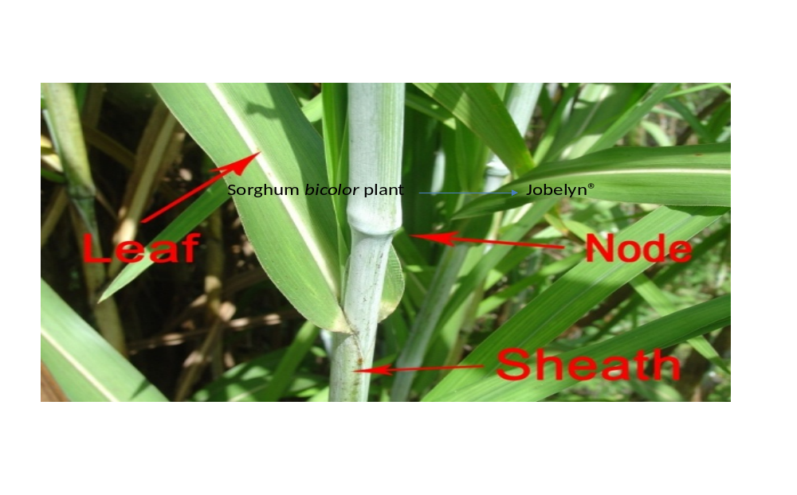



Passport number: A07191369

