Extremely rare multiple malformations: Pituitary duplication, and split spinal cord
Slobodan Marinković, MD, PhD, Faculty of Medicine, Belgrade, Serbia

Statement of the Problem: Some malformations appear only once per several years worldwide. The purpose of this study is to present two of those abnormalities. Methodology & Theoretical Orientation: Mulstislice CT and MRI were performed. Findings: A 21-year-old male patient was presented with pituitary duplication associated with the following malformations: bilateral duplication of the posterior clinoid processes; a very broad clivus; the third occipital condyle; an inverse foramen magnum; a median agenesis of the anterior and posterior atlas arches; duplication of the odontoid process; a median cleft of the axis body; a fusion of the C2-C4 vertebrae; and, hypoplasia of the vertebral arteries, early bifurcation of the basilar artery, hypoplasia of the P1 segment, and segmental dilatation of the A2 segment. The second patient, i.e. a 5-year-old girl, was presented with: C7 vertebra – agenesis of the left part of the body; T1 and T2 – an incomplete vertical cleft of the left pedicle; T3 – agenesis of the right arch; T4 – absence of the right pedicle, and a cleft of its arch; T5, T7 and T12 – agenesis of the right half of the body, hypoplasia of the right half, and defect of the left arch; T6 – a vertical cleft of the body, agenesis of its arch, and enlarged vertebral foramen; T8 – a defect of the left arch, and enlarged vertebral foramen; T10 and T11 – absence of the arches, and duplication of the vertebral foramen; T12 – duplication of the vertebral foramen; L1 – small defect of the right half of the body, arch agenesis, and duplication of the vertebral foramen; L3 – a mediosagittal cleft of its arch; L4 – agenesis of the left arch; from L5 to S3 – a complete absence of their arches. The spinal cord was duplicated at the level between the T6 and T10. Conclusion & Significance: These extremely rare malformations are very important from the embyologic and neurologic aspect.


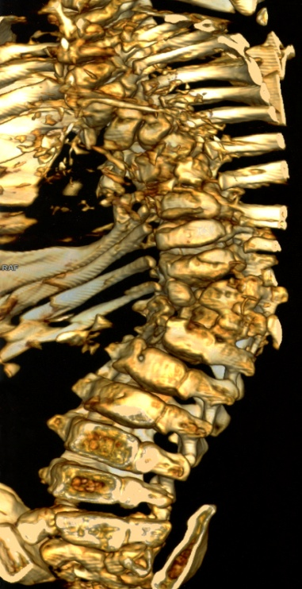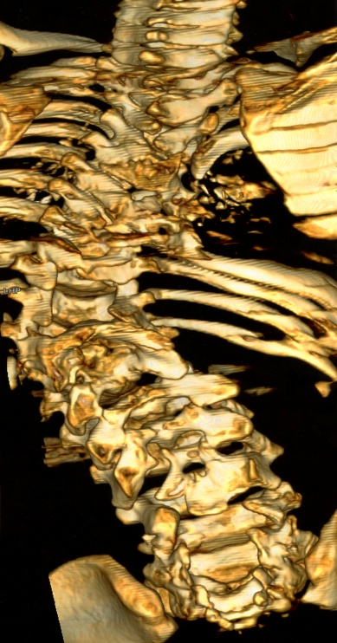
Figure 1. Multiple malformations of the ribs, spine and spinal cord in anterior view (left) and posterior view (right)
- Marinković S et al (2005) Microanatomy of the intrachoroidal vasculature of the lateral ventricle. Neurosurgery 57(1 Suppl):22-36.
- Marinković S et al (2010) Neuroradiology and art: a review and personal contribution. Tohoku J Exp Med 222(4):297-302.
- Marinković S et al (2017) Morphometric multislice computed tomography examination of the craniovertebral junction in neck flexion and extension. Folia Morphol (Warsz) 76(1):100-109.
- Djulejić V, Marinković S et al (2012) Morphometric analysis, region of supply and microanatomy of the lenticulostriate arteries and their clinical significance. J Clin Neurosci 19(10):1416-21.
- Djulejić V, Marinković S et al (2015) Common features of the cerebral perforating arteries and their clinical significance. Acta Neurochir (Wien) 157(5):743-754.

.

Slobodan Marinković has completed his PhD at the age of 31 years from Belgrade University and postdoctoral studies from Laboratories in Copenhagen (Denmark) and Washington (USA). He has published 2 international books, four chapters in 2 other books, 8 national books, more than 60 papers in reputed journals. He has about 1200 citations in the international publications. He has been a chairman person on three occasions. He is a Full Professor of Anatomy at University of Belgrade, and a Visiting Professor at Shinshu University, Matsumoto, Japan.
Slobodan Marinković
00381-644866829
Neuroimaging, Oral presentation
slobodan.marinkovic@med.bg.ac.rs

