Genomics of OLIG family of bHLH transcription factor

Shouhartha Choudhury¹ Prosenjit Paul² and, Supriyo Chakraborty^{3*}
¹Department of Biotechnology, Assam University, Silchar-788011
²School of Life Sciences, Assam University, Silchar-788011

Keywords: OLIG2, OLIG Family, bHLH transcription factor, Gene expression
Abstract
The present study investigated OLIG (Oligodendrocyte lineage gene) induce differentiation of neural progenitors and express oligodendrocyte and putative immature progenitor cells in adult central nervous system. The murine bHLH transcription factors OLIG1 and OLIG2 are neural progenitors and essential for oligodendrocyte development found to chromosome 21. OLIG1 participate oligodendrogenesis and OLIG2 express in immature neuron and multipotential glia in the embryonic olfactory neurons. OLIG2 a marker of diffuse glioma and faithfully restricted to the normal oligodendroglia in human brain. In rodents, expression heterogeneity demonstrated OLIG1 and OLIG2 characteristics of various glial tumors. OLIG3 is a third gene of OLIG family detected in the dorsal neural tube in midbrain, hindbrain, and spinal cord. In this study, we curated literature-derived information of the OLIG family and their specific bHLH domain recorded in genomic data. We accumulate eukaryotic organism genome i.e. Homo sapiens and Mus musculus and performed comparative and functional analysis. The complete bHLH transcription factor data analysis suggested number of encoded genes and their domain, motifs, phylogeny, chromosome location and expression. In this study, we performed bioinformatics and computational techniques to the current knowledge of OLIG family of bHLH transcription factor in eukaryotes.

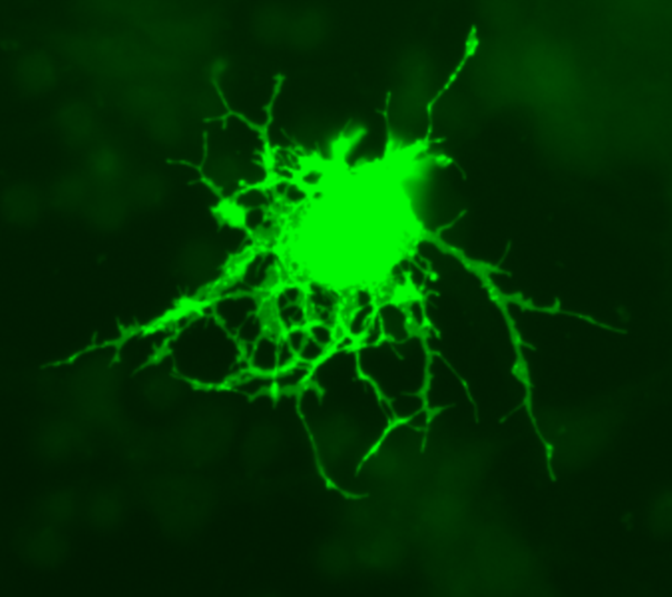

Reference
- Diamond, M.C., et al., On the brain of a scientist: Albert Einstein. Experimental neurology, 1985. 88(1): p. 198-204.
- Lu, Q.R., et al., Oligodendrocyte lineage genes (OLIG) as molecular markers for human glial brain tumors. Proceedings of the National Academy of Sciences, 2001. 98(19): p. 10851-10856.
- Marie, Y., et al., OLIG2 as a specific marker of oligodendroglial tumour cells. The Lancet, 2001. 358(9278): p. 298-300.

Biography
Shouhartha Choudhury has completed his B.Tech and M.Tech in Bioinformatics from India and now pursuing integrated pre-Ph.D. from School of Life Sciences, Department of Biotechnology, Assam University, Silchar-788011. He submitted four research reports entitled (a) Genome-wide analysis of AP2/ERF Family in plants, (b) Comparative Genomics: Novel: BCL-2 Family, (c) Genomics of OLIG Family of bHLH transcription factor and, (d) Genome-wide analysis of NeuroD Family of bHLH transcription factor in Assam University, for short communication

Author details

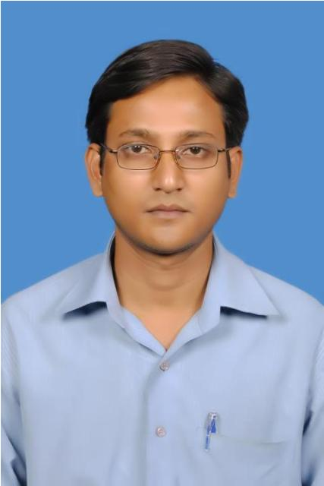
Full Name: Shouhartha Choudhury
Contact number: +91-9954411181
Twitter account: Shouhartha Choudhury
Linked In account: Shouhartha Choudhury
Session name/ number:
Category: (Oral and poster presentation)
Passport Number:

