Wilson’s Disease: Overview Analysis of Publications Study

Wael Ibrahim^{1,2}, MD

- Department of Neurology, Kasralainy hospital, Faculty of medicine, Cairo University; Egypt.
- Kasralainy Movement Disorders unit (KAMDU), Faculty of Medicine, Cairo University; Egypt.

Keywords: Wilson’s Disease, network analysis, semantic analysis, Web of science

- Abstract Body
Researchers from different fields and various communities performed a lot of studies related to Wilson’s Disease (WD) in more than 30 subject areas.
We apply recently developed models of network analysis for publications in the fields of WD to reveal the links between research clusters, rank their importance and track changes of scientific groups attention.
One of the applied approaches is citation analysis which is the study of the impact and assumed quality of an article, an author, or an institution based on the number of times works and/or authors have been cited by others.
Recently developed network analysis algorithms including new centrality indices have been applied for publications databases on different aspects of WD. Articles with keywords “Wilson’s Disease” were analyzed. Data were taken from Web of Science (WOS) publications database and consist of more than 3500 articles dated from 1980 to 2018.
Our results reveales ~3500 articles in WOS related to WD, ˃160 articles in 2017. 160 × -2017 publication dates of analyzed articles. Average citation per item: 18.16, while Sum of times cited: ~62,000. Document types: 2275 articles, 331 reviews, 521 Meeting Abstracts. TOP 3 Most Cited Articles: 1. Wilson's disease by: Ala, Aftab; Walker, Ann P.; Ashkan, Keyoumars; et al. LANCET, 2007; 2. EASL Clinical Practice Guidelines: Wilson's disease by: Ferenci, Peter; Czlonkowska, Anna; Stremmel, Wolfgang; et al. JOURNAL OF HEPATOLOGY, 2012; 3.Copper in disorders with neurological symptoms: Alzheimer's, Menkes, and Wilson diseases by: Strausak, D; Mercer, JFB; Dieter, HH; et al. BRAIN RESEARCH BULLETIN, 2000.

- Images

Table 1: WOS Key Categories of Wilson’s Disease related Articles
WOS Key Categories of Wilson’s Disease related Articles | Number
Clinical Neurology | 742
Gastroenterology/Hepatology | 594
Neurosciences | 405
Biochemistry Molecular Biology | 316
Medicine General Internal | 287
Psychiatry | 200
Surgery | 198
Pediatrics | 165
Transplantation | 143
Medicine Research Experimental | 122

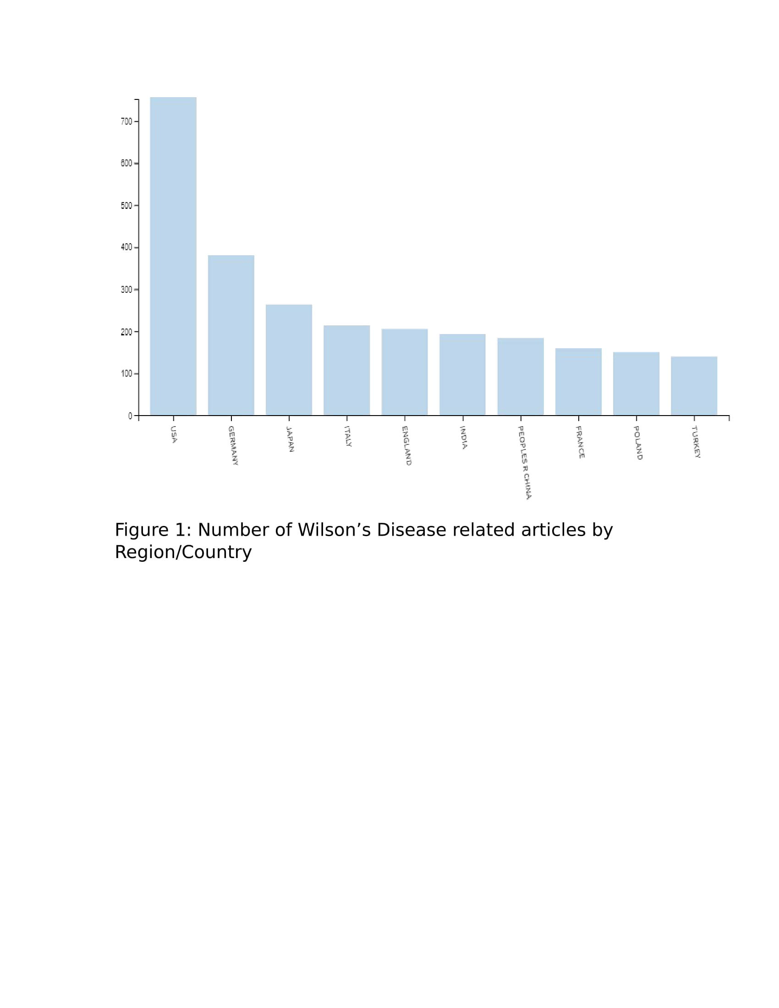

- References

- Aleskerov F, Khutorskaya O, Buldyaev A, Yamilov A. Parkinson’s disease: network analysis of publications activity. in Polish Neurological Review (PPN); electronic Supplement A, Vol. 14, 146, Year 2018.

- Meho LI, Yang K. A New Era in Citation and Bibliometric Analyses: Web of Science, Scopus, and Google Scholar. J Am Soc Inf Sci Technol. 2006:49.

- Biblography
Wael Ibrahim has finished his medical school at faculty of medicine, Cairo university, Egypt in November 2008 with grade Excellent with honor. He was appointed as neurology resident and finished master degree in Neurology & psychiatry on November 2014 and obtained his doctoral degree in Neurology on September 2018. He is now Lecturer of Neurology at Kasralainy hospital, Faculty of Medicine, Cairo University. He published 4 articles and another 4 articles as abstract. He attended several international conferences and previously presented 4 poster presentations.

- Presenting Author details

Full Name: Wael Mahmoud Ezzat Ibrahim
Contact number: +201111919927
Category: Poster presentation
Passport Number: A19335546

