Spinal Decompression Surgery for Lumbar Disc Herniation in Pakistan: A Neuroanatomical Perspective

Dr Safia Tasawar 1, Dr. Muhammad Shahid Akhtar 2, Dr. Muhammad Muneeb Ather,3 Dr Ashiq Hussain 4, DR KINZA FATIMA 5, , Dr Saqib Khalil 6, Dr.Maria Zafar 7, Dr Hassan Mumtaz 8
^{1,7} Al Aleem Medical College, Pakistan
²King Edward Medical University Lahore, Pakistan
³Sahiwal Medical College Pakistan
^{4, 6}Women Medical College Abbottabad, Pakistan
⁵ RASHID LATIF MEDICAL COLLEGE, Lahore, Pakistan
⁸BPP University London, United Kingdom

Abstract:
Statement of the Problem: The herniated intervertebral disc is among the most prevalent afflictions that lead to low back pain and neurological dysfunction and disputed that there is a need for spinal decompression. In Pakistan, the neuroanatomical factors related to the treatment of this condition have not been well- studied. This study aims to assess the outcome of patients with lumbar disc herniation who undergo spinal decompression surgery using neuroanatomical parameters as a basis.
Methodology and Theoretical Orientation: This practical longitudinal study took place over one year at Jinnah International Hospital Abbottabad in Pakistan from June 2023 to May 2024 after ethical approval. Adult patients with LDH, as per the inclusion criteria, were recruited. Outcome measures on postoperative pain relief, functional recovery, and complications were examined in light of neuroanatomical changes determined at surgery and the respective outcomes. Subject Group A included patients with standard presentation of LDH (compression of the common nerve root at the L4-L5 or L5-S1 levels), while subject Group B incorporated patients with variations in neuroanatomy and/or presentation, for example, foraminal and far lateral herniation types. Both groups of patients eventually underwent decompression surgeries employing the open or minimally invasive discectomy approaches as clinically indicated. Neuroanatomical outcomes such as the extent of nerve root /discal compression and herniation were assessed intraoperatively to allocate the participants into their respective groups for later assessment of outcomes.


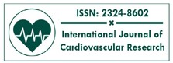
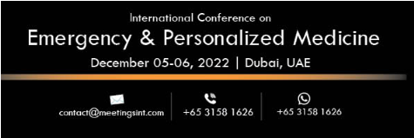
Findings: Initial data shows that there was significant pain relief with a mean difference of 3.5, p < 0.01 with functional recovery being seen in 85% of the respondents, nerve root involvement being crucial.
International Journal of
Cardiovascular Research
ISSN: 2324-8602
Volume 10
Issue 4
Conclusion & Significance: These findings indicate that without accurate neuroanatomical ‘gating’ of the surgical procedures, surgical success will be limited. In low resource countries like Pakistan, such approaches can maximize improvement and provide new evidence with relevance to the treatment of lumbar disk herniation.

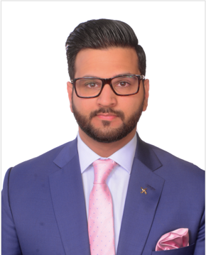
Biography
Dr Hassan Mumtaz is a medical doctor with a postgraduate master’s in public health & administration obtained A grades in Qualitative Research, Applied Epidemiology and biostatistics, and Hospital Management. He is currently enrolled in an MSc in Data Science at BPP University London.

He has four years of experience working in the healthcare sector, of which two years were invested in gaining knowledge of running clinical trials in Pakistan; funded by the McMaster University Canada, Bill & Malinda Gates Medical Research Institute, NIH USA, Shinogi Japan, CanSino Biologics, Aims Vaccine Co China & Alvotech Switzerland. He was involved in writing the REVISE trial Protocol, which is published in BMC Medical Research Methodology IF 4.

Dr Hassan has vast experience of clinical research having published 176 indexed papers with 543 citations & an h-index of 13. He has published in Scientific Reports Nature IF 4.6 & MDPI Vaccines IF 7.8, Q1 journal. He has participated on a Fuel Poverty Project, an NHS in offered to Primary Care Network (PCN) in collaboration with Leeds GP confederation UK. He has also collaborated with the Center for Global Public Health Pakistan and the University of Manitoba, Canada, to investigate the burnout level and coping strategies of healthcare providers during the COVID-19 pandemic. He has worked on a project a mmWave Radar Applications in Healthcare with the University of West Scotland, Glasgow, and another one with the Lincoln University on "evaluating the severity of low back pain, based on computer vision and machine learning techniques".

Dr Hassan has done 7 weeks electives at Guys & St Thomas Hospital London where his duties involved ward rounds, attending surgeries and consultant clinics, taking out blood samples. Performed an audit & cohort study under Professor Muhammad Shamim Khan & Professor Prokar Dasgupta. He has presented a two-day session on Clinical Audits in collaboration with BMY HEALTH & Dr Tahir Khan, Pediatric Orthopedic Consultant from Royal National Orthopaedic Hospital (RNOH) NHS Trust UK.

