Acute hydrocephalus: An atypical and rare presentation of herpes simplex viral encephalitis in adolescents

Sandeep Bhardwaj

Background- Viral encephalitis is a most lethal clinical syndrome associated with severe morbidity and mortality. Viral encephalitis presenting with acute hydrocephalus is a very rare presentation with few cases documented in literature so far.
Case - Author reported a case of 23 year male with history of fever, headache and altered sensorium with GCS (11/15). On evaluation with MRI (Magnetic resonance imaging) brain, there was dilated bilateral lateral and third ventricle suggestive features of acute hydrocephalus. Ventriculoperitoneal (VP) shunt was done in view of obstructive hydrocephalus. CSF was sent for routine and PCR (polymerase chain reaction) examination for common viruses. However, patient did not improve clinically and neurologically following VP Shunt and GCS dropped to 7/15 (E2V2M3). Patient was further evaluated with MRI brain, which was suggestive of florid radiological features of viral encephalitis. Meanwhile PCR results too came positive for HSV-1 confirming diagnosis of viral encephalitis.
Conclusion - Acute hydrocephalus can be a rare presentation of viral encephalitis in adolescents and should be further evaluated with repeat imaging and CSF for common viral PCR to rule out viral encephalitis as in our case.

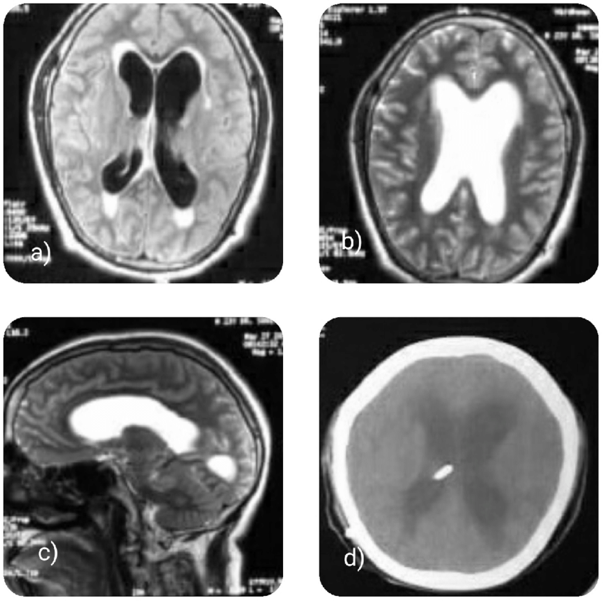

a) MRI brain flair axial image suggestive of dilatation of bilateral lateral ventricles and third ventricle with normal appearing fourth ventricle with periventricular ooze. b, c) MRI brain T2 axial image suggestive of dialted ventricles. d) Post operative scan suggestive of moderate dilated ventricles with VP shunt in situ.

Recent publications
- Sinha VD, Bhardwaj S, Purohit D, Chopra S. Unusual extrusion of distal end of ventriculo-peritoneal shunt: Case series with literature review. Interdisciplinary Neurosurgery: Advanced techniques and Case Management 2021;24:101026
- Bhardwaj S, Chaurasiya M. Can visual complaints be only symptom in slit ventricle syndrome ? A difficult diagnosis to be made. Acta Scientific Neurology 2020;4(1)
- Bhardwaj S, Vij M. Acute hydrocephalus: An atypical and rare presentation of herpes simplex viral encephalitis in adolescents. Interdisciplinary Neurosurgery : Advanced techniques and Case Management 2021;24:101015
- Bhardwaj S, Bansil R. Sharing experience of Telemedicine for Neurosurgery Management during Covid 19 Pandemic. IJSR 2020;9(6):538-539.
- Bhardwaj S, Sinha VD, Shekhawat JS, Gora NK .Large chronic calcified subdural hematoma with empyema – A long term complication following shunt surgery. J Neurosci Rural Pract 2020

a
Dr Sandeep Bhardwaj is well accomplished neurosurgeon with 14 years of surgical experience with super-specialization in field of brain and spine surgery.He has been widely acknowledged for his versatile surgical skills and patient centric approach. He has more than 10 publications and various under process of publications in various reputed international journals. He is one of youngest neurosurgeons to achieve and has passion for further research in field of neurosurgery.

