Guggulsterone Mediated JAK/STAT and PPAR-Gamma Modulation Prevents Neurobehavioral and Neurochemical Abnormalities in Propionic Acid-Induced Experimental Model of Autism

Sumit Kumar, research scholar, Department of Pharmacology, Neuropharmacology Division, ISF College of Pharmacy, Moga 142001, Punjab, India

Abstract (300 word limit)

Autism spectrum disorder is a neurodevelopmental disorder marked by repetitive behaviour, challenges in verbal and non-verbal communication, poor socio-emotional health, and cognitive impairment. An increased level of signal transducer and activator of transcription 3 (STAT3) and a decreased level of peroxisome proliferator-activated receptor (PPAR) gamma have been linked to autism pathogenesis. Guggulsterone (GST) has a neuroprotective effect on autistic conditions by modulating these signalling pathways. Consequently, the primary objective of this study was to examine potential neuroprotective properties of GST by modulating JAK/STAT and PPAR-gamma levels in intracerebroventricular propionic acid (ICV PPA) induced experimental model of autism in adult rats. In this study, the first 11 days of ICV-PPA injections in rats resulted in autism-like behavioural, neurochemical, morphological, and histopathological changes. The above modifications were also observed in various biological samples, including brain homogenate, CSF, and blood plasma. GST was also observed to improve autism-like behavioural impairments in autistic rats treated with PPA, including locomotion, neuromuscular coordination, depression-like behaviour, spatial memory, cognition, and body weight. Prolonged GST treatment also restored neurochemical deficits in a dose-dependent manner. Chronic PPA administration increased STAT3 and decreased PPAR gamma in autistic rat brain, CSF, and blood plasma samples, which were reversed by GST. GST also restored the gross and histopathological alterations in PPA-treated rat brains. Our results indicate the neuroprotective effects of GST in preventing autism-related behavioural and neurochemical alterations.
Image
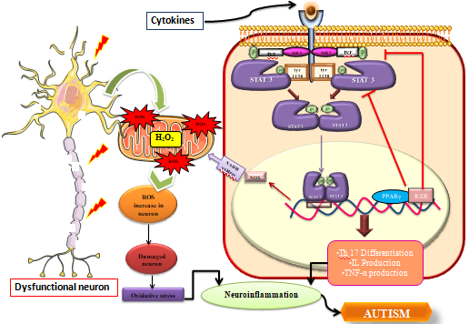
Recent Publications
- Jadaun, K. S., Mehan, S., Sharma, A., Siddiqui, E. M., Kumar, S., & Alsuhaymi, N. (2022). Neuroprotective Effect of Chrysophanol as a PI3K/AKT/mTOR Signaling Inhibitor in an Experimental Model of Autologous Blood-induced Intracerebral Hemorrhage. Current Medical Science, 1-18.

- Khera, R., Mehan, S., Bhalla, S., Kumar, S., Alshammari, A., Alharbi, M., & Sadhu, S. S. (2022). Guggulsterone Mediated JAK/STAT and PPAR-Gamma Modulation Prevents Neurobehavioral and Neurochemical Abnormalities in Propionic Acid-Induced Experimental Model of Autism. Molecules, 27(3), 889.

 Biography (150 word limit)
Mr. Sumit Kumar has completed his bachelor in pharmacy at the age of 21 years from ISF College of Pharmacy, Moga, INDIA. Currently, he is a budding research scholar pursuing his Masters in Pharmacology at the age of 23 years from INDIA. He presented posters in international conferences. His area of interest is translational neuroscience and at present he is working on motor degenerative disorder- ALS (Amyotrophic lateral sclerosis). He is investigating the neuroprotecting potential of phytoconstituents.
Email: sumitsrivastav223@gmail.com

