A snake toxin as a theranostic agent for type 2 vasopressin receptor-related diseases
Laura Droctovea Justyna Cioleka Gilles Mouriera Charles Truilletb Bernard Mouillacc Christiane Mendrec Ralph Witzgallb Denis Serventa Nicolas Gillesa
aUniversité Paris Saclay, CEA, INRAE, Department of Medicines and technologies for health, 91191 Gif-sur-Yvette, France.
b Université Paris-Saclay, CEA, CNRS, Inserm, BioMaps, Orsay, 91401, France.
cInstitute of functional genomic, CNRS, Montpellier, France. dIBMM, CNRS, Montpellier, France.

Abstract (300 word limit)

The type 2 vasopressin receptor (V2R), in normal physiological condition, is almost exclusively expressed in the kidney where it regulates water homeostasis. Its blockage is linked to several diseases, among those, the polycystic kidney disease (PKD) and the hyponatremia. Currently, only one drug succeeded to reach the market, but with many concerns (Anderegg, Kidney medicine 2020).

Scorpions, spiders, snakes, conus, etc… are often seen as dangerous, frightening and ugly animals. But their venoms are extremely rich in toxins which are highly valuable in the context of human use and drug development. We optimized a process to identified GPCR active toxins linked to unmet therapeutic needs. The mambaquaretin (MQ) was discovered in the green mamba snake African venom and it is the most selective antagonist ever find for the V2R. We challenged it with successes on rodent models of PKD (pcy mice) and hyponatremia (rat model, Ciolek PNAS 2017; Droctové Theranostics 2020). MQ represents a new hope for patients affected by these diseases.

In tumor conditions, V2R is also ectopically expressed in various cancers like the prostatic, the breast, the bladder ones or in the metastatic form of renal carcinoma. By grafting 89Zr on MQ, we validated this toxin, by TEP imaging, as the first ligand able to label in vivo the V2R. The couple MQ/V2R is under exploitation to develop diagnostic tools against some cancers.
Image
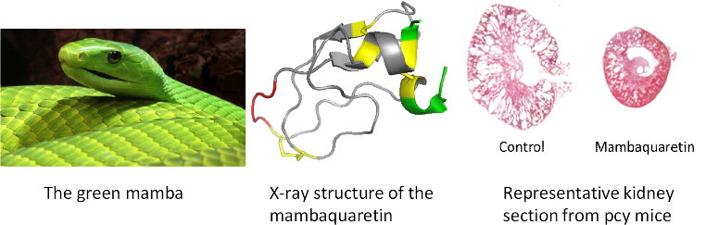
Recent Publications (minimum 5)
1. Droctové (2020) A snake toxin as a theranostic agent for the type 2 vasopressin receptor. Theranostics. Sep 18;10(25):11580-11594.
2. Ciolek (2017) Green mamba peptide targets type-2 vasopressin receptor against polycystic kidney disease. Proc. Natl. Acad. Sci. U. S. A. 114, 7154–7159.
3. Reynaud (2020 ) A Venomics Approach Coupled to High-Throughput Toxin Production Strategies Identifies the First Venom-Derived Melanocortin Receptor Agonists. J Med Chem.
4. Upert, (2014) High-throughput production of two disulphide-bridge toxins. Chem. Commun. (Camb). 50, 8408–11.
5. Haler (2020 ) Can IM-MS Collision Cross Sections of Biomolecules Be Rationalized Using Collision Cross-Section Trends of Polydisperse Synthetic Homopolymers J Am Soc Mass Spectrom. 1;31(4):990-995.

Biography (150 word limit)
Dr. Nicolas Gilles position is a full time researcher at the Department of Medicines and Technologies for Health, in the Toxins Receptors and Channel team (CEA, France). In charge of the identification and therapeutic development of animal toxins active on G-Protein Coupled Receptors for human benefit.
Dr. Nicolas Gilles has a 20-year experience in the study of animal toxins. He is pioneering the investigation of animal toxins acting on GPCRs, the largest therapeutic target class. His strongest expertise lies in venom manipulations, HT screening, toxin production, selection of therapeutic targets, molecular pharmacology and in vivo experiments. When the pharmacological properties of these new ligands are deemed exceptional, a hit-too-lead process is realized and its therapeutic development initiates. This is the case for a snake toxin for V2R-related disease.
Email: nicolas.gilles@cea.fr

Notes/Comments:

