Sepsis-Septic Shock-Acute Kidney Injury Sequence: The Most Important Complication of Steroid Responsive Nephrotic Syndrome
Saptarshi Ghosh, Final year MBBS Student, Medical College Kolkata (Presenting Author)
Sanat K. Ghosh, Professor , Dr B C Roy PGIPS, Kolkata (Senior Author)
Debanjan Sinha, Post Graduate Trainee, Dr B C Roy PGIPS, Kolkata (Co-Author)

Abstract Image
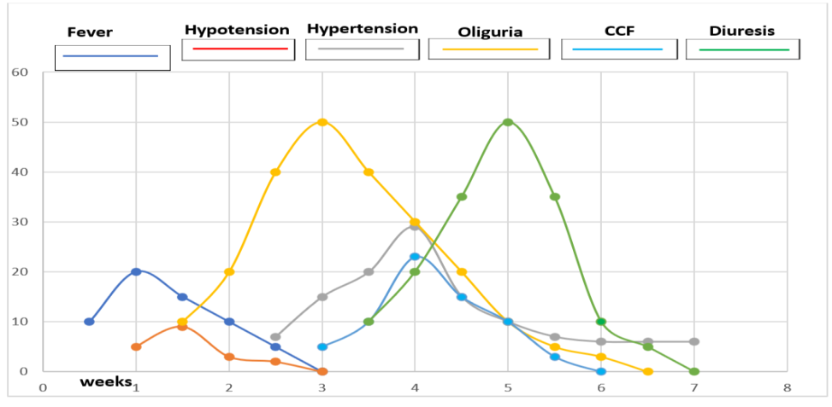
Figure 1: Clinical Profile of Septic AKI
Sepsis is a well-recognized complication of nephrotic syndrome. Systemic inflammatory response syndrome (SIRS) insult in the nephrotic background initiates interplay between inflammation and oxidative stress, leading to septic acute kidney injury (SAKI). Thus, the sepsis-septic shock-AKI sequence ie SAKI develops as a complication of nephrotic syndrome. Data on this subject is lacking. The present study is conducted to know the prevalence, clinical profile, complications and outcomes of this sequence in steroid responsive nephrotic syndrome.

It was an observational cross-sectional study conducted at Dr B C Roy PGIPS, Kolkata, India. Consecutively hospitalised children with steroid responsive nephrotic syndrome below 12 years were included after exclusion of pre-existing chronic kidney disease. Sepsis & septic shock were identified by Sepsis-3 criteria.
Outcomes were development of AKI (identified by KDIGO), morbidity and mortality.

Out of 235 subjects, 64 (27.23%) develop AKI. 59 (92.18%) of them developed septic AKI (SAKI). Among the 59 subjects with SAKI, 40 (67.79%) had Sepsis and 19 (32.20%) had septic shock. As per KDIGO AKI staging of 59 patients with SAKI–
38 (64.4%), 12(20.33%) and 9 (15.25%) subjects developed stage 1, stage 2 and stage 3 AKI respectively. Severity of AKI was associated with sepsis 3 score (p value <0.0000). Clinical features included features of peritonitis, sepsis, or septic shock followed by prolongation of the oliguric phase, development of hypertension, azotemia and congestive heart failure in some cases. Edema, CCF, azotemia subsided with diuresis. Hypertension persisted for a variable period. Duration of hospital stay, requirement of PICU care and mortality were higher in this group compared to non-AKI and non-septic AKI group (p value 0.00005360, <0.0000001 and 0.02215 respectively).
Table 1: Increased morbidity and mortality in septic AKI group compared to non-AKI group and non-septic AKI group

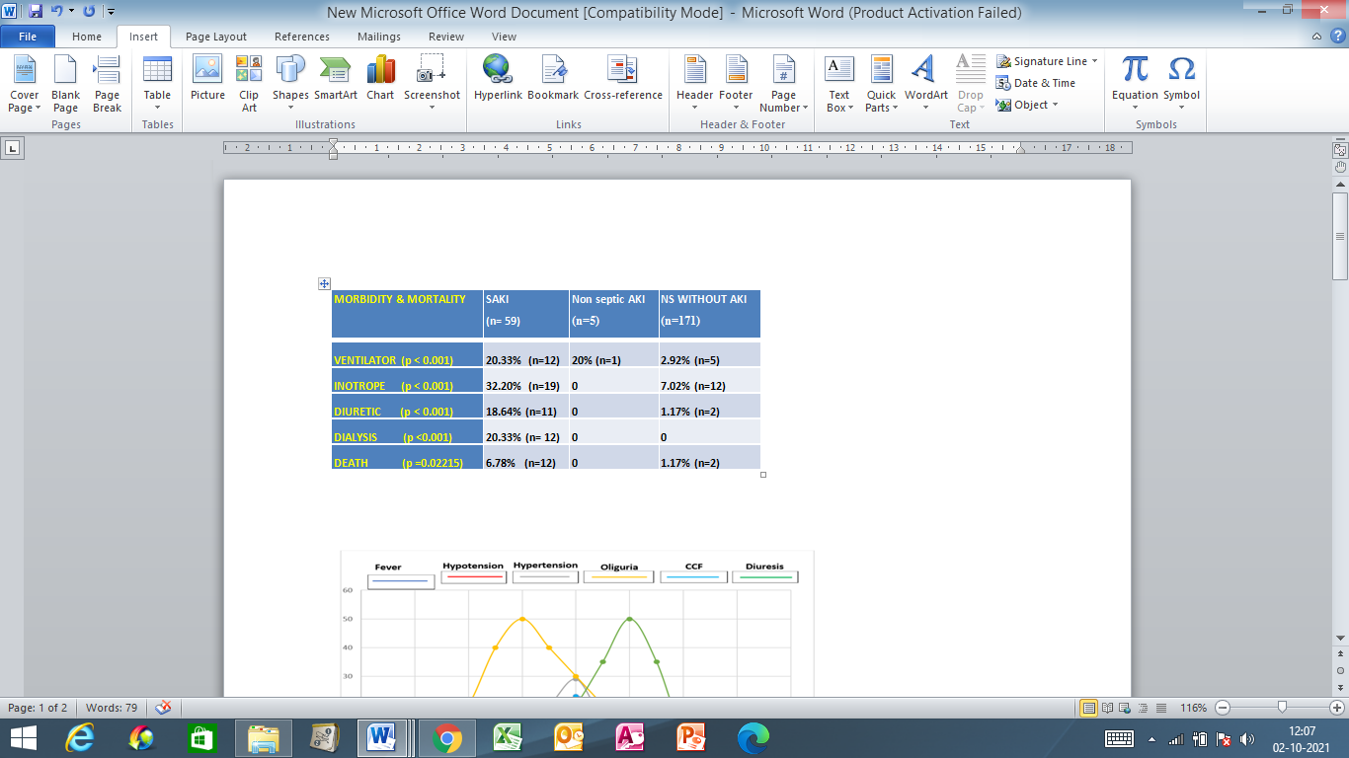

Prevalence of sepsis-septic shock-AKI sequence in steroid responsive nephrotic syndrome was quite high. Sepsis-3 score correlated with severity of AKI staging. SAKI was associated with increased length of hospital stay, increased frequency of inotropes & ICU requirement and increased mortality. Thus, sepsis-septic shock-AKI sequence is the most important complication of steroid responsive nephrotic syndrome. Published data on septic AKI in nephrotic syndrome is very scanty.

Recent Publications
1. Gomez H, Ince C, De Backer D, Pickkers P, Payen D, Hotchkiss J, Kellum JA. A unified theory of sepsis-induced acute kidney injury: inflammation, microcirculatory dysfunction, bioenergetics and the tubular cell adaptation to injury. Shock (Augusta, Ga.). 2014 Jan;41(1):3.
2. Kim MY, Cho MH, Kim JH, Ahn YH, Choi HJ, Ha IS, et al. Acute kidney injury in childhood-onset nephrotic syndrome: Incidence and risk factors in hospitalized patients. Kidney Res Clin Pract [Internet]. 2018 Dec 31;37(4):347–55. Available from: http://www.krcp-ksn.org/journal/view.html?doi=10.23876/j.krcp.18.0098
3. Rheault MN, Zhang L, Selewski DT, Kallash M, Tran CL, Seamon M, et al. . AKI in children hospitalized with nephrotic syndrome. Clin J Am Soc Nephrol. (2015) 10:2110–8. 10.2215/CJN.06620615 [PMC free article] [PubMed] [CrossRef] [Google Scholar]
4. Meyrier A, Niaudet P. Acute kidney injury complicating nephrotic syndrome of minimal change disease. Kidney Int. (2018). 94:861–9. 10.1016/j.kint.2018.04.024 [PubMed] [CrossRef] [Google Scholar]
5. Rheault MN, Wei CC, Hains DS, Wang W, Kerlin BA, Smoyer WE. Increasing frequency of acute kidney injury amongst children hospitalized with nephrotic syndrome. Pediatr Nephrol. (2014) 29:139–47. 10.1007/s00467-013-2607-4 [PMC free article] [PubMed] [CrossRef] [Google Scholar]
6. Sharma M, Mahanta A, Barman AK, Mahanta PJ. Acute kidney injury in children with nephrotic syndrome: a single-center study. Clin Kidney J. (2018) 11:655–8. 10.1093/ckj/sfy024 [PMC free article] [PubMed] [CrossRef] [Google Scholar]

Biography

Sanat K Ghosh is a professor of pediatrics working as a clinical

pediatrician and nephrologist for more than 20 years

at Dr B C Roy Post Graduate Institute of Pediatric Sciences,

Kolkata, India which is among the few big pediatric hospitals in India.

Complications of nephrotic syndrome, particularly, sepsis induced AKI

is one of his fields of special interest.

Debanjan Sinha is a post graduate trainee of pediatrics at Dr B C Roy PGIPS, Kolkata. He has the experience of working in a number of research projects.

Saptarshi Ghosh is a final year MBBS student at Medical College Kolkata. He also has the experience of working in other research projects including a project of Indian Council of Medical Research (ICMR).
Email: gsaptarshi1998@gmail.com

