Factor Affecting Dialysis and Medication Adherence among End-Stage Renal Disease Patients in Metro Vigan

Edmundo F. Ancheta III, RPh., University of Northern Philippines College of Medicine, Philippines
Lyndon John A. Albay, RN., University of Northern Philippines College of Medicine, Philippines
Fides Angeli C. Alsong, RMT., University of Northern Philippines College of Medicine, Philippines
Salustiano A. Anacta III, RN., University of Northern Philippines College of Medicine, Philippines
Allen M. Andrada, RMT., University of Northern Philippines College of Medicine, Philippines
Myellerva Jayne F. Araneta, LPT., University of Northern Philippines College of Medicine, Philippines
Mikeman E. Bacon, University of Northern Philippines College of Medicine, Philippines
Luz Gregoria Lazo-Velasco, MD, FPCP, University of Northern Philippines College of Medicine, Philippines

Abstract
Background: End-Stage Renal Disease is the last stage of chronic kidney disease where kidney function is declining up to the point that the kidneys can no longer function on their own. ESRD was the seventh leading cause of death in the Philippines in 2018. ESRD patients are prescribed a multi-pharmacological treatment and this contributes to a high pill burden intake. This study aimed to determine the factors affecting the adherence of ESRD patients to hemodialysis and medication therapy in Metro Vigan. Methods: The study used a descriptive method of research that utilized a questionnaire-checklist and interviews to gather data from the four selected dialysis centers. Total enumeration was used with a total of 70 respondents and was analyzed using frequency and percentage distribution. Results: Findings revealed that majority belong to 61-70 age bracket, college graduates, with family monthly income of Php <10,000, residence was >25 km away from the dialysis units, funded by PhilHealth, commuting on a tricycle. Some patients were not attending dialysis treatment due to transportation and financial problems. Majority were diagnosed in 2017-2019, due to Diabetic Nephropathy and had twice a week dialysis schedule with four hours duration. Majority had high confidence in their doctor’s advice throughout the therapy and said it is highly important to follow their dialysis schedule and medication schedule. Two-thirds of the respondents were taking >5 drugs and almost half of the respondents said that the number of medications was a concern because of its cost. Conclusion: The study showed that high level of education, with insurance and with a good physician-patient relationship suggests better adherence to their treatment regimen. In contrast, older age, low household income, more distant residence from the dialysis center, commuters, and high medication intake may result in non-adherence to their hemodialysis and medication therapy.


Image
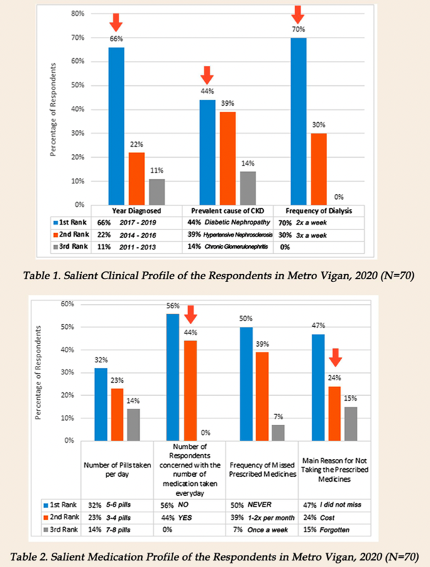
Recent Publications (minimum 5)
- Burnier, M., Pruijm, M., Wuerzner G. et al. (2015), Drug adherence in chronic kidney disease and dialysis. Nephrol Dial Transplant
- Chauhan, R., Mendonca, S. (2015). Adequacy of twice weekly hemodialysis in end stage renal disease patients at a tertiary care dialysis centre. Indian J Nephrol.
- Inquirer Lifestyle (2020), Kidney disease is on the rise — But there’s a new standard in dialysis treatment. Retrieved on May 27, 2020 from https://lifestyle.inquirer.net/336563/kidney-disease-is-on-the-rise-but-theres-a-new- standard-in-dialysis-treatment/#ixzz6NWkvlJDp.
- Jameson, JL., (2018), Chronic kidney disease. In: Harrison's principles of internal medicine. 20th ed. New York: McGraw-Hill
- Philippine Health Corporation (2015), Philhealth Circular No. 022-2015

Biography
Edmundo F. Ancheta III is a 4th year medical student and good student leader advocating for fair service to all students. He received Leadership Excellence Award by APMC-SN. He is currently taking up doctor of medicine at the University of Northern Philippines College of Medicine. He is self-driven and motivated medical student and awarded as Dean’s Lister in 2 consecutive years. His research interest revolves around public health which he plans to serve the community as Doctors to the Barriors when he passes his Physicians Licensure Examination.

Email: edmundoanchetaiii@gmail.com

