Near Infra-RED, Non-Invasive Serum Creatinine Determination and Monitoring
Z. Barnea Burbea¹, R. Cernes¹, David Abookasis²
¹Wolfson Medical Center, Nephrology, Holon, & TA University, Israel 2
²Ariel University, Israel
Introduction
The aim of the study to develop an online, non-Invasive serum creatinine measurement and monitoring eGFR in acute kidney injury (AKI) & Chronic Kidney Disease (CKD) set up. A method that can be applied in various situations where AKI can develop e.g. during cardiac catheterization, sepsis, hemodynamic insult and other situations.

Methods
The method is based on near infrared (NIR) spectrometry. An oximeter like manner approach was applied for serum creatinine. It is based on illuminating a light beam on the skin where a detector collects the reflected beam. The back light withholds information on the target molecule. The obtained data is processed through an algorithm of prediction/calculating resulting in a real-time eGFR determination. 60 blood samples from normal individuals, CKD & hemodialysis patients with serum creatinine of 0.8-12.4 mg/dl traditionally determined were NIR analyzed in special tubes for simulating human fingers for comparison between the suggested method and the traditional one.
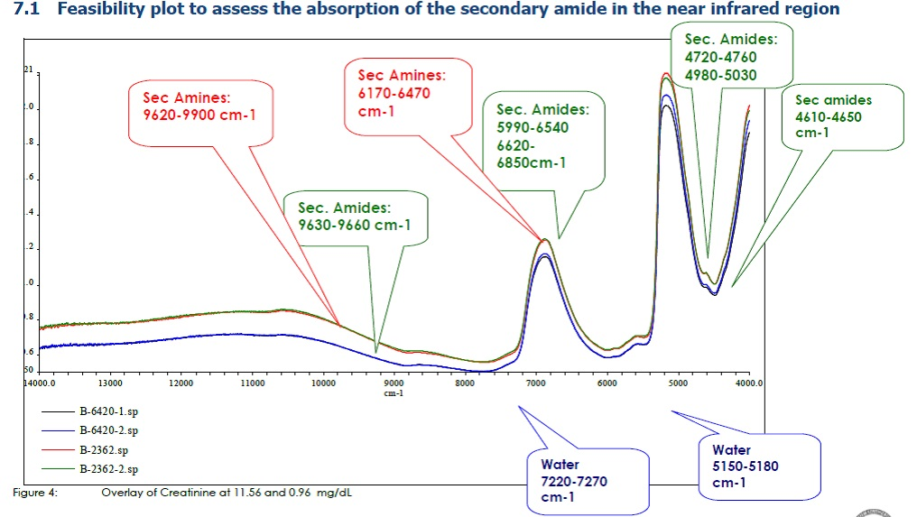
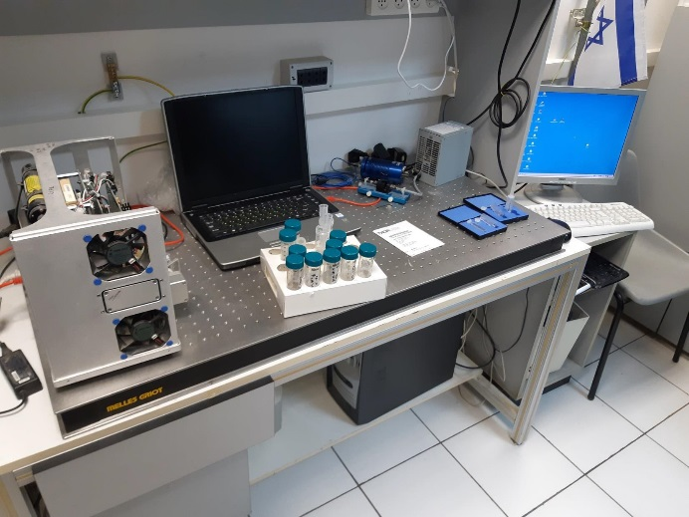

Results
Correlation of 0.99% were obtained (Figure) between the reference samples (traditionally determined) results and the calculated concentrations by using NIR analysis of the diffracted/reflected spectra.

Conclusions
A reliable eGFR monitoring via an optic method can be applied in ICU, medical departments and any point of care CKD and AKI risk situations.

