The effect of biliary drenage on uremic state
Zümrütdal E.
Department of General Surgery, EPC Hospital, Adana, Turkey
Keywords: Renal Failure, Biliary Drenage
This study aims to investigate the therapeutic properties of bile drainage in renal failure(RF).
This study included two groups of rabbits (Group1,n=8 and Group2,n=8). Both of the groups underwent bilateral nephrectomy and RF was established. In Group 2, a stent was placed into the choledoc and then the stent was taken out of the abdomen(Figure-1). Biochemical parameters in serum and oxidative markers in liver and lung tissues were compared at 0 and 12 hours in group 1 and 2.
Figure-1
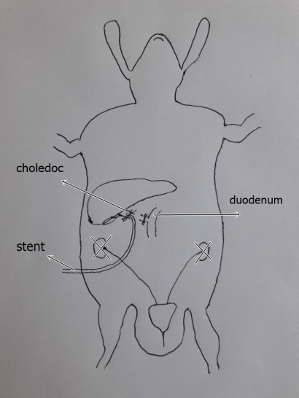
Potassium level in group-2 at12th hour was lower than group-1. At the 12th hour, reduced glutathion(GSH) levels were higher in liver and lung tissue samples in group-2, compared to group-1. And thiobarbituric acid reactive substances(TBARS) levels were lower than group-1(Table-1).
Table-1
 | 0th hour (Blood) |  |  |  | 12th hour (Blood) |  |  | Group-2 (Bile)
 | Group-1 | Group-2 | p |  | Group1 | Group2 | p | 0th hour |  | 12th hour |  | p
Sodium (mmol/lt) | 139.5 | 141.5 | >0.05 |  | 140.5 | 143.2 | >0.05 | 154.4 |  | 151.1 |  | >0.05
Potassium (mmol/l) | 3.3 | 3.3 | >0.05 |  | 5.5 | 4.2 | <0.05 | 4.8 |  | 5.0 |  | >0.05
Phosporus (mg/dl) | 6.1 | 6.3 | >0.05 |  | 6.5 | 7.25 | >0.05 | 1.3 |  | 1.6 |  | >0.05
Urea (mg/dl) | 40.8 | 48.5 | >0.05 |  | 125.6 | 132.3 | >0.05 | 42.1 |  | 133 |  | <0.05
Creatinine (mg/dl) | 1.1 | 1.2 | >0.05 |  | 4.7 | 5.0 | >0.05 | 1.0 |  | 4.9 |  | <0.05
Uric acide (mg/dl) | 0.11 | 0.13 | >0.05 |  | 0.16 | 0.15 | >0.05 | 0.2 |  | 0.19 |  | >0.05
 | GSH (μmol/mg) |  |  |  |  | TBARS (nmol/mg)
 | Group-1 | Group-2 |  | p |  | Group-1 |  |  | Group-2 |  | p
Liver | 0.003151 | 0.008882 |  | 0.012 |  | 1.2893 |  |  | 1.0425 |  | >0.05
Lung | 0.000543 | 0.015738 |  | 0.001 |  | 1.1213 |  |  | 1.0013 |  | 0.028

Hyperpotasemia and hypervolemia are the most important problems in RF patients especially in patients with heart failure, septic shock and burn who can not be dialysed easily. In this innovative application, gently removal of liquid and potassium from the body by a choledoc stent may be life-saving in such patients. Lower potassium levels may be a result of the excretion of potassium with stent. Higher GSH levels and lower TBARS levels in group-2 indicate the less oxidative stress. And this may be related with the ultrafiltration and removal of excess fluid by choledoc stent which eliminate the mechanical stress on the cells. This procedure may be useful in such critically ill RF patients and it can be achieved with a minimally invasive nasobilier stent application.

Biography

He was born in 1967 in Adana. Medical doctor. General surgeon. He has many original papers in various well-known medical journals.

Full Name: Emin Zümrütdal
E-mail:ezumrutdal@yahoo.com
Contact number: +09 0 505 581 07 66
Category: Poster presentation

