Abstract

Title: higher risk of persistent glomerular filtration rate impairment with viral hepatitis C than B in sub-Saharan African population.

MACKANGA JR^{1,2}, KAMGANG M², ITOUDI BIGNOUMBA EP², KOMBILA UD², MOUENDOU MOULOUNGUI EG², EHOUMBA ODZAGA FE², NZOUTO PD², IBA-BA J², MISSOUNGA L², MOUSSAVOU KOMBILA JB², BOGUIKOUMA JB²
¹Nephrology Department of University Hospital Center of Nantes, Nantes, France
²Department of Internal Medicine, University of health sciences, Libreville, Gabon

Keywords: viral hepatitis B and C – persistent glomerular filtration rate impairment- sub-Saharan Africa - Gabon

- Abstract Body
The higher renal susceptibility with viral hepatitis C than B according to proteinuria is described [1]; but comparative impact on glomerular filtration rate (GFR) of both viruses stays unclear. The purpose of study was to estimate the risk difference between both viruses for expected event “persistent GFR impairment (PGFRI)”. 181 patients (chronic viral hepatitis B vs C) with baseline GFR >100 (ml/min/1.73m², CKD-Epi, creatinine) were monitored in cohort. PGFRI=GFR<75 persistent during successive annual measurements. Covariables: age, gender, body mass index (BMI), diabetes mellitus, hypertension, and antiviral treatment. Survival analysis and Cox regression used, p = 0.05. The 54.7% of patients had B virus vs C (p=0.23); 58.0% masculine gender (p=0.048); median age 43.0(IQR: 53.0-31.0) years. The incidence proportion of PGFRI was 2.1(CI: 1.3-3.2) cases per 100 persons per year, cumulative crude incidence: 9.9 % (CI: 0.062-0.148). For expected event PGFRI, unadjusted hazard ratio C virus vs B HR=6.2(CI: 2.0-21.7)p=0.0002, risk difference: 17.4%(CI:0.074-0.270). After adjustment, cumulative hazard stays higher with C virus vs B (Figure). Beside, only gender masculine vs feminine: HRa=4.7(CI: 1.5-14.7) p=0.007 and age >60year vs under: HRa= 16.7(CI: 1.5-187.3) p=0.022 were associated with significant risk of PGFRI. No effect of treatment in both group (C virus p=0.12; B virus p=0.71) in sub analysis. In conclusion, in sub-Saharan African people, renal susceptibility according to persistent GFR impairment seems higher in population with chronic viral hepatitis C than B. Urinary monitoring must be systematic beside creatinine measurement in routine assessment in this population.

- Image:
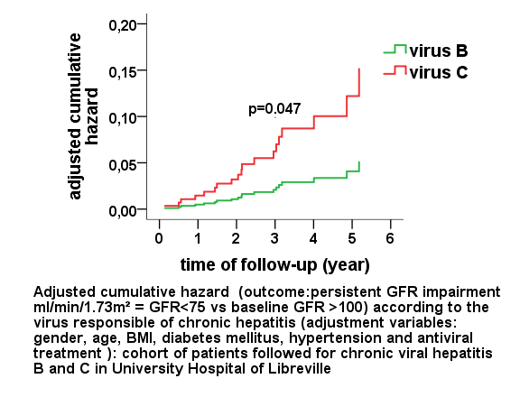

- Reference:
- Huang JF et al. J Intern Med 2006; 260(3): 255-62;
- Biography:
Jean Rodolphe MACKANGA has completed his MD from University of Health Sciences of Libreville (Gabon) and postdoctoral studies from Nantes University in medical education topic. He is the responsible of clinical research in nephrology in department of internal medicine in University of Health Sciences of Libreville. He has participated yet at the scientific conference of French society of nephrology dialysis transplantation with poster (4 times) and published the papers in reputed journals (73 words)
- Presenting author details


Presenting author details
Full name: Jean Rodolphe MACKANGA
Contact number: +330751192421
Twitter account:
Linked In account:
Session name/ number:
Category: Poster presentation:

