Animal toxins for human health, case of the Mambaquaretin for the treatment of polycystic kidney diseases.
Laura Droctoveª Justyna Ciolekª Helen Reinfrank^{b} Gilles Mourierª Bernard Mouillac^{c} Christiane Mendre^{c} Ralph Witzgall^{b} Denis Serventª Nicolas Gillesª
a CEA-Saclay, Institut de Biologie et de Technologie de Saclay, 91191 Gif-sur-Yvette, France.
bInstitute of molecular and cellular anatomy, university of Regensburg, Germany.
cInstitute of functional genomic, CNRS, Montpellier, France.

Abstract (300 word limit)

Autosomal dominant polykystose kidney disease affect 1 over 1,000 peoples, leading to end-stage renal disease. The blockage of the Vasopressin type 2 receptor (V2R) is a validated therapeutic line in human by preventing the vasopressin-induced elevation in intracellular cAMP concentration. Currently, only tolvaptan (jirnac) succeed to reach the market but with many concerns (Torres et al., 2017). Scorpions, spiders, snakes, conus, insects, miriapodes are often seen as dangerous, frightening and ugly animals. Their venoms are extremely rich in toxins historically identified for their toxicities. We believe that animal toxins are highly valuable in the context of human use and drug development. We developed a specific strategy in order to identified toxins with the purpose of discover novel drug candidates. Mambaquaretin was discovered in the green mamba venom by a bioguidage strategy directed against the V2R. This toxin belongs to the Kunitz fold peptide family, and its displays a nanomolar affinity for the V2R. Molecular pharmacological essays demonstrated that mambaquaretin is the most selective V2R antagonist. Daily injection of 13 µg of mambaquaretin to pcy mice, a model of juvenile recessive kidney polykystose, over a period of 99 days, allowed the drug candidate to inhibit cyst growth area by almost 30%. No apparent toxicity was observed in treated animals (Ciolek et al., 2017). Mambaquaretin is a promising drug candidate with an original mode of action. Molecular modelling and structure function analysis allowed us to propose a model of interaction of the mambaquaretin/V2R complex.

Torres, V.E., Chapman, A.B., Devuyst, O., Gansevoort, R.T., Perrone, R.D., Dandurand, A., et al. (2017). Multicenter, open-label, extension trial to evaluate the long-term efficacy and safety of early versus delayed treatment with tolvaptan in autosomal dominant polycystic kidney disease: the TEMPO 4:4 Trial. Nephrol. Dial. Transplant 1–13.

Image
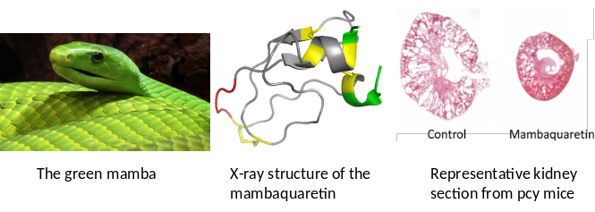
Recent Publications (minimum 5)
Ciolek, J., Reinfrank, H., Quinton, L., Viengchareun, S., Stura, E.A., Vera, L., et al. (2017). Green mamba peptide targets type-2 vasopressin receptor against polycystic kidney disease. Proc. Natl. Acad. Sci. U. S. A. 114: 7154–7159.
Maïga, A., Dupont, M., Blanchet, G., Marcon, E., Gilquin, B., Servent, D., and Gilles, N. (2014) Molecular exploration of the α(1A)-adrenoceptor orthosteric site: binding site definition for epinephrine, HEAT and prazosin. FEBS Lett. 588, 4613–9.
Gilles, N., and Servent, D. (2014) The European FP7 Venomics Project. Future Med. Chem. 6, 1611–2.
Maïga, A., Merlin, J., Marcon, E., Rouget, C., Larregola, M., Gilquin, B., Fruchart-Gaillard, C., Lajeunesse, E., Marchetti, C., Lorphelin, A., Bellanger, L., Summers, R. J., Hutchinson, D. S., Evans, B. A., Servent, D., and Gilles, N. (2013) Orthosteric binding of ρ-Da1a, a natural peptide of snake venom interacting selectively with the α1A-adrenoceptor. PLoS One 8, e68841
Gilles, N., Servent, D., Quinton, L., Mendre, C., Mouillac, B., Witzgall, R., and Reinfranck, H. (2012) PEPTIDE ANTAGONISTS OF THE VASOPRESSIN-2 RECEPTOR. EP2708235_A1

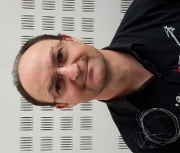Biography (150 word limit)
Dr. Gilles has completed his PhD at the age of 34 years from Paris Descartes University. He is pioneering the investigation of animal toxins acting on GPCRs, the largest therapeutic target class. His strongest expertise lies in receptor pharmacology, synthetic production of disulfide-linked animal toxins and in vivo experiments. He has published more than 70 papers and three patents. His strongest interest is now to stimulate the therapeutic development of animal toxins for the benefit of human health. Email: nicolas.gilles@cea.fr

Notes/Comments:

