Unveiling the Role of PAR 1: A Crucial Link with Inflammation in Diabetic Subjects with COVID-19


Varinder Singh*, Md Altamash Ahmad, Ravinder Singh, Thakur Gurjeet Singh, Rupinder Kaur, Rajwinder Kaur
Chitkara College of Pharmacy, Chitkara University, Punjab, India.

Abstract
Statement of the Problem: Inflammation is a notable clinical feature of both COVID-19 and type 2 diabetes mellitus (T2DM), frequently linked with inflammatory dysfunctions, insulin resistance, metabolic disturbances, and additional complications. This study aims to examine whether serum levels of PAR-1 vary between diabetic COVID-19 patients (T2DM) and non-diabetic individuals with COVID-19, and to explore their relationships with various biochemical parameters and inflammatory markers. Methodology & Theoretical Orientation: We recruited 50 T2DM patients with COVID-19, who had glycated hemoglobin (HbA1c) levels of 9.23 ± 1.66, and 50 non-diabetic COVID-19 patients, with HbA1c levels of 4.39 ± 0.57. Serum levels of PAR-1 (measured using the ELISA method) were assessed in both groups and analyzed alongside factors such as age, BMI, and inflammatory markers including CRP, interleukin 6 (IL-6), tumor necrosis factor-alpha (TNF-α), D-dimer, homocysteine, and N-terminal pro-B-type natriuretic peptide (NT-proBNP). Findings: Notable differences were observed in demographic variables such as BMI (29.21 ± 3.52 vs. 21.30 ± 2.11) and HbA1c (9.23 ± 1.66 vs. 4.39 ± 0.57), with higher values in the COVID-19 T2DM patients compared to the non-diabetic COVID-19 group. Similarly, levels of several inflammatory markers and PAR-1 were significantly higher in the diabetic group. Univariate analysis showed that increased serum PAR-1 levels were positively associated with higher HbA1c, BMI, inflammatory cytokines, D-dimer, homocysteine, and NT-proBNP levels. Conclusion & Significance: The results of this study indicate that elevated serum PAR-1 levels may act as an independent marker of inflammation in COVID-19 patients with T2DM.

Image
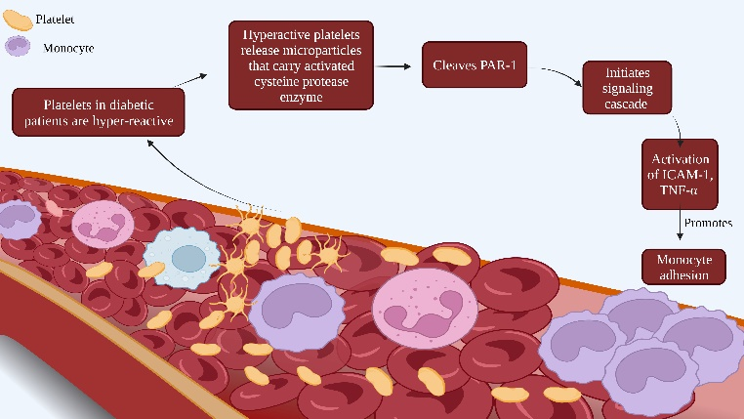

Recent Publications
- Kaur R, Choudhary D, Bali S, Bandral SS, Singh V, Ahmad MA, Rani N, Singh TG, Chandrasekaran B. Pesticides: An alarming detrimental to health and environment. Science of The Total Environment. 2024 Jan 15:170113..
- Singh R, Singh V, Ahmad MA, Pasricha C, Kumari P, Singh TG, Kaur R, Mujwar S, Wani TA, Zargar S. Unveiling the Role of PAR 1: A Crucial Link with Inflammation in Diabetic Subjects with COVID-19. Pharmaceuticals. 2024 Apr 1;17(4):454.
- Lang DK, Singh V, Ahmad MA, Saini B, Chandrasekaran B, Kaur R. Recent advances in sustainability science for environmental conservation. Role of Green Chemistry in Ecosystem Restoration to Achieve Environmental Sustainability. 2024 Jan 1:83-90..
- Singh V, Kaur R, Kumari P, Pasricha C, Singh R. ICAM-1 and VCAM-1: gatekeepers in various inflammatory and cardiovascular disorders. Clinica Chimica Acta. 2023 Jul 11:117487
- Kaur R, Singh V, Kumari P, Singh R, Chopra H, Emran TB. Novel insights on the role of VCAM-1 and ICAM-1: Potential biomarkers for cardiovascular diseases. Annals of Medicine and Surgery. 2022 Dec 1;84.

 Biography
Varinder Singh is a final year Pharm.D student at Chitkara University, who has made significant contributions to pharmaceutical and health sciences research. In addition to his academic publications, Varinder Singh has also innovated within the field of chemical sciences with patents for a "Chemical Incubator" and a "Chemical Catalyzer," demonstrating his prowess in practical applications of his research knowledge. Currently, Singh is expanding his expertise by interning in health economics, where he applies his comprehensive knowledge of pharmacy and medical sciences to broader economic contexts affecting health policies and management. Varinder Singh's work is characterized by his enthusiasm for research and his ability to apply academic findings to real-world problems. He continues to evolve as a prominent figure in his field, aiming to impact public health and environmental safety through both his studies and inventions.
.Email: Singhvarinder28nov@gmail.com

