Influence of Сurcuma longa rhizome powder on morphofunctional parameters of kidneys in rats with experimental model of diabetes mellitus
Roman Aizman, D.Sc. in Biology, Novosibirsk State Pedagogical University, Russia
Anna Kozlova, PhD in Biology, Novosibirsk State Pedagogical University, Russia
Galina Koroshchenko, PhD in Biology, Novosibirsk State Pedagogical University, Russia

Abstract

The effect of turmeric rhizome powder (Curcuma longa) on water-mineral balance, morphological structure, and kidney functions was studied in experiments on rats with an alloxan-induced model of type 1 diabetes mellitus. Three groups of animals were studied: control ones (C) and diabetic rats: on standard diet (D) and animals, which got Curcuma longa at the amount of 2% of the food mass (D+Cl). It was found that in diabetic rats the plasma sodium and potassium concentrations did not change, while urea concentration (from 18.2±1.6 to 29.5±3.2 mmol/L) and creatinine level (from 0.8±0.01 to 1.4±0.08 mmol/L) significantly increased compared to similar parameters of healthy animals (C). The other plasma parameters between diabetic animals on a standard feed (D) and the rats, consuming turmeric (D+Cl), did not differ. The study of the basal hydro- and ionouretic renal function in diabetic rats did not reveal a significant increase in urine output in the experimental groups. Glomerular filtration rate and level of tubular reabsorption did not significantly differ between groups as well as the fractional potassium (22.2±4.9 and 27.3±3.0 %) and sodium (0.4±0.11 0.6±0.09%) excretion. But in rats with DM the characteristic damage of renal tissue consisting in occurrence of protein, fibers, collagen, sulfatic glycosaminoglycans and a sclerosis of nephritic little bodies between leafs of Shumljansky-Boumen’ capsule was marked. The use of turmeric optimized the morphological processes in the kidney of animals with diabetes mellitus and reduced structural damage in the renal bodies. These results of morphohistochemical and functional analysis of kidneys suggest that the consumption of turmeric by animals with diabetes reduces the level of structural disorders in the nephrons, but does not cause significant changes in kidney functions in conditions of spontaneous urination.
Image

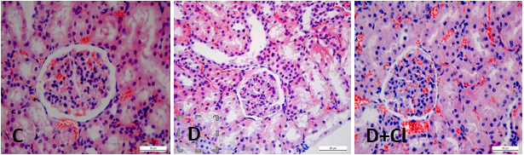

Figure 1: Structural elements of the kidney nephron of rats of the control group (C), with an alloxan model of diabetes mellitus (D) and after taking turmeric (D+Cl)

Recent Publications
- Aizman RI, Koroshchenko GA, Gaidarova AP, Lukanina SN, Subotyalov MA (2015) The mechanisms of plant rhizome Curcuma longa action on carbohydrate metabolism in alloxan - induced diabetes mellitus rats. American Journal of Biomedical Research. 3(1): 1-5.
- Rahmani AH, Alsahli MA, Aly SM, Khan MA, Aldebasi YH (2018) Role of Curcumin in Disease Prevention and Treatment. Adv Biomed Res. 7:38.
- Aizman RI, Kozlova AP, Gordeeva EI, Golovin MS, Koroshchenko GA, Nedovesova SA, Lomovskiy IO (2019) Effect of Curcuma longa and Galega orientalis on renal function in rats with experimental diabetes mellitus and acute renal failure. Pathological physiology and experimental therapy. 63(4): 88-95.
- Avila-Rojas SH, Lira-León A, Aparicio-Trejo OE, Reyes-Fermín LM, Pedraza-Chaverri J (2019) Role of Autophagy on Heavy Metal-Induced Renal Damage and the Protective Effects of Curcumin in Autophagy and Kidney Preservation. Medicina (Kaunas). 55(7): 360.
- Patel SS, Acharya A, Ray RS, Agrawal R, Raghuwanshi R, Jain P (2020) Cellular and molecular mechanisms of curcumin in prevention and treatment of disease. Crit Rev Food Sci Nutr. 60(6): 887-939.

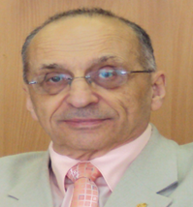
Biography

Aizman Roman I., the honoured worker of Science and Education of the Russian Federation, the corresponding member of the International Academy of sciences of the High School and Russian Academy of Natural Sciences, the academician of the International academy of sciences of ecological safety, Dr.Sci.Biol., Professor, Head of Dept. of anatomy, physiology and safety of live, Director of scientific research institute of health and safety at Novosibirsk State Pedagogical University, the honoured professor of Tuva State University. The foreign member of the American physiological society, the full member of the European society of pediatrists-nephrologists, the editorial member of seven scientific journals. In 1996 was included in the International biographic directory of famous scientists. He has over 800 publications that have been cited over 5900 times, and his publication H-index is 31.
Email: aizman.roman@yandex.ru

Notes/Comments

