Role of Acacia Senegal fibres (Gum Arabic) as Antioxidant and Anti-inflammatory among Haemodialysis Patients
Noor E. Ali, MSc Physiology, Alneelain University, Sudan Lamis A. Kaddam, Ph.D. Physiology, Alneelain University, Sudan
Suad Y. Alkarib, Ph.D. Pharmaceutics, Karary University, Sudan
Babikir G. Kaballo , Consultant nephrologist , Omdurman Military Hospital, Sudan
Sami A. Khalid , Ph.D. Pharmaceutical Chemistry, University of Science & Technology, Sudan
Abdalazim M. Abdalazim, Senior lab of renal unit , Omdurman Military Hospital, Sudan
Alla Abdalhabib , Residence Doctor Renal unit, Omdurman Military Hospital, Sudan
Alla Allaaldeen , Residence Doctor Renal unit, Omdurman Military Hospital, Sudan
Aled O. Phillips, Consultant nephrologist, Cardiff University School of Medicine, UK
Amal M Saeed, Ph.D. Physiology, University of Khartoum, Sudan

Abstract (300 word limit)
Statement of the Problem: Several studies suggested that oxidative processes might increase in patients with end stage renal disease (ESRD). Oxidative stress (OS) was considered as a risk of atherosclerosis and cardiovascular complication that are the major causes of mortality among ESRD patients’ .Haemodialysis (HD) is a state of chronic inflammatory activation which is associated with accelerated cardiovascular disease and high cardiovascular mortality. Gum Arabic (GA) has been claimed to act as an anti-oxidant and cytoprotective agent, protecting against experimental hepatic, renal and cardiac toxicities in both animal and human studies. This study was designed to test a hypothesis that Gum Arabic supplementation of the diet in a population of patients receiving renal replacement therapy by haemodialysis will reduce oxidative stress and therefore reduce the state of chronic inflammatory activation associated with chronic HD. Methodology & Theoretical Orientation: In this study 40 end stage renal failure (ESRF) patients aged 18-80 years who were on regular haemodialysis in Arif Renal Center, Omdurman, Sudan, were recruited. All recruited patients met the inclusion criteria and signed the informed consent. Patients received 30 g/day of GA for 12 weeks. Renal function test (RFT), C-reactive protein (CRP), Total anti-oxidant capacity (TAC) and the oxidative stress marker malondialdehyde (MDA) levels were measured before and after GA intake .Ethical approval from the national medicine and poisons board was obtained. Findings: Gum Arabic significantly increased TAC level (P < 0.001) and decreased the oxidative marker MDA and CRP (P < 0.001). Conclusion & Significance: GA has revealed potent anti- oxidative and anti-inflammatory properties in hemodialysis patients. Daily supplementation of GA (30 g/day) significantly reduced the oxidative stress in hemodialysis patients.

Image
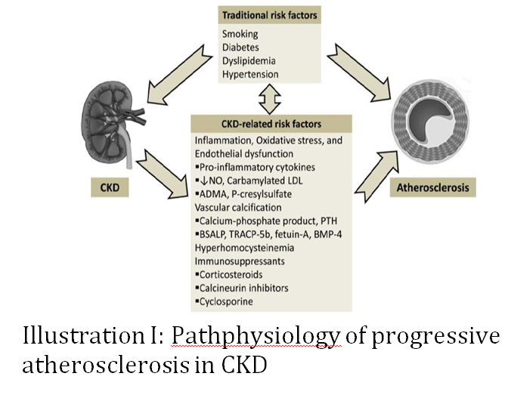
Recent Publications (minimum 5)
- Kaddam L, Fadl-elmula I, Eisawi OA, Abdelrazig HA, Salih MA, Lang F, et al.( 2017) Gum Arabic as novel anti-oxidant agent in sickle cell anemia , phase II trial. 2017;1–6.
- Ali BH, Al-husseni I, Beegam S, Al-shukaili A, Nemmar A, Schierling S, et al. (2013) Effect of Gum Arabic on Oxidative Stress and Inflammation in Adenine – Induced Chronic Renal Failure in Rats. 2013;8(2).
- Gosmanova EO, Le N.( 2011) Cardiovascular Complications in CKD Patients : Role of Oxidative Stress.
- Jackson P, Mcnamee PT, Young IS. (1995) Effect of Hemodialysis on Total Antioxidant Capacity and Serum Antioxidants in Patients with Chronic Renal Failure. 1995;41(8):1135–8.
- Ali BH, Ziada A, Blunden G. (2009) Biological effects of gum arabic : A review of some recent research. Food Chem Toxicol. 2009;47(1):1–8.

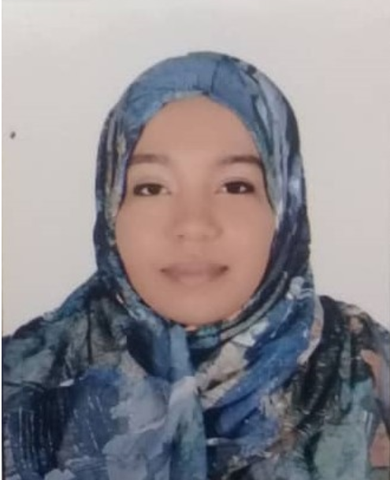Biography (150 word limit)
Nour Elkhair Ali Khallaf Allah lecturer in physiology
Date of birth: 3/3/1991
Gender: Female
Phone: 00249911288100
Address: Sudan-Khartoum –Omdurman
EDUCATION
2015 – 2018 AlNeelain University
Master of Medical Physiology
2016 – 2017 AlNeelain University /Maryland university
Diploma of research methodology
2016 Sudan Medical Council
Certificate of full Registration
2014 University of science and technology
Bachelor of medicine and Surgery
2008 Sudan Ministry of General Education
Sudan school certificate examinatin
2003 - 2004 Sudan Ministry of General Education
Primary school certificate examination
2018 - Current AlNeelain University
PhD student

INTERESTS
Gum Arabic , physiology , Internal medicine , nephrology .

Email: nooralkhair@gmail.com

Notes/Comments:

