In vitro Evaluation Antioxidant Properties of Aqueous Extracts from leave of Psidium guajava L., Syzygium polyanthum, and Annona muricata

Pamela Hendra Heng
Kris H. Timotius
Ika Rahayu
Research and Development Departemen
Faculty of Medicine, UKRIDA

Abstract

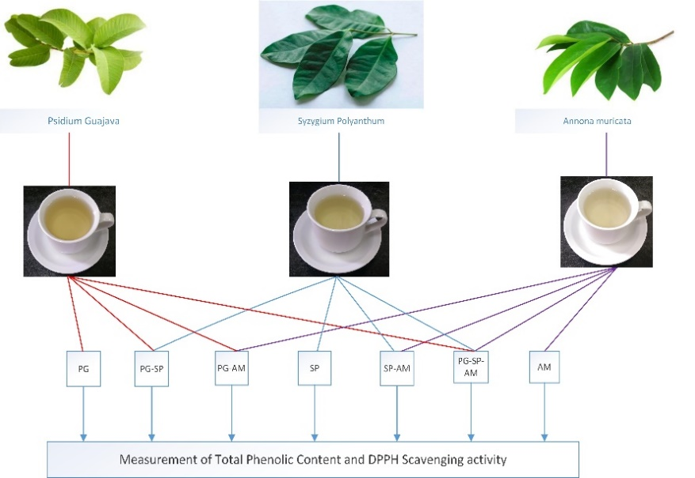
Objectives: To investigate the antioxidant activity of mixed aqueous extract from leave of Psidium guajava, Syzygium polyanthum, and Annona muricata. Methods: Air dried leave were extracted with boiled aquadest. The antioxidant activities of the extract were measured. Results: Based on the total phenolic content (GAE) of the extract, antioxidant activities of P.guajava and S.polyanthum showed a comparable result with the BHT as positive control. The extract of A. muricata showed higher IC₅₀ than BHT. The mixture of the extract showed an synergistic affect if there was no additional A.muricata extract. The antagonistic effect was found when A.muricata extract was added. Conclusion: Leave aqueous extracts have good antioxidant activities. The use of mixed extracts have additional effect. Mixture P. guajava and S. polyanthum showed synergitic effect, but all mixture with A. Muricata showed antagonist effect.

Figure. Measurement of TPC and DPPH scavenging activity

Recent Publications

1. Ablat, Abdulwali, Jamaludin Mohamad, Khalijah Awang, Jamil A.Shilpi, and Aditya Arya, 2014. Evaluation of Antidiabetic and Antioxidant Properties of Brucea javanica Seed. Hindawi Publ. Corporation. The Scientific World Journal Article ID 786130, 8 pages.
2. Blois, M.S. Antioxidant determination by the use of a stable free radical. Nature 181: 1199-1200.
3. Indrianingsih, Anastasia Wheni; Sanro Tachibana and Kazutaka Itoh, 2015. In vitro evaluation of antioxidant and α-Glucosidase inhibitory assay of several tropical and subtropical plants. Procedia Environmental Sciences 28: 639-648.
4. Shukla, S., Juyeon, P., Dong-Ho, K., Sung-Yong, H., Jong, S.L., and Myunghee K. 2016. Total phenolic cotent, antioxidant, tyrosinase and α-glucosidase inhibitory activities of water soluble extracts of noble starter culture Doenjang, a Korean fermented soybean sauce variety. Food control, 59: 854-861.
5. Guimarặes R., Barreria J.C.M., Barros L., Carvalho A.M., Ferreira I.C.F.R. 2011. Effects of oral dosage forms and storage period in the antioxidant properties of four species used in traditional herbal medicine. Phytother. Res, 25: 484-492



Ika Rahayu
Ika was graduated as Master in Molecular Medicine at Universitas Gadjah Mada, Indonesia. Her main research interest is about diabetes mellitus and especially diabetic foot ulcer. She is also doing research on antidiabetic compound extracted from herbal materials, including the combined effect for their antioxidant as well as antidiabetic activity of the extract.
Email: ika.rahayu@ukrida.ac.id

