Raw Japanese quail egg (RQE)
Produces Analgesic, Anti-
Inflammatory and Gastro-
Protective effects in rats

Ismaila M.S^{1*} , Shafiu. Y¹, Abubakar, M.S². Buhari, S³, Sherifat O.B¹, Mustapha, A¹, Biobaku, KT³ and Agaie B.M¹

¹Department of Veterinary Pharmacology and Toxicology, Usmanu Danfodiyo University, Sokoto
²Department of Veterinary Pathology, Usmanu Danfodiyo University, Sokoto
³Department of Veterinary Surgery and Radiology, Usmanu Danfodiyo University, Sokoto
⁴Department of Veterinary Pharmacology & Toxicology, University of Ilorin, Ilorin

Abstract

Over the years, Japanese quail egg has been in use in the management of diseases. The objective of this study was to evaluate the analgesic, anti-inflammatory and gastro-protective effects of raw Quail egg (yolk + albumin) in rats. Pain was assessed in rats by recording the latent period and writing reflex, anti-inflammatory effect was determined using both motility and compression test, while the gastro-protective effects were assessed by observing the histology of the stomach after diclofenac induced gastric ulcers and subsequent treatment with the quail egg, Rats were randomly assigned into 4 groups; Groups I: were the control non-treated (NT), Group II were treated with Tramadol 50 mg/kg/Os (TMD) or Indomethacin (IND) 5mg/kg/Os (positive control for the writhing reflex determination), while group III and IV were treated with 3 and 6g/kg of raw quail egg respectively). Groups treated with quail egg in both doses showed a significant increase in the latent period (p<0.05) when compared to the control NT, but lower than the group treated with tramadol at 20mins interval (p<0.05). Writing reflexes decrease in groups II, III, and IV compared to the NT group (p<0.05). While motility increases significantly (p<0.05) in groups II, compared to I (p<0.05). Control non-treated rats showed a quicker and extensive response to compression using the Vanier calliper on the inflamed paw compared to groups II-IV (p<0.05). Histological studies of the stomach revealed sloughing of the epithelia, cellular infiltration with micro abscesses in the non-treated, while groups treated concurrently with quail egg showed proliferation of the glandular epithelia and goblet cells, and those treated 30 minutes before diclofenac administration showed proliferation of glands, and thickening of the squamous epithelia. This study showed that quail egg has analgesic, anti-inflammatory and gastro-protective potentials and can be used as adjuvant treatment whenever COX-2 enzymes inhibitors are indicated

Image
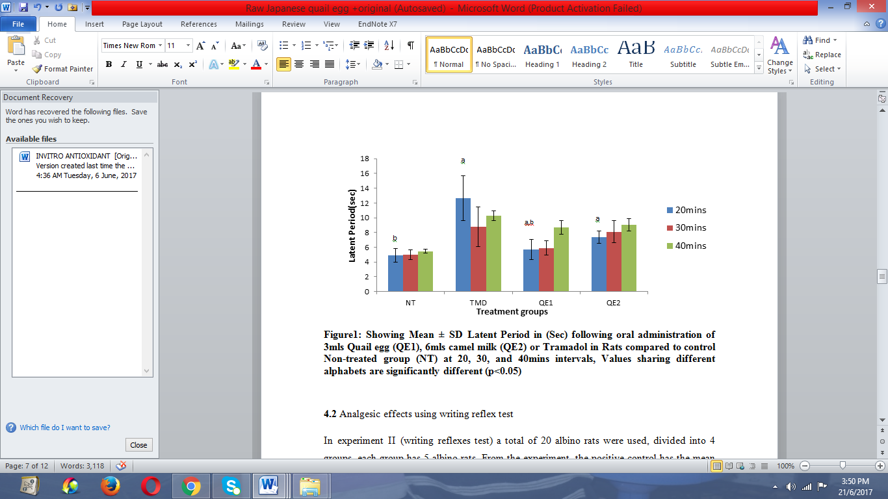
Recent Publications
Genchev, A. (2012). Comparative Investigation Of The Egg Production In Two Japanese Quail Breeds-Pharaoh And Manchurian Golden. Trakia J. Sci,10: 48-56.
Kumari, B. P., Gupta, B. R., Prakash, M. G. & Reddy, A. R. (2008). A Study On Egg Quality Traits In Japanese Quails (Coturnix Coturnix Japonica). Tnjvas, 4: 227-231.
Lanas, A., García-Rodríguez, L.-A., Arroyo, M.-T., Gomollón, F., Feu, F., González-Pérez, A., Zapata, E., Bástida, G., Rodrigo, L. & Santolaria, S. (2006). Risk Of Upper Gastrointestinal Ulcer Bleeding Associated With Selective Cyclo-Oxygenase-2 Inhibitors, Traditional Non-Aspirin Non-Steroidal Anti-Inflammatory Drugs, Aspirin And Combinations. Gut, 55: 1731-1738.
Punya Kumaril, B., Ramesh Gupta, B., Gnana Prakash, M. & Rajasekhar Reddy, A. (2008). A Study Of Egg Quality Traits In Japanese Quails. J. Veterinary & Animal Sc, 4: 227-231.
Santos, L., Feres, C., Melo, F., Coelho, M., Nothenberg, M., Oga, S. & Tagliati, C. (2004). Anti-Inflammatory, Antinociceptive And Ulcerogenic Activity Of A Zinc-Diclofenac Complex In Rats. Brazilian Journal Of Medical And Biological Research, 37: 1205-1213.

 Biography
M.S.Ismaila (PhD ) Pharmacololgy is presently lecturing with the Department of Pharmacology and Toxicology, Faculty of Veterinary Medicine, Usmanu Danfodiyo University sokoto, Nigeria. He has published a number of articles in high impact journals, Presented articles on both National and international conferences. The main area of his research is on Nutri-genomics and pharmacogenomics in relation to mechanisms involved especially gene regulations in animals treated with Nutraceuticals, medicinal food or herbs involved in metabolic diseases.
Email:sani.ismaila@udusok.edu.ng

Notes/Comments:

