Biological investigation of the benefits and risk of plants consumed by diabetics in Ngaoundere
Mbarawa Kofia Ibrahim, MSc, University of Buea, Cameroon
Ndoe Guiaro Marcellin, MSc, University of Ngaoundere, Cameroon
Tamanji Marcel Nanji, MSc, Regional Hospital of Ngaoundere, Cameroon
Nwabo Kamdje Armel, PhD, University of British Columbia, Canada
Zofou Denis, PhD, University of Buea, Cameroon
Assob Nguedia, PhD, University of Buea, Cameroon

Abstract
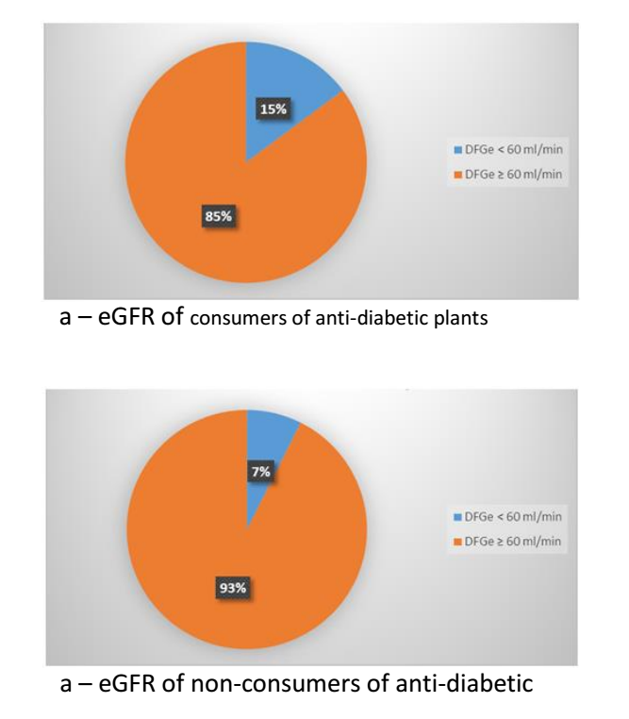

Diabetes remains dangerous disease with high prevalence of death and morbidity around the world [I]. It evolution leads to other complications such as retinopathy, neuropathy, sexual disorders and chronic kidney diseases (CKD) [III]. In Africa, population likes to use medicinal plant for better management of these diseases [x Medicinal plants have been reported as high risk of kidney failure among consumers [3, 4]. Around 80% in sub-Saharan population consume medicinal plants [5]. This present study aimed to evaluate the influence of everyday life consumption of anti-diabetic plants among diabetic patients. We performed an analytical study in diabetic population. We included 27 consumers of anti-diabetic plants and 27 non-consumers. We estimated the kidney function with the measurement of the serum creatinine, urine creatinine, serum urea and fasting blood glucose. We estimated the GFR with the creatinine clearance of 24h. We identified 4 anti-diabetic plants used by participants which are Leptadenie hastata, Detarium microcarpum, Boswellia dalzielii and Moringa oleifera. The average value of fasting blood glucose was low in patient consumers of plants (166 ± 43 mg/dl) than in non-consumers (229±53 mg/dl). We noted that consumers of Moringa oleifera (148.14±42 mg/dl) and Leptadenia hastata (148.25±46 mg/dl) presented best values of fasting blood glucose. We noted high prevalence of stage 3 and 4 of CKD in consumers of plant extracts (15%) than non-consumers (7%). Patient consumers of Detarium microcarpum and Boswellia dalzielii presented average value of eGFR in stage 2 of CKD. Though, consumers of Moringa oleifera and Leptadenia hastata presented healthy status of kidney function (116 ml/min/1.73m² and 115 ml/min/1.73m²) followed by non-consumers group (102 ml/min/1.73m²). These results showed that Moringa oleifera and Leptadenia hastate are better anti-diabetic plants for management of diabetes and they could have nephron-protection effect among diabetics.



Figure 4 a&b-. Graphical representation showing the eGFR distribution according to the utilization of plant.
References
- WHO (2013) World health report in 2013: research for universal health coverage.. Luxembourg
- Gilles C (2013) Diabetes in omnipratic. 3rd Edition.. Edition Bas-Saint-Laurent Health and Social Services Agency, Rimouski (Quebec), Canada
- Saydah SH, Eberhardt MS (2006) Use of complementary and alternative medicine among adults with chronic diseases: United States. 2002. J Altern Complement Med.; 12(8):805–812
- Hasan SS, Ahmed SI, Bukhari NI, Loon WCW (2009) Use of complementary and alternative medicine among patients with chronic diseases at outpatient clinics. Complement Ther Clin Pract. 15(3):152–157.
- WHO (2002) Traditional Medicine Strategy 2002-2005. WHO. Geneva. Amsterdam.

Bibliography

Mbarawa Marat Kofia is a PhD candidate in chemical pathology in Cameroon. He works on the influence of medicinal plant in diabetics and hypertensive patients in Cameroon. He also works in the importance of biomarkers for diagnostic and management of HIV, diabetes, metabolic syndrome and kidney failure in Cameroonian context. He prepares a thesis in the development of new supplement from medicinal plants for better management of kidney failure, diabetes, hypertension and HIV/AIDS patients.
Email: mbarawamarat@gmail.com

