BIOLOGICAL INVESTIGATION OF THE BENEFITS AND RISK OF PLANTS CONSUMED BY DIABETICS IN NGAOUNDERE
Mbarawa Kofia Ibrahim^{1, 2, *}, Nga Esther³, Ndoe Guiaro Marcellin^{2, 3}, Gilles Mache³, Tamanji Marcel Nanji⁴, Sitty Eguessa², Nwabo Kamdje Armel^{2, 5}, Zofou Denis⁶, Assob Nguedia¹
¹Department of Medical Laboratory Sciences, Faculty of Health Sciences, University of Buea, Buea, Cameroon
²Department of Biomedical Sciences, Faculty of Sciences, University of Ngaoundere, Ngaoundere, Cameroon
³National School of Agro-Industrial Sciences (ENSAI), Ngaoundere, Cameroon
⁴Regional Hospital of Ngaoundere, Ngaoundere, Cameroon
⁵Biomedical Research Center, University of British Columbia, Vancouver, British Columbia, Canada
⁶Biotechnology Unit, Faculty of Science, University of Buea, Buea, Cameroon
*Corresponding author: mbarawamarat@gmail.com . 00237679173277 (M. K. Ibrahim)

Introduction: Medicinal plants have been reported as high risk of kidney failure among consumers [1, 2]. Around 80% in sub-Saharan population consume medicinal plants [2]. This present study aimed to evaluate the influence of everyday life consumption of anti-diabetic plants among diabetic patients.

Material and Methods:We performed an analytical study in diabetic population. We included 27 consumers of anti-diabetic plants and 27 non-consumers. We estimated the kidney function with the measurement of the serum creatinine, urine creatinine, serum urea and fasting blood glucose. We estimated the GFR with the creatinine clearance of 24h.

Results and discussion:We identified 4 anti-diabetic plants used by participants which are Leptadenie hastata, Detarium microcarpum, Boswellia dalzielii and Moringa oleifera. The average value of fasting blood glucose was low in patient consumers of plants (166 ± 43 mg/dl) than in non-consumers (229±53 mg/dl). We noted that consumers of Moringa oleifera (148.14±42 mg/dl) and Leptadenia hastata (148.25±46 mg/dl) presented best values of fasting blood glucose. We noted high prevalence of stage 3 and 4 of CKD in consumers of plant extracts (15%) than non-consumers (7%). Patient consumers of Detarium microcarpum and Boswellia dalzielii presented average value of eGFR in stage 2 of CKD. Though, consumers of Moringa oleifera and Leptadenia hastata presented healthy status of kidney function (116 ml/min/1.73m² and 115 ml/min/1.73m²) followed by non-consumers group (102 ml/min/1.73m²).
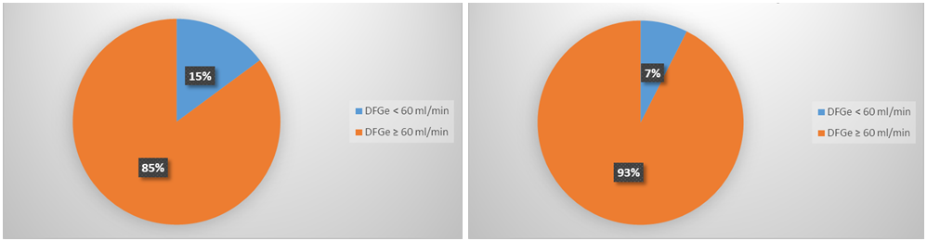
Figure 4. Graphical representation showing the eGFR distribution according to the utilization of plant.

Conclusion: These results showed that Moringa oleifera and Leptadenia hastate are better anti-diabetic plants for management of diabetes and they could have nephron-protection effect among diabetics.
Reference
- Saydah SH, Eberhardt MS: Use of complementary and alternative medicine among adults with chronic diseases: United States. 2002. J Altern Complement Med. 2006; 12(8):805–812
- Hasan SS, Ahmed SI, Bukhari NI, Loon WCW. Use of complementary and alternative medicine among patients with chronic diseases at outpatient clinics. Complement Ther Clin Pract. 2009; 15(3):152–157.
- WHO. Traditional Medicine Strategy 2002-2005. WHO. 2002. Geneva. Amsterdam.

