Improving the performance of carbon-based perovskite solar modules (70 cm²) by incorporating cesium halide in mesoporous TiO₂
Kavya S. Keremane, PhD, NITK, SURATHKAL, INDIA Subodh Mhaisalkar, PROFESSOR, NTU, SINGAPORE
A. V. Adhikari, PROFESSOR, NITK, SURATHKAL, INDIA

Abstract (300 word limit)

Organic-inorganic lead halide perovskite solar cells (PSCs) belonging to thin-film solar cells, have gained much attraction due to their low cost, high molar extinction coefficients and excellent charge carrier mobility. Currently a highest efficiency of 25.7% is reported for solar cells employing these hybrid perovskite light harvester materials. The major problem in many of the reported high efficiency PSCs arises from the use of organic hole transport layers such as Spiro–OMeTAD or PEDOT: PSS, which are unstable in the ambient air. To overcome these challenges, PSCs fabrication is reported with the carbon-based whole mesostructured architecture, where carbon layer acts as moisture barrier and prevents the hydration of the infiltrated perovskite thus substantially reduces the degradation kinetics.

In this research work, we present the fabrication of highly efficient large-area carbon-based perovskite solar cells (C-PSCs) using CsX (X = Cl, Br and I) modified mesoporous (mp)-TiO₂ beads of 40 nm size as an electron transport material. Here, triple-layered scaffolds made of cesium halide modified TiO₂ exhibit the efficient charge extraction as confirmed by the enhanced photoluminescence quenching and inhibit the UV-activated degradation processes of perovskite leading to an enhanced operational stability. Out of the three cesium halide modifications, devices containing CsBr modified TiO₂ showed the highest short-circuit current density yielding a photo-conversion efficiency (PCE) of 12.59 % over the device with 0.7 cm² active area and 11.55 % for a large-area module (70 cm²). These devices are stable in an ambient atmosphere (25 °C, 65-70% RH) over 2700 h as well as at high-temperature (85 °C) over 750 h with virtually no hysteresis.
Image
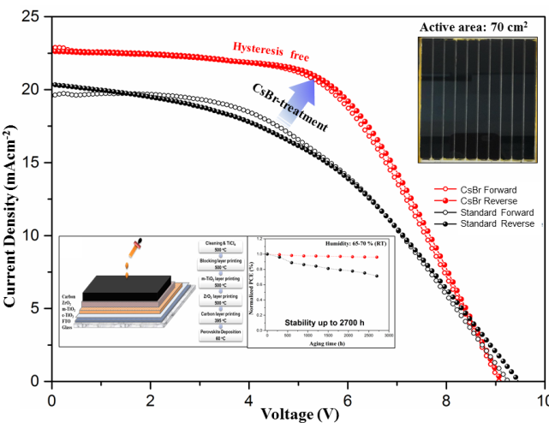
Recent Publications (minimum 5)
- Kojima, A.; Teshima, K.; Shirai, Y.; Miyasaka, T. (2009) Organometal Halide Perovskites as Visible-Light Sensitizers for Photovoltaic cells. J. Am. Chem. Soc. 131, 6050–6051.
- Lee, M. M.; Teuscher, J.; Miyasaka, T.; Murakami, T. N.; Snaith, H. J. (2012) Efficient Hybrid Solar Cells Based on Meso- super structured Organometal Halide Perovskites. Science 338, 643-647
- Priyadarshi, A.; Haur, L. J.; Murray, P.; Fu, D.; Kulkarni, S.; Xing, G.; Sum, T. C.; Mathews, N.; Mhaisalkar, S. G. (2016) A Large Area (70cm2) Monolithic Perovskite Solar Module with a High Efficiency and Stability. Energy Environ. Sci. 9, 3687–3692.
- Chen, H.; Yang, S. (2017) Stabilizing and Scaling up Carbon-Based Perovskite Solar Cells. J. Mater. Res. 2017, DOI:10.1557/jmr.2017.294.
- Park, N.; Grätzel, M.; Miyasaka, T.; Zhu, K.; Emery, K. (2018) Towards Commercially Avilable Perovskite Solar Cells. Nat. Energy, 1, 16152.

 Biography (150 word limit)
Dr. Kavya Keremane received her Ph.D. (2022) in materials science from National Institute of Technology Karnataka, Surathkal, India in collaboration with Nanyang Technological University (NTU), Singapore, Université de Nantes, France, and NC State University, USA. Her primary research interests includes optoelectronic materials and their applications in photovoltaic devices, such as dye-sensitized solar cells and perovskite solar cells. Her Ph.D. research is mainly focused on fabricating highly efficient and stable large-area inorganic lead halide carbon-based perovskite solar cells and their commercialization.
Email: kavyakeremane@gmail.com

Notes/Comments:

