Ultra-Fast Heat Dissipating Aerogels Derived from Polyaniline Anchored Cellulose Nanofibers as Sustainable Microwave Absorbers
Avinash R. Paiª, Binumol T^{b}, Deepu A. Gopakumar^{c}, Daniel Pasquini^{d}, Bastien Seantier^{e}, Nandakumar Kalarikkalª, Sabu Thomas^{a,b*}
ª International and Inter University Centre for Nanoscience and Nanotechnology,
Mahatma Gandhi University, Kottayam, Kerala-686560, India.
^{b} School of Chemical Sciences, Mahatma Gandhi University, Kottayam, Kerala 686560, India.
^{c} Université de Toulouse, IMT Mines Albi, RAPSODEE CNRS UMR-5302, Campus Jarlard, F-
81013 Albi Cedex 09, France.
^{d} Chemistry Institute, Federal University of Uberlandia-UFU, Campus Santa Monica-Bloco1D-CP 593, Brazil.
^{e} Univ. Bretagne Sud, UMR CNRS 6027, IRDL, F-56100 Lorient, France.
*Corresponding author: sabupolymer@yahoo.com, sabuthomas@mgu.ac.in

Graphical Abstract
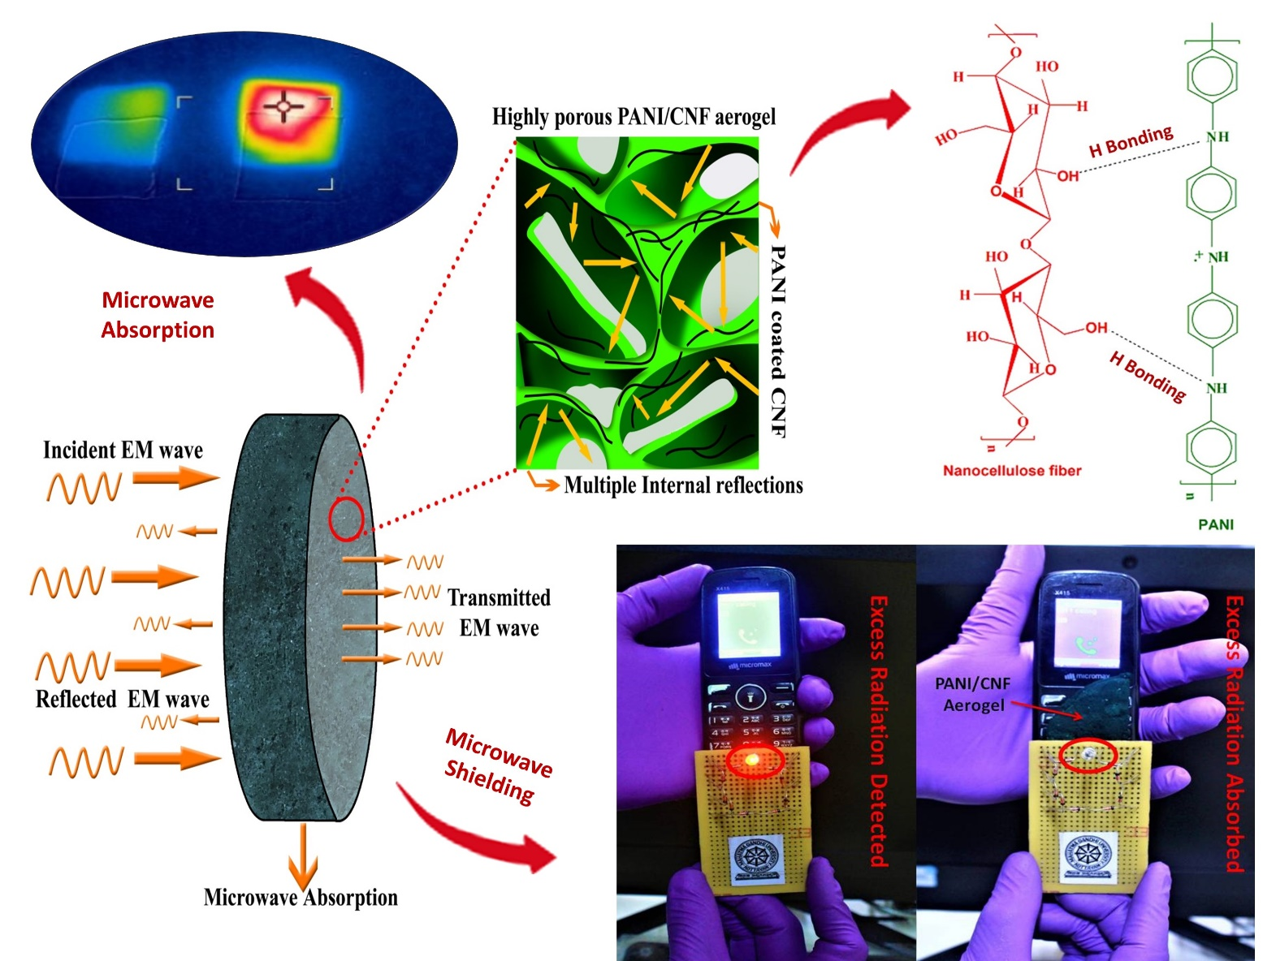
Highlights:
- A 3D porous EMI shielding aerogel of cellulose nanofiber anchored poly(aniline) was fabricated.
- Shields exhibited maximum EMI shielding of -32 dB with a high specific EMI SE ~1667 dB.cm³.g⁻¹.
- The porous shields predominantly absorbed (95%) excess EM radiations with minimal reflection (5%).
- These aerogels readily absorbed undesired EM radiations emitted out from a mobile phone.
- The aerogel possess ultra-fast heat dissipation behavior upon high power microwave exposure.
Abstract.
Electromagnetic (EM) pollution is ubiquitous and has soared to a great extent in the past few decades. The use of plant sourced cellulose nanofibers to fabricate sustainable and high performance electromagnetic shielding materials is foreseen as a green solution by the electronics industry to address this unseen pollutant. In this view, we report a facile and environmentally benign strategy to synthesize ultra-light and highly conductive aerogels derived from cellulose nanofibers (CNF) decorated with polyaniline (PANI) via a simple in-situ polymerization and subsequent freeze drying process devoid of any volatile organic solvents. The obtained conductive aerogels exhibited density as low as 0.01925 g/cc with a maximum EMI shielding value -32 dB in X band region. These porous shields demonstrated strong microwave absorption behavior (95%) with minimal reflection (5%) coupled with high specific EMI SE value ~1667 dB.cm³.g⁻¹ which make these aerogels a potential candidate for use in telecommunication, military and defense applications.
Keywords: Cellulose Nanofibers, Sustainable Aerogels, Polyaniline, Electromagnetic Interference Shielding, Microwave Absorption, Heat Dissipation.

