Scalable Drop-to-Film Condensation on a Nanostructured Hierarchical Surface for Enhanced Humidity Harvesting
Ankit Nagar, Indian Institute of Technology Madras, India

Abstract (300 word limit)

Active cooling-based atmospheric water generators, despite their growing demand, continue to be energy intensive and offer poor collection efficiencies (energy consumption per liter of water production). Despite progress in micro-/ nanofabrication techniques and functional coatings, advanced surfaces have not been successfully scaled onto such harvesters to accelerate condensation and improve their efficiencies. Here, we present a scalable dual-nanostructured hierarchical surface that comprises sporadically distributed bundles of randomly oriented faceted microcones having facets composed of nanostructures, which are either bumps or ridges. Condensate removal on this surface occurs via drop-to-film coalescence, followed by film shedding in the form of macrodrops. Compared to a conventional plain metal surface used for condensation, the improvement in latent heat transfer coefficient using a hierarchically textured surface ranged from 19.9% at a subcooling of ∼8 °C to 1048.4% at a subcooling of ∼1 °C in laboratory scale experiments, subcooling being defined with respect to the dew point. To demonstrate utility at industrial scale and to ensure scalability of the modified surfaces, we create a prototype assembly comprising a tube-fin heat exchanger with hierarchically textured fins, cooled using a standard refrigeration cycle, producing ∼25 L of water per day. The prototype containing hierarchically textured fins provides ∼10.8% enhanced water collection at ∼10.4% improved average collection efficiency compared to the traditional water generator when tested in outdoor conditions.
Image
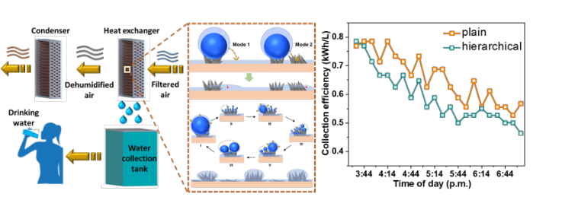
Recent Publications (minimum 5)

1. Islam, M.R., Khurana, P., Srikrishnarka, P., Nagar, A., Jash, M., Jenifer, S.K., Ganayee, M.A., Kumar, M. and Pradeep, T., 2021. Aminoclay‐Graphene Oxide Composite for Thin‐Film Composite Reverse Osmosis Membranes with Unprecedented Water Flux and Fouling Resistance. Advanced Materials Interfaces, 8(20), p.2100533.
2. Nagar, A. et al., 2021. Scalable Drop-to-Film Condensation on a Nanostructured Hierarchical Surface for Enhanced Humidity Harvesting. ACS Applied Nano Materials, 4(2), pp.1540-1550.
3. Nagar, A. and Pradeep, T., 2020. Clean water through nanotechnology: Needs, gaps, and fulfillment. ACS nano, 14(6), pp.6420-6435.
4. Sarkar, D., Mahapatra, A., Som, A., Kumar, R., Nagar, A., Baidya, A. and Pradeep, T., 2018. Patterned Nanobrush Nature Mimics with Unprecedented Water‐Harvesting Efficiency. Advanced Materials Interfaces, 5(19), p.1800667.

Biography (150 word limit)
Ankit Nagar is a research scholar and an entrepreneur from India. He works in the area of clean water. His interest lies in fundamental research as well as technology translation for social good. His research has led to the incubation of two successful startups over the span of past six years.
Email: ankitnr19@gmail.com

Notes/Comments: This work is an exemplary of how lab-scale research can be translated into technologies for social good.

