nanoHUB.org – always “on” - New Paradigms
in Global Scientific Knowledge Transfer, Publishing, and Assessment
Gerhard Klimeck, Alejandro Strachan, Lynn Zentner, Michael Zentner*
Purdue University, West Lafayette, IN 47906
*San Diego Supercomputer Center, CA

Abstract (300 word limit)
By serving a community of over 2 million users in the past 12 months with an ever-growing collection of over 6,500 resources, including over 700 simulation tools, nanoHUB.org has established itself as “the world’s largest nanotechnology user facility” [1]. All nanoHUB tools and compact models are now listed in the Web of Science and Google Scholar as proper publications. nanoHUB.org is driving significant knowledge transfer among researchers and speeding transfer from research to education, quantified with usage statistics, usage patterns, collaboration patterns, and citation data from the scientific literature. Over 89,000 students used nanoHUB simulation tools in over 3,800 classes at 185 institutions. The adoption of research tools into classrooms is typically less than 6 months after publication on nanoHUB [2]. Over 2,500 nanoHUB citations in the literature resulting in over 54,000 secondary citations with h-index of 105 prove that high quality research by users outside of the pool of original tool developers can be enabled by nanoHUB processes. In addition to high-quality content, critical attributes of nanoHUB success are its open access, ease of use, utterly dependable operation, low-cost and rapid content adaptation and deployment, and open usage and assessment data. The open-source HUBzero software platform, built for nanoHUB and now powering many other hubs, is architected to deliver a user experience corresponding to these criteria.

Image
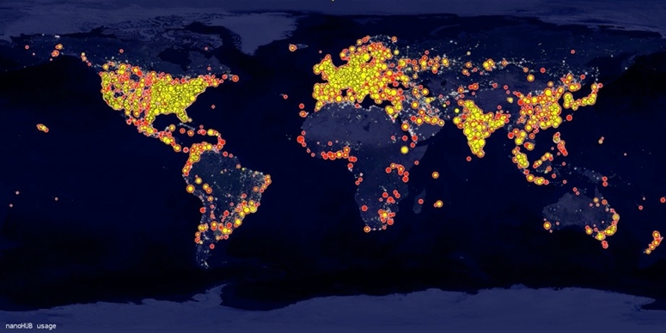
Publications
- Quote by Mikhail Roco, Senior Advisor for Nanotechnology, National Science Foundation.
- Krishna Madhavan, Michael Zentner, Gerhard Klimeck, "Learning and research in the cloud", Nature Nanotechnology 8, 786–789 (2013).

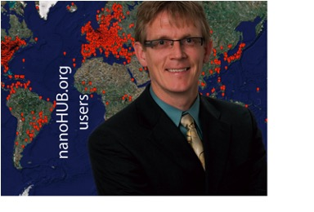Biography (150 word limit)
Gerhard Klimeck is the Reilly Director of the Center for Predictive Materials and Devices (c-PRIMED) and the Network for Computational Nanotechnology (NCN) and a Professor of Electrical and Computer Engineering at Purdue University. He guides the technical developments and strategies of nanoHUB.org. He was previously with NASA/JPL and Texas Instruments leading the Nanoelectronic Modeling Tool development (NEMO). His work is documented in over 500 peer-reviewed journal and proceedings articles resulting in over 20,000 citations and a citation h-index of 68 on Google Scholar. He is a fellow of the IEEE, APS, IOP, AAAS, and Alexander von Humboldt.
Email: gekco@purdue.edu

Notes/Comments:

