New approach for reducing particle trapping voltage in insulator-based dielectrophoretic systems
Granados-Unger F., B.Sc. Biotechnology Engineering, ITESM, Mexico
Cervantes-González A.P., B.Sc. Biomedical Engineering, ITESM, Mexico
Hernández-Medina D.H., B.Sc. Biomedical Engineering, ITESM, Mexico

Abstract (300 word limit)

Insulator based dielectrophoresis (iDEP) allows for great trapping properties, yet big voltages are required to achieve this, involving an increase in cost and difficult translation into other applications, therefore in this study the aim is to achieve a lower voltage requirement to obtain the same electric field and electric potential magnitude values of the one previously reported by Pérez-González et al. (2018). This was achieved, first, by replication of the reported model and then by design and testing of 20 different insulating posts geometries, later on narrowing to the top 5 performers and the overall best, which was then compared with the original geometry response. Results showed that an input voltage of 390 V in modified rectangular-shaped posts proved to obtain the same results as those previously reported, where a staggering 1000 V were needed, using oval-shaped insulating posts. Therefore, a 61% reduction in the input voltage requirement was achieved with the top performing model developed in this study.
Image
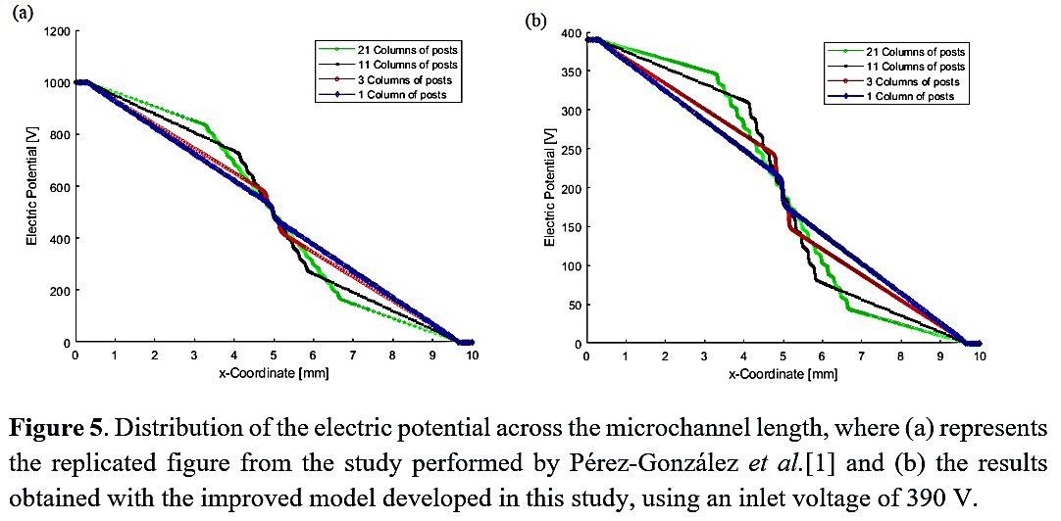

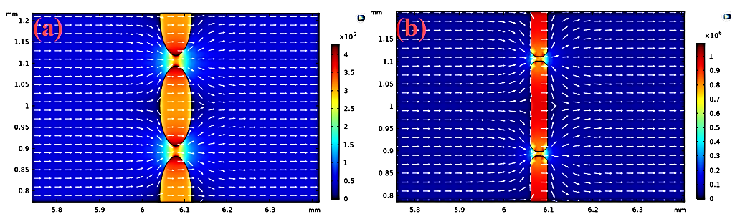

Recent Publications
- Ying, G., Manríquez, J., Wu, D., Zhang, J., Jiang, N., Maharjan, S., Hernández-Medina, D.H., & Zhang, Y. S. (2020). An open-source handheld extruder loaded with pore-forming bioink for in situ wound dressing. Materials Today Bio, 8, 100074. Heilig M, Egli M (2006) Pharmacological treatment of alcohol dependence: Target symptoms and target mechanisms. Pharmacology and therapeutics 111:855-876.

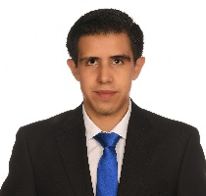 Biography (150 word limit)
Federico is a Biotechnology Engineer from Mexico. He’s an active member of the European Low Gravity Research Association (ELGRA), the Space Generation Advisory Council (SGAC), as well as of the "Space Medicine and Life Sciences Project Group" (which forms part of SGAC). He has participated in hackathons such as the "NASA Space Apps COVID-19 Challenge", the “ActInSpace Hackathon”, the "MIT COVID-19 Buildathon", and the "MIT COVID-19 Challenge" (where his team was named as one of the 3 winners of the Track B). He has participated in various research projects within national and international institutions, which are related to diverse fields of study, including: Parkinson’s disease, both brain and colorectal cancers, biodiesel production, the growth of vegetable species for human consumption in harsh environments and electrokinetic-driven microfluidics.

Email: federico.gu@exatec.tec.mx

