Connecting Chemistry and Nanotechnology: Ab-Initio Molecular Dynamics Simulations
Prof. Dr. Irmgard Frank, Leibniz University Hannover, Germany

Abstract

The Schrodinger equation is extremely successful in describing nanosystems of any kind in a bottom-up approach. That is, we compose matter of any kind atom by atom and the Schrodinger equation allows us to compute optimized structures and other properties. These calculations are easy to perform using established computer codes for isolated molecules, liquids, solids, solutions, clusters, surfaces, etc. All this refers to the time-independent Schrodinger equation as applied to the electronic structure. This electronic structure looks like a cloud surrounding the nuclei and causes binding interactions which lead to bond formation. Nuclear motion is normally not considered in these standardized calculations. This does not mean that nuclear motion is not important. Chemistry is nothing else but nuclear motion and rearrangements on the lower nanoscale. Maybe the first way out of this restriction to time-independent phenomena was proposed by Car and Parrinello, who dared to describe nuclear motion very simply using Newton dynamics. In the present talk I will show some examples of such reactive molecular dynamics simulations. It can be demonstrated nowadays on the basis of computationally demanding calculations, that this conceptually simple approach by Car and Parrinello is superior to a quantum mechanical description of nuclear motion. This leads to a very simple philosophical picture: Schrodingers cat dies deterministically, there is no quantum entanglement in nuclear motion. Quantum phenomena of any kind are exclusively due to the quantum nature of the electronic cloud.

Image

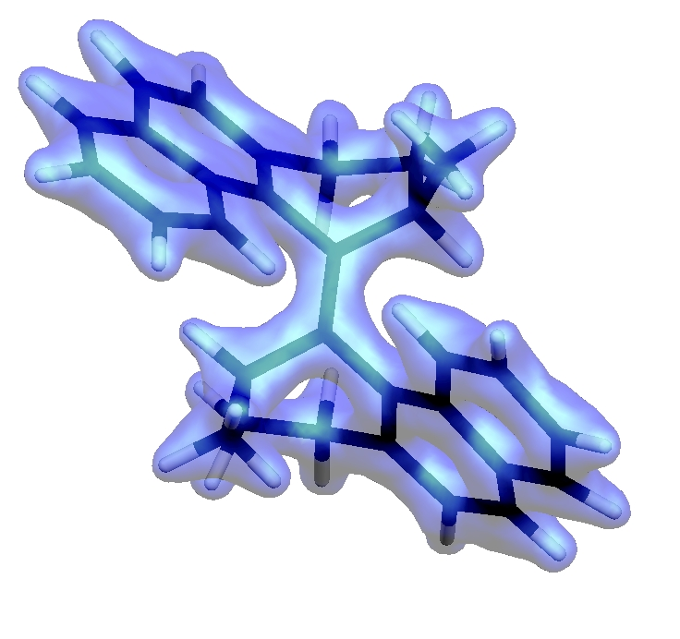

Recent Publications
- Grimm S, Brauchle C, Frank I (2005): Light-driven unidirectional rotation in a molecule: ROKS simulation, ChemPhysChem, 6:1943.
- Schulte M, Frank I (2010): Restricted open-shell Kohn-Sham theory: N unpaired electrons, Chem. Phys., 373: 283.
- Frank I, Genuit S, Matz F, Oschinski H (2020): Ammonia, water, and hydrogen: Can nuclear motion be described classically?, Int. J. Quantum Chem., 120:e26142.
- Frank I (2020): Classical motion of the nuclei in a molecule: A concept without alternatives, Chem. Select, 5:1872.
- Buchel RC, Rudolph DA, Frank I (2021): Deterministic quantum mechcanics: The role of the Maxwell-Boltzmann distribution, Int. J. Quantum Chem., accepted.


Biography
Irmgard Frank studied chemistry at the LMU Munich (1988 – 1993). Already in her diploma work in the group of Christoph Bräuchle she investigated excited states in complex molecular systems theoretically. She went to the University of Bonn where she completed her PhD thesis in the group of Sigrid Peyerimhoff in 1995. It became apparent that, to fulfill the expectations of the experimentalists, a method was needed, that could describe not only the excitation to the excited state, but also the molecular dynamics in an excited state. She became a postdoc in the group of Michele Parrinello at the Max-Planck institute for solid state science in Stuttgart where she developed the restricted-open shell Kohn-Sham method (ROKS) with which it became possible to simulate excited state reactions at a high theoretical level. She went back to Munich and completed her Habilitation in 2004. Her work focused on the simulation of chemical reactions and took mainly two directions: photochemistry and mechanochemistry. In 2008 she was appointed associate professor at the University of Hannover. More recently she developed the idea of Deterministic Quantum Mechanics (DQM). DQM is a simple way out of quantum mechanical paradoxa.
Email: irmgard.frank@theochem.uni-hannover.de

Notes/Comments:

