Thermochemical and electrochemical study of anatase TiO₂ nanotube arrays electrode
in ionic liquid based electrolyte for lithium-ion batteries

Dajana Lazarević, Milan Vraneš, Snežana Papović
Department for Chemistry, Biochemistry and Environmental Protection, Faculty of Sciences, University of Novi Sad, Serbia

Keywords: Ionic liquids, Lithium-ion batteries, Nanotube arrays

- Abstract
Lithium-ion battery (LIB) systems are not sufficiently safe mainly owing to undesired reactions between the battery components and flammable electrolytes, leading to an exothermic reaction of the electrolyte with the electrode materials. The ionic liquids (ILs) considered as electrolytes for next generation of lithium-ion batteries, because of their low flammability, thermal stability, good conductivity and wide electrochemical stability window. In order to decrease viscosity and further increase conductivity ILs are usually combined with some organic solvent (cosolvent) for LIBs applications^{1,2}. The electrochemical performances of 2 electrolytes are compared. One is based on 1,3-diethylimidazolium bis(trifluoromethylsulfonyl)imide ([C2C2im][TFSI]), while the second is based on the same IL, with added molecular solvent γ-butyrolactone (GBL) by using robust anatase TiO₂ nanotube arrays (NTAs) electrode. The galvanostatic (GS) testing was performed at different current rates and also at different temperatures, 25-55ºC, at current rate 3C. Capacity of TiO₂ NTAs is due to both bulk and surface storage of Li⁺-ion, and significantly increases with temperature increase. GS experiments demonstrated excellent capacity retention with improved Coulombic efficiency during final cycling at current rate ~3 C, but with the decrease in capacity of TiO₂ NTAs comparing to values before temperature raise or change of current rate³. The decomposition of electrolyte was observed by detecting the change of colour of electrolyte in bottle type cell during experiments at elevated temperatures.

Image: Anodic

electrochemical material

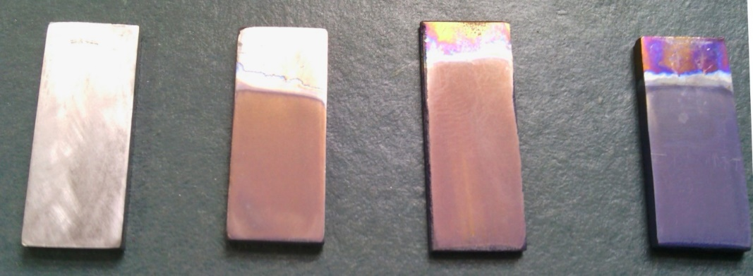
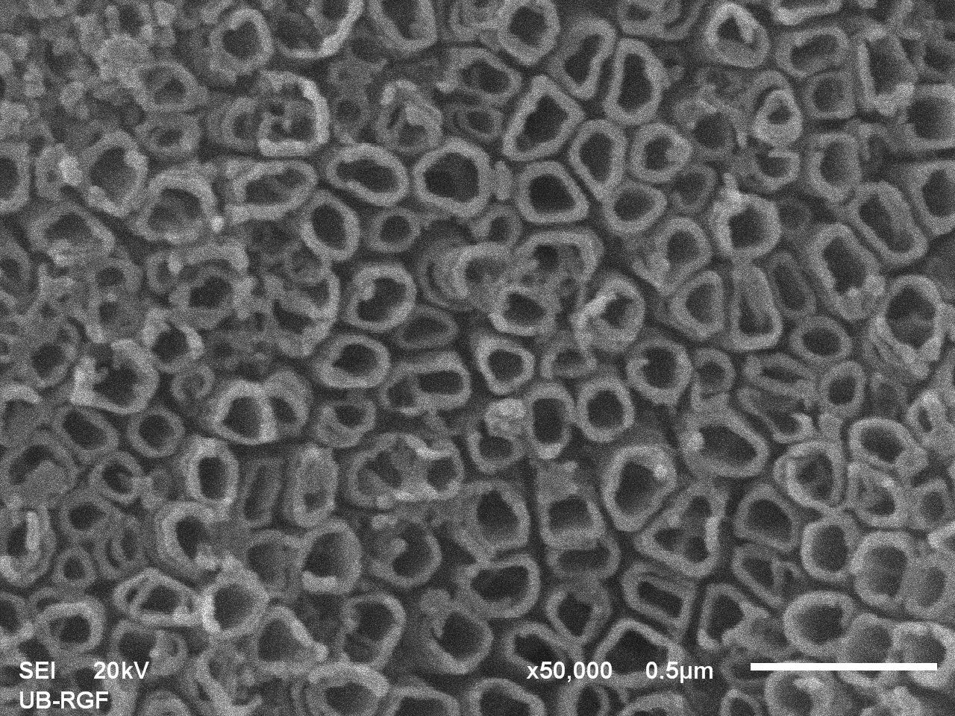
TiO₂ nanotubes

- Reference:
TiO₂ nanotubes

1 Vraneš et al., 2017. Electrical, electrochemical and thermal properties of the ionic liquid + lactone binary mixtures as the potential electrolytes for lithium-ion batteries. J. Mol. Liquids, 243; 52−60.

- Papović et al., 2017. Physicochemical and electrochemical characterisation of imidazolium based IL + GBL mixtures as electrolytes for lithium-ion batteries. PCCP, 19; 28139–28152.

- Vraneš et al., 2019. Electrochemical study of anatase TiO2 nanotube array electrode in electrolyte based on 1,3-diethylimidazolium bis(trifluoromethylsulfonyl)imide ionic liquid. Ionics 25; 5501–5511.

Biography:
Dajana Lazarević has completed her Bachelor of Science in Chemistry and Master of Science in Chemistry at the age of 23 years, from Faculty of Sciences, University of Novi Sad. She is a member of “Serbian physicochemical society”, “Society of Environmental Toxicology and Chemistry” and “International Society of Electrochemistry”. She works on science promotion at The European Researches Night'. She is a secretary of Leo club "Mileva Marić Ajnštajn" from 2017.

Presenting author details



Full Name:
Dajana Lazarević
Contact number: +38164/455-29-21
Session name/ number:
Category: Poster presentation

