Abstract

Epoxy/multi wall carbon nanotube network composite prepared via Joule heating

SLOBODIAN P¹, RIHA P2, OLEJNIK R1, MATYAS J1,
1Centre of Polymer Systems, University Institute, Tomas Bata University, Tr. T. Bati 5678, 760 01 Zlin, Czech
2The Czech Academy of Sciences, Institute of Hydrodynamics, Pod Patankou 5, 166 12 Prague 6, Czech Republic

Keywords: Carbon nanotubes, polymer composites, Joule heating, fast curing

- Abstract
An epoxy multi-walled carbon nanotube composites were prepared and cured by resistive heating (Joule heating). As epoxy matrix of two component elastic resin was used and as a filler and an electrically conductive heating, the carbon nanotube network (buckypaper) was embedded. When DC current is applied to CNT network, it leads to increase of the temperature accelerating curing process from 48 hours for a pure resin at RT to several minutes when Joule heating is imposed. Among technological advantages of the prepared composites belong the multi-function properties. The composite can be thermoformed after DC heating, fixing the shape by cooling. When the structure is again heated above matrix glass transition, the temperature shape memory behavior is observed. Also from mechanical point of view brittle buckypaper (strain and stress at break 0,75 %, 1 MPa) to values (2.9 %, 24 MPa) for composite containing 60 wt. % of epoxy, which corresponds to buckypaper porosity. Another application is to use the composite for adhesive bonding of metal parts. Achieved bonding strength 19.5 N/mm² compared with 17.3 N/mm² for pure epoxy. Finally strip of buckypaper can be successfully polymerize on surface of any solid body then acting as deformation sensor.

Image:
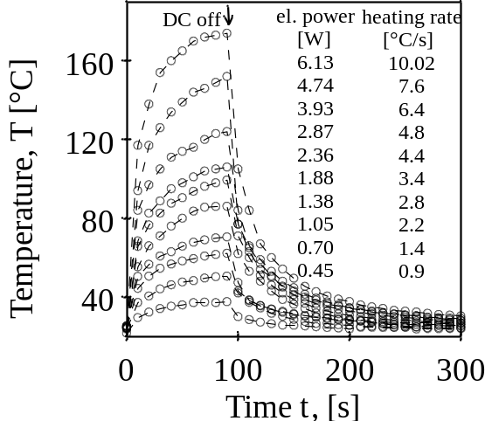
Fig. 1 Dependence of bucky paper temperature by applied DC voltage. DC Joule heating for different applied. Electrical powers and heating rates are indicated the figure.
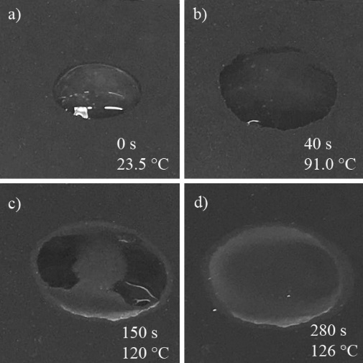
Fig. 2 A droplet of resin on surface of bucky paper and gradual curing by applied DC voltage, time and increment in temperature indicated.

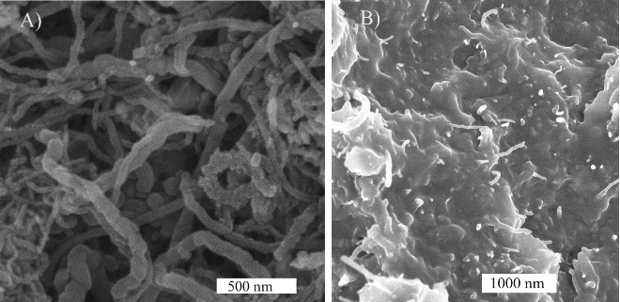
Fig. 3 SEM analysis upper surface of entangled structure made from MWCNT (buckypaper) and fracture surface of epoxy/buckypaper composite.

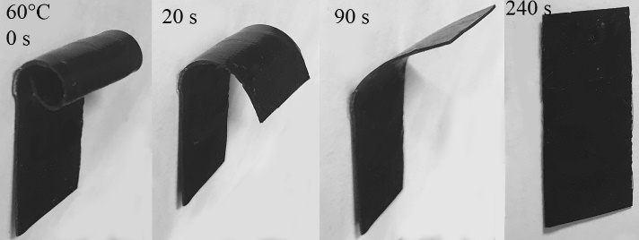
Fig. 3 Shape memory recovery of thermoformed epoxy/buckypaper composite triggered by temperature 60°C.

- Reference:

1 Kim H., Yarin A.L., Lee M.W. Ultra-fast bull's eye-like self-healing using CNT heater. Polymer 180, 2019, Article Number: UNSP 121710.

- Jang S.H., Kim D., Park Y.L. Accelerated Curing and Enhanced Material Properties of Conductive Polymer Nanocomposites by Joule Heating. Materials 9(11), 2018, Article Number: 1775.
- Mas B., Fernandez-Blazquez J.P., Duval J., Bunyan H., Vilatela J.J. Thermoset curing through Joule heating of nanocarbons for composite manufacture, repair and soldering. Carbon 63, 2013, 523-529.

Biography:
Prof. Ing. Petr Slobodian, Ph.D. received the Ph.D. degree in polymer science from the Faculty of Technology, Tomas Bata University (TBU), Zlin, Czech Republic and the Ms. degree from the Brno University of Technology, Brno, Czech Republic. He is a Scientific Researcher at the Centre of Polymer Systems, TBU and a Professor at the Faculty of Technology. He is author or co-author of 76 scientific articles all published in the impacted journals. His main interests are polymer composite materials, carbon nanotubes and their use in the organic vapor sensors, strain sensors and stretchable thermoelectric materials.



Presenting author details

Full Name:Petr Slobodian
Contact number:00420576031350
Twitter account:
Linked In account:
Session name/ number: Nano technology and Nano materials
Category: Poster
Passport Number:

