Abstract Template

Deep Eutectic Solvent assisted synthesis of morphology controlled ZnO nanostructures: Photoluminescence and photocatalytic properties

Satwant Kaur Shahi
Department of Chemistry, ASBASJSM College, Bela, Ropar, Punjab, INDIA
email:shahi.satwant@yahoo.co.in, Tel. No.: 91-9815620645
Keywords: Zinc dioxide; Deep eutectic solvents; Wurtzite; Photocatalytic degradation; methyl orange
- Abstract Body (up to 300 words)

In this paper, the use of deep eutectic solvents (DES), choline chloride / ethylene glycol and choline chloride / citric acid as efficient templating agents, for the controlled fabrication of flower and cauliflower -like 3D hierarchical ZnO structures, constructed by nanoparticles via simple hydrothermal approach at 150°C has been presented. The obtained samples were characterized by XRD, TEM, SEM, UV-Vis diffuse reflectance spectroscopy, EDX and photoluminescence (PL) studies. The XRD analysis confirmed the presence of hexagonal wurtzite structure of ZnO and the morphology results demonstrated the structure directing effect of deep eutectic solvents. The photoluminescence spectra showed that the prepared ZnO nanostructures exhibited strong green emission related to the oxygen vacancies and defects. The synthesized flower-like ZnO nanostructure showed higher photocatalytic degradation efficiency for methyl orange as compared to commercial ZnO powders.

Image:

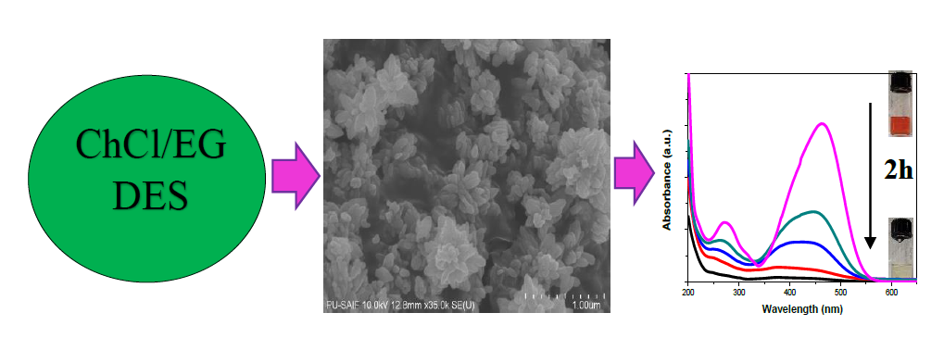
- Reference:

- Tomé L. I. N., Baião V., Silva W., Brett C. M. A., Deep eutectic solvents for the production and application of new materials, Applied Materials Today, 2018, 10, 30-50.
- Li N., Dang H., Chang Z., Zhao X. Zhang M., Li W., Zhou H., Sun C., Synthesis of uniformly distributed magnesium oxide micro-/nanostructured materials with deep eutectic solvent for dye adsorption, Journal of Alloys and Compounds, 2019, 808, 151571.
- Mjalli F. S., Naser J., Jibril B., Alizadeh V., Gano Z., Tetrabutylammonium chloride based ionic liquid analogues and their physical properties, Journal of Chemical & Engineering Data 2014, 59, 2242-2251.
- Wagle D. V., Zhao H., Baker G. A., Deep eutectic solvents: sustainable media for nanoscale and functional materials, Accounts of chemical research 2014, 47, 2299-2308.
- Wang Q., Dong B., Zhao Y., Huang F., Xie J., Cui G., Tang B., Controllable green synthesis of crassula peforata-like TiO2 with high photocatalytic activity based on deep eutectic solvent (DES),
Chemical Engineering Journal, 2018, 348, 811-81.

Biography:
Dr. Satwant Kaur Shahi did her M.Sc., M. Phil from Panjab University, Chandigarh and earned Ph.D in Chemistry from PEC University of Technology, Chandigarh, India in 2016 under the supervision of Professor Vasundhara Singh. Currently, an Associate Professor and Head of the Chemistry Department, ASBASJSM Postgraduate College, Bela, India. Her research interests include nanomaterials synthesis, concentrating on physico-chemical and morphological studies, photocatalysis and functionalized ionic liquids.

Presenting author details

Full Name: Dr. Satwant Kaur Shahi
Contact number: 9815620645
Twitter account: Linked In account:
Session name/ number:
Category: Oral presentation
Passport Number:

