Title: Study of self-assembled monolayers of cyclohexane thiol on Au disclosed by STM
Ayesha Mubshrah¹
¹ Department of Physics, Comsats University Islamabad, Lahore campus, Pakistan
Keywords: Self assembled monolayer (SAM), Cyclohexane thiol (CHT), Scanning Tunneling Microscope (STM), Scanning Tunneling Spectroscopy (STS), Solution immersion method
Abstract:
Structural integrity and electronic properties of SAMs of cyclohexane thiol on Au (111) have been investigated through STM. Thiols chemisorb on gold surface in the form of thiolate due to strong bond strength of Au-S. To get desired stability and maximum coverage of SAMs results are depicted on two parameters various immersion time and temperature. Initially chemisorption occurs with fast kinetics but at long immersion time this process slows down. By considering structural view at high resolution describes that no. of pits decline after increasing immersion time. It is due to the chemisorption of organic molecule having thiol group on gold substrate. At high temperature SAMs covered area increases due to thermal excitation of molecules. Rapid and precise survey of electronic properties through STS reveals the dependence of tunneling current on bias voltage and tip substrate distance. Kinks in IV and IZ curves predict the presence of tip substrate contact.

Images:
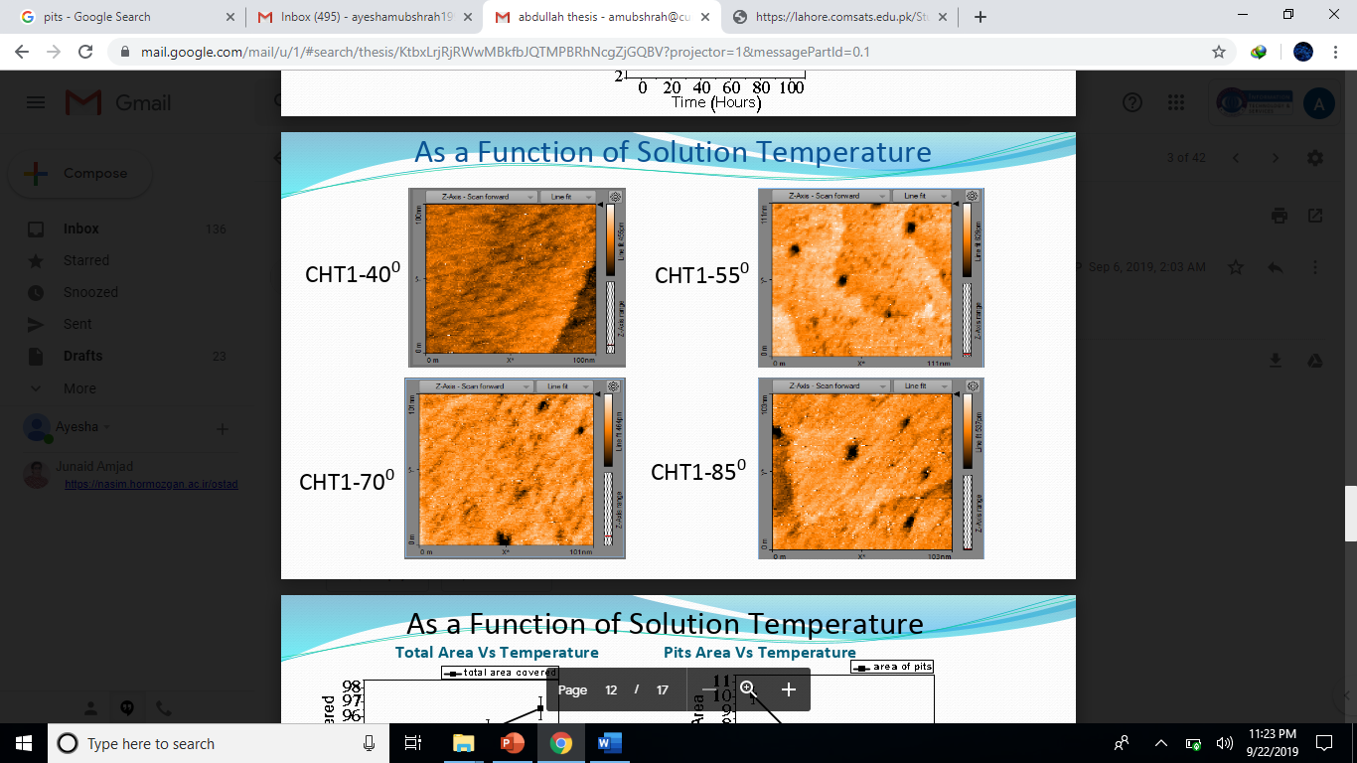
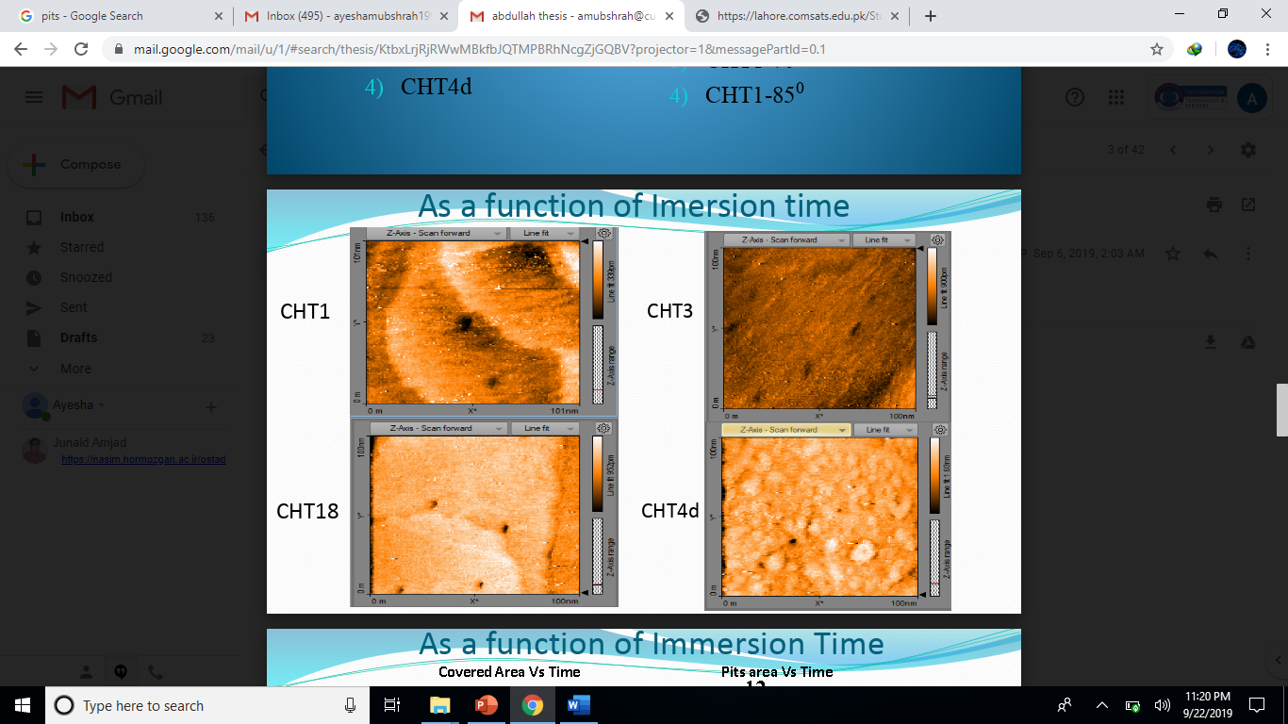

References:
- Brinkman, William F., Douglas E. Haggan, and William W. Troutman. "A history of the invention of the transistor and where it will lead us." IEEE Journal of Solid-State Circuits 32.12 (1997): 1858-1865.
- Marculescu, Radu, and Paul Bogdan. "The chip is the network: Toward a science of network-on-chip design." Foundations and Trends® in Electronic Design Automation 2.4 (2009): 371-461.
- Huang, Zhifeng, et al. "Single molecule junctions formed via au− thiol contact: stability and breakdown mechanism." Journal of the American Chemical Society 129.43 (2007): 13225-13231.
Biography:
Ayesha Mubshrah is doing MS in Physics from Comsats University Islamabad, Lahore campus, Pakistan. She is working on a project funded by Pakistan government ( HEC – NRPU ) and also working on research paper of same abstract.
Presenting Author details:
Full name: Ayesha Mubshrah
Phone no.: +923045772835
Presentation type: Oral presentation
Passport No.: AP0015251

