Polymer – nanoparticles composites: Principles of formation and properties
Raisa V. Talroze, Professor, Ph.D., D.Sc. A.V. Topchiev Institute
of Petrochemical Synthesis, Russian Academy of Sciences,
Russian Federation

Abstract
Statement of the Problem. Modern science and engineering demonstrates a trend from synthesis of nanoparticles (NPs) to the construction of nanocomposite media with desired properties. In particular, nanocomposites consisting of semiconductor QDs and metal NPs embedded into a polymer host matrix have the potential to show unique optical properties, which are different from those of pure QDs, plasmonic metals and the embedding matrix. The major goal of the research area under discussion is the analysis of the major regularities of the formation of polymer-NPs composites providing the structural stability and unique properties resulted from the interaction between different components of composites. Methodology & Theoretical Orientation: Polymers were synthesized via reversible addition–fragmentation chain transfer (RAFT) polymerization providing the functionality in the end group of macromolecules. The combination of the modern physical-chemical methods was used to address the structure and optical properties of composites both in solutions and in the solid state. Findings: Nanocomposites involving CdSe QDs and gold nanoparticles are synthesized, and conditions of synthesizing these composites with large amounts of NPs and QDs are ascertained. The first steps of the process of the interaction of polymer and QDs are shown with the dynamic light scattering. The structure of polymer-NPs composites is analyzed and the models depending on the structure of NPs and polymer molecular weight are developed. The possibility of the control the photoluminescence of QDs in nanocomposites is shown. Conclusion & Significance: New materials based on modified polymers and CdSe QDs are created being stable due to chemical binding. Plasmon Au NPs is shown to affect the photoluminescence of QDs in polymer films. The analysis of these results via modeling shows the role of Au NPs on light absorption and reabsorption affecting photoluminescence. The results received will allow finding the optimal conditions for the development of new sources of photoluminescence.

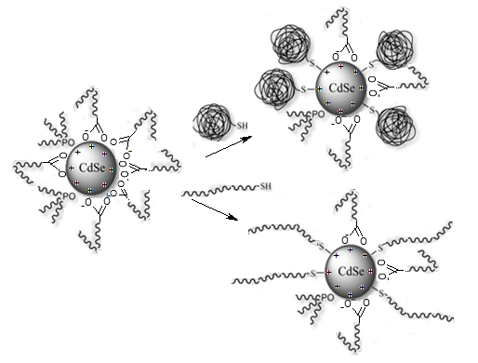
Figure 1. Scheme of the synthesys of polymer-QDs composite for macromolecules of different length.
Recent Publications
1. Shandryuk G.A., Matukhina E.V., Vasil’ev R.B., Rebrov A.I., Bondarenko
G. N., Merekalov A. S., Gas’kov A M., Talroze R. V. (2008) Semiconductor Quantum Dots Organized by a Liquid Crystal Polymer MediumMacromolecules: 41: 2178 -2185
2. Tselikov G. I., Shandryuk G.A., Kutergina I.Yu., Shatalova A.M.,
Merekalov A.S., Timoshenko V.Yu., Talroze R.V. (2014)
Photoluminescence of Nanocomposites of Liquid Crystalline Polymers and Cadmium Selenide Quantum Dots. Polymer Science, Ser. A. 56: 781-785
3. Tselikov G.I., Timoshenko V.Yu., Golovan L.A., Plenge Yu.,Shatalova A.M., Kutergina I.Yu., Merekalov A.S., Ruehl E., Talroze R.V. (2015) Role of the polymer matrix on the Luminescence of embedded CdSe quantum dots. ChemPhysChem 16: 1071-1078
4. Ezhov A.A., Derikov Ya.I., Chernikova E.V., . Abramchuk S.S., Shandryuk G.A., Merekalov A.S., Panov V.I., Talroze R.V. (2015) Monochelic copolymer as a matrix for cholesteric composites with gold nanoparticles. Polymer 77: 113–121.
5. Litmanovich E.A., Bekanova M.Z., Shandryk, G.A., Chernikova E.V., Talroze R.V.(2018) “Macromolecules – ghosts” in dynamic light scattering analysis: an approach to study interaction between CdSe quantum dots and RAFT-based poly(methyl methacrylate). Polymer 142:1-10
6. Karpov O. N., Shandryuk G. A., Derikov Ya. V., Merekalov A. S., Otmakhova O. A., Shatalova A. M., Talroze R. V.(2018). Blend Composites Based on Polystyrene–CdSe Quantum Dots and Polystyrene–Gold Nanoparticles Hybrid Systems. Polymer Sci. Series B, 60:370–379


Biography
Raisa Talroze is a world known scientist in the broad field of polymers chemistry and physics, liquid crystals and nanomaterials based on semiconductor quantum dots QDs and gold nanoparticles NPs. Pioneered in investigation the main electro-optical phenomena in liquid crystal polymers,. discovered the possibility to control over the structure and orientation of polymers with the aid of electric and magnetic fields, discovered the gelation phenomena in solutions of crystalline comb-shaped polymers in aliphatic alcohols and hydrocarbons; investigated new phenomena in the H-bond LC polymer films related to the thermally activated re-connecting of the H-bond structures under stress resulting in the yield stress. Her contribution in the field of nanoscience and nanotechnology allowed creating new materials which are based on semiconductorQDs and plasmonic metals NPs embedded in polymer matrix. Her group in the Russian Academy of Sciences works on the synthesis of nanoparticles, polymers, composite structures and analysis of structure - properties relationship.
Email: rtalroze47@gmail.com

Notes/Comments:


