All-Inorganic Perovskite Quantum Dots Nanocomposites and Large Amount Production by Microﬂuidic System for the Applications in Q-LCD and QLED
Ru-Shi Liu, PhD, Department of Chemistry, National Taiwan University, Taipei 106, Taiwan eanna L Mulvihill, Shu-Shu-Fen Hu, PhD, Department of Physics, National Taiwan Normal University, Taipei, Taiwan

Abstract
All-inorganic CsPbX3 (X = I, Br, Cl) perovskite quantum dots (PQDs) have been extensively investigated because of their unique optical properties, such as tunable wavelength, narrow band, and high quantum efficiency. These fascinating features of inorganic nanocrystals have been utilized in light emitting diode (LED) devices. For application in lighting and backlight display, the stability of PQDs should be further improved. Degradation of PQDs is mainly caused by temperature, oxygen, moisture, and light. Surface passivation and surface protective shell can improve the stability of LEDs. After resolving this problem, we further applied wide color-gamut in PQD-based LEDs for backlight display. We also successfully used PQDs in an on-chip LED device. Our white LED device for backlight display pass through a color filter with an NTSC value of 113% and Rec. 2020 of 85%. To further improved the stability of CsPbBr3, we developed three-steps treatment on CsPbBr3. For lighting application, we fabricated white LEDs exhibit a luminous efficiency of 19.0 lm/W, R9 of 96, CRI of 84.7 and a CCT of 3328 K, respectively. Successive and scalable synthesis of highly stable Cs4PbBr6 perovskite microcrystal by the microﬂuidic system and their application in backlight display will be demonstrated.

Image
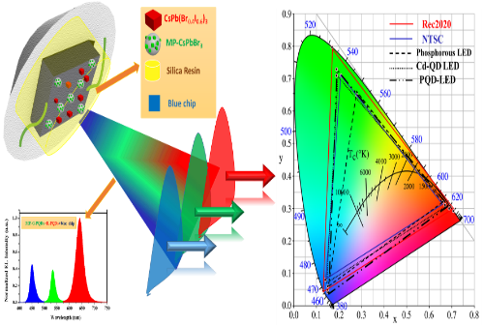

Recent Publications
- Wang H.C, Lin, S.Y.,Tang, A.C.,Singh, B.P.,Tong, H.C.,Chen, C.Y., Lee, Y.C.,Tsai, T.L., Liu, R.S. (2016) Angew. Chem. It. Edit. 55:7924-7929.
2. Zhang, X.J., Wang, H.C., Tang, A.C., Lin, S.Y., Tong, H.C., Chen, C.Y., Lee, Y.C., T.L.Tsai, Liu, R.S. (2016) Chem. Mater. 28:8493-8497.
3. Wang, H.C., Wang, W.G., Tang, A.C., Tsai, H.Y., Bao, Z., Ihara T., Yarita N., Kanemitsu Y., Chen, S., Liu, R.S. (2017) Angew. Chem. Int. Edit. 56:13650-13654.
4. Bao Z., Wang H.C., Jiang Z.F., Chung R.J., Liu R.S. (2018) Inorg. Chem. 57:13071-13074.

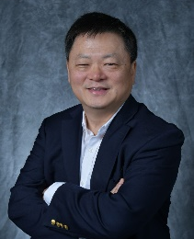Biography
Professor Ru-Shi Liu received his Bachelor degree in Chemistry from Soochow University (Taiwan) in 1981. He got his Master Degree in nuclear science from the National Tsing Hua University (Taiwan) in 1983. He obtained two Ph.D. degrees in Chemistry from National Tsing Hua University in 1990 and from the University of Cambridge in 1992. He joined Materials Research Laboratories at Industrial Technology Research Institute as an Associate Researcher, Research Scientist, Senior Research Scientist and Research Manager from 1983 to 1995. Then he became an Associate Professor at the Department of Chemistry of the National Taiwan University from 1995 to 1999. Then he promoted as a Professor in 1999. In July 2016, he became the Distinguished Professor. He got the Excellent Young Person Prize in 1989, Excellent Inventor Award (Argentine Medal) in 1995 and Excellent Young Chemist Award in 1998. He got the 9th Y. Z. Hsu scientific paper award due to the excellent energy saving research in 2011. He received the Ministry of Science and Technology award for distinguished research in 2013 and 2018. In 2015, he received the distinguished award for Novel and Synthesis by IUPAC & NMS. In 2017, he got the Chung-Shang Academic paper award. In 2018 he received the highly cited researchers by Clarivate Analytics and Hou Chin-Tui Award. His research is concerning in the Materials Chemistry. He is the author and co-author of more than 560 publications in scientific international journals with total citations > 14,838, h-index: 63. He has also granted more than 200 patents.
Email: rsliu@ntu.edu.tw

