Fluorescent molecular switches for super-resolution imaging of nanostructures
Ming-Qiang Zhu, Wuhan National Laboratory for Optoelectronics, Huazhong University of Science and Technology, Wuhan, 430074 China.

Abstract
Super-resolution fluorescent imaging based on photoswitchable fluorophores provide promis-ing perspective of optical microscopy with na-noscale resolution (10-100 nm). We report a series of fluorescence molecular photoswitches including spiropyrans (SP)1,2, dithienylethene (DTE)3-5 and hexaarylbiimidazole (HABI)6,7, which have been screened for super-resolution fluorescent imaging (SURF). The molecular photoswitches undergo photoinduced isomeriza-tion and photoswitchable fluorescence, which is essential for super-resolution fluorescence im-aging. The super-resolution imaging applica-tions of these photoswitchable fluorophores have been demonstrated that fine nanostructures have been characterized with 40 nm resolution in the self-assembly of amphiphiles, block co-polymers and polymer nanofibers as well as inorganic nanowires.

Image
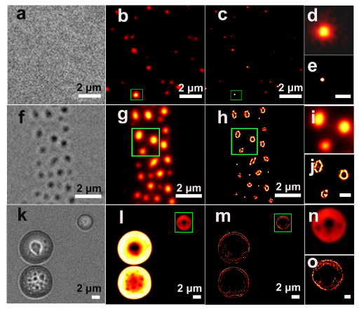
Figure 1. Super-resolution fluorescent imaging for typical self-assemblies of amphiphilic molecules.
Recent Publications
- Yan J et al. (2015) Optical nanoimaging for block copolymer self-assembly. J Am Chem Soc. 137:2436-2439.
- Zhu M.-Q. et al. (2014) Reversible fluorescence switching of spiropyran-conjugated biodegradable nanoparticles for super-resolution fluorescence imaging. Macromolecules 47:1543-1552.
- Li C. et al. (2014) A trident dithienylethene-perylenemonoimide dyad with super ﬂuorescence switching speed and ratio. Nat. Commun. 5:5709.
- Li C. et al. (2014) Water-soluble polymeric photoswitching dyads impart super-resolution lysosome highlighters. Macromolecules 47:8594-8601.
- Liu J.-X. et al. (2017) PEGylated perylenemonoimide-dithienylethene for super-resolution imaging of liposomes. ACS Appl. Mater. & Inter. 9:10338-10343.
- Hua, Q.-X. et al. Super-resolution imaging for self-assembly of amphiphilic photoswitchable macrocycles. (2017) Chem. Commun. 53:2669-2672.
- Gong, W.-L. et al. (2016) Blue light-induced fluorescence quenching and spontaneous recovery enabling single-wavelength-controlled in situ optical nanoimaging. Photochem. Photobio. Sci. 15:1433-1441.

Biography (150 word limit)
Ming-Qiang Zhu has her expertise in organic and nano-optoelectronics. His main research interests include fluorescence molecular switch and super resolution Imaging, aggregation-induced emission material, and advanced energy nanomaterials and devices.
Email: mqzhu@hust.edu.cn

Notes/Comments:

