Fluorescent Molecular Switches for Super-Resolution Imaging
Ming-Qiang Zhu*
Wuhan National Laboratory for Optoelectronics, Huazhong University of Science and Technology, Wuhan, 430074 P. R. China. *mqzhu@hust.edu.cn.
Super-resolution fluorescent imaging based on photoswitchable fluorophores provide promising perspective of optical microscopy with nanoscale resolution (10-100 nm). We report a series of fluorescence molecular photoswitches including spiropyrans (SP)^{1,2}, dithienylethene (DTE)³ and hexaarylbiimidazole (HABI), which have been screened for super-resolution fluorescent imaging (SURF). The molecular photoswitches undergo photoinduced isomerization and photoswitchable fluorescence, which is essential for super-resolution fluorescence imaging. The super-resolution imaging applications of these photoswitchable fluorophores have been demonstrated that fine nanostructures have been characterized with 40 nm resolution in the self-assembly of amphiphiles, block copolymers and polymer nanofibers as well as inorganic nanowires.
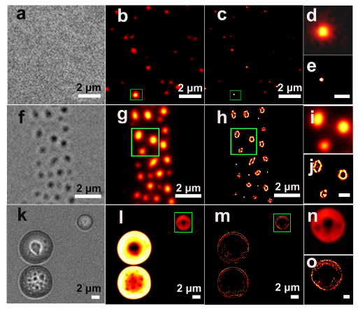
Figure 1. Super-resolution fluorescent imaging for typical self-assemblies of amphiphilic molecules.
References
1. J. Yan, L.-X. Zhao, C. Li, Z. Hu, G.-F. Zhang, Z.-Q. Chen, T. Chen, Z.-L. Huang, J. Zhu, M-Q. Zhu, J. Am. Chem. Soc. 2015, 137, 2436-2439.
2. M.-Q. Zhu, G.-F. Zhang, M/. P. Aldred, C. Li, W.-L. Gong, T. Chen, Z.-L. Huang, S. Liu, Macromolecules 2014, 47, 1543-1552.
3. C. Li, H. Yan, L.-X. Zhao, G.-F. Zhang, Z. Hu, Z.-L. Huang, M.-Q. Zhu, Nat. Commun. 2014, 5, 5709.
4. C. Li, Z. Hu, M. P. Aldred, L-X. Zhao, H. Yan, G.-F. Zhang, Z.-L. Huang, A. D. Q. Li, M.-Q. Zhu, Macromolecules 2014, 47, 8594-8601.
5. W.-L. Gong, Z.-J. Xiong, B. Xin, H. Yin, J.-S. Duan, J. Yan, T. Chen, Q.-X. Hua, B. Hu, Z.-L. Huang, M.-Q. Zhu, J Mater. Chem. C 2016, 4, 2498-2505.
6. J.-X. Liu, B. Xin, C. Li, N.-H. Xie, W.-L. Gong, Z.-L. Huang, M.-Q. Zhu, ACS Appl. Mater. & Inter. 2017, 9, 10338-10343.
7. J.-X. Liu, B. Xin, C. Li, W.-L. Gong, Z.-L. Huang, B. Z. Tang, M.-Q. Zhu, J. Mater. Chem. C 2017, DOI:10.1039/C7TC02526B.

