Emerging Material Application in Nanoelectronic Devices and Corresponding Electrical Performance Characterization
Hui-Lin Chang ^{1, 2}
¹ Material Science and Engineering Department, National Chiao Tung Unviersity, HsinChu, Taiwan
² Device Department, Micron Technology at Manassas, VA, 20110

Abstract:
Sustaining Moore’s law into the future requires continuous transistor scaling. Therefore, the adoption of emerging materials has become of great importance for the development of future nanoelectronics applications. Various emerging devices have been found to be promising candidates to extend Moore's law, such as Si nanowires, carbon nanotubes, and III-V compound field effect transistors (FETs). In this study, a systematic analysis and characterization of the structures and corresponding properties of the following emerging materials was conducted random oriented SiCN tubes, nanowire / conical rods and 2D graphite/seaweed structures. This study addresses the growth mechanisms and electronic properties of the aforementioned nanostructured materials (Fig.1-2). The development of nanostructured materials is critical for enhancing emerging device applications. The integration of carbon nanotubes (CNTs) into Si-based metal-oxide semiconductor field effect transistors (MOSFETs) or new nanoelectronics remains a challenge in the areas of transistors and interconnects. CNTs are recognized candidates for use in molecular electronics to overcome the physical limitations of currently used Si transistors and Cu interconnections [1-2]. Bundles of CNTs are naturally deposited in the vertical dimension, since they tend to adhere to each other vertically. The feasibility of realizing this vision depends on direct approaches to selective deposition in the trench or holes of Si wafers. Bundles of CNTs in the trenches and holes can provide sufficient current density in the form of channels and conductors, respectively (Fig.3). This paper systematically elucidates the synthesis of CNTs by microwave plasma CVD (MPCVD). In this study, Fe catalysts, CoSi2 films, and NiSi2 films employed frequently as gate electrodes and as a contact material in Si nanoelectronics are applied. The selective growth of CNTs in trench/hole/planar approaches is also investigated. Furthermore, the morphology and nanostructures of CNTs are characterized. The field emission characteristics and ballistic conduction behaviors of CNTs deposited in the trenches and holes are addressed to determine electronic performance.
Keywords: nanoelectronic device, graphene, carbon nanotube, 2 dimension, 1 dimension, nano scale characterization.
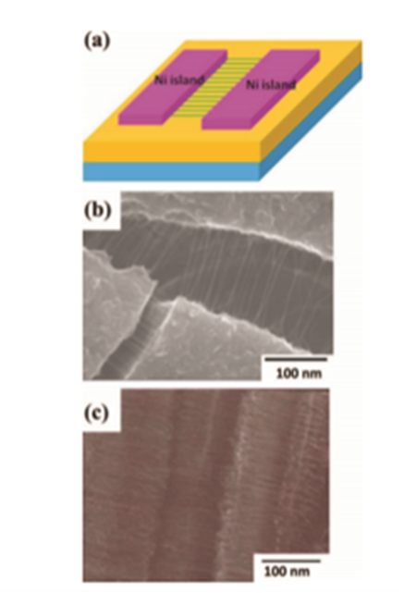
Fig. 1 Schematic diagram of horizontal CNTs growth on parallel Ni islands. (b), (c) Corresponding SEM images of horizontal CNTs growth in between two islands.
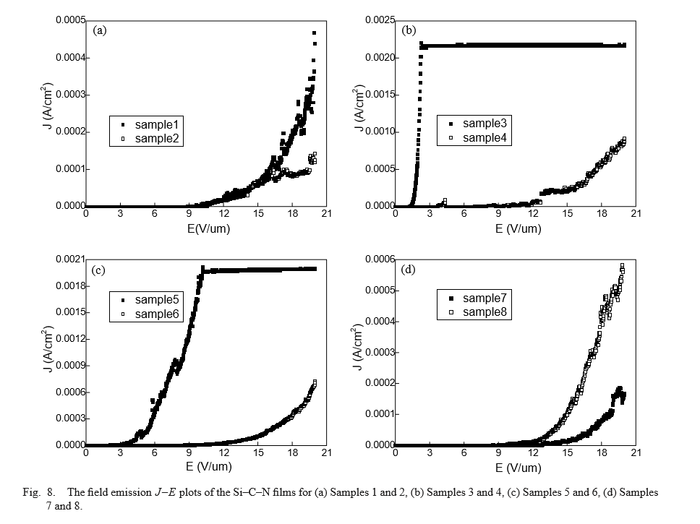

Figure 2: The ﬁeld emission J–E plots of the Si–C–N ﬁlms for (a) Samples 1 and 2, (b) Samples3 and 4, (c) Samples 5 and 6, (d) Samples 7 and 8.
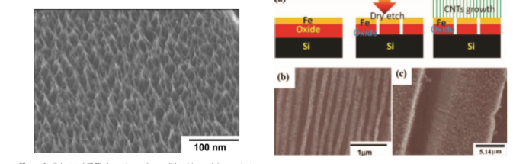
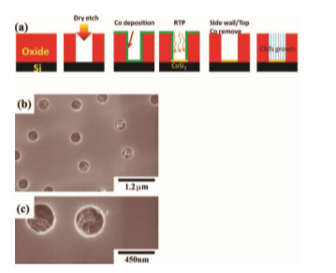
Fig. 3 Process ﬂows of forming CNTs on Fe trench arrays, oxide ﬁlm deposition→Fe ﬁlm deposition→dry etching→CNTs growth Fe assisted CNTs deposition on trench array in low and high magniﬁcation. Fe assisted CNTs deposition (b) trench arrays (c) high magniﬁcation.

References:
- S. K. Hwang, K. D. Lee and K. H. Lee: Jpn. Appl. Phys. Lett. 40 (2001) L580.
- Y. Avigal and R. Kalish: Appl. Phys. Lett. 78 (2001) 2291.

 Biography (150 word limit)
Dr. Hui-Lin Chang is currently working at Micron Technology. Her previous work experience includes working in GlobalFoundries as Senior Member of Technical Staff, Samsung Electronics in South Korea as a Principal Engineer and Taiwan Semiconductor Manufacturing Co. Ltd. (TSMC) as a Technical Manager in Hsin Chu, Taiwan, as well as a Senior Researcher in National Chiao Tung University in Taiwan. She served as a technical program committee member at the 6th International Conference on Mechanical Science and Engineering (ICMSE2015), organized by the International Association of Applied Science and Engineering Technology (IAASET).
Hui-Lin Chang was awarded a PhD in Material Science and Engineering from National Chiao Tung University in Taiwan in 2002. She also received an Executive Master’s degree of Business Administration (EMBA) from National Chiao Tung University and the University of California – Berkeley in 2010. In addition, in 2016, she was designated a Stanford Certified Project Manager by the Stanford University Center for Professional Development.
Hui-Lin Chang has been awarded 24 patents by the U.S. Patent and Trademark Office (USPTO), many of which have also been published by the USPTO's counterpart in China, the State Intellectual Property Office (SIPO). In addition to her many granted patents, she is a named inventor of 10 pending patent applications. Hui-Lin Chang’s contributions to the existing academic literature and industrial practices related to fracture mechanisms of nanoelectronic devices, in particular her novel testing approaches, are truly original and significant.
Email: gladies.chang@gmail.com

Notes/Comments:

