Theoretical studies of single wall carbon nanotubes for synthesis and growth mechanism
Mr. Pradeep Kumar Khiriya , Dr jyotsna Chauhan *
* Head of Department School of Nanotechnology, RGPV, Bhopal (mp)
Abstract
The term ‘controlled production’ of single-wall nanotubes _SWNT. implies the ability to control the selectivity towards SWNT by changing catalyst formulations and operating conditions, combined with a quantitative measurement of the SWNT obtained. In this contribution, a significant advancement towards the controlled production of SWNT is reported. A family of Fe-Ru catalysts has been found to be able to produce SWNT with high selectivity, depending on the -Ru ratio, the temperature of operation, and the processing time. The optimization of the catalyst was possible by the application of a simple and direct method of quantification of the SWNT production.
1. Introduction of Carbon Nanotube
Relying on the pioneering work on carbon nanotubes (CNTs) by Iijima in 1991, [1] great efforts have been made and continue in optimizing CNT growth, so as to controllably access their unusual electrical, optical, chemical, thermal, and mechanical properties. Many applications have been proposed and numerous applications demonstrated. The ability of single-walled carbon nanotubes (SWCNTs) to be either metallic or semiconducting depending on their chirality makes them ideal building blocks for nano electronics. Examples include field effect transistors (FETs), logic circuits, biosensors, and environmental and medical sensors. Still today, we are lacking behind a suitable methods for making CNT with selective conductivity hurdle for the development of SWCNTs for large-scale electronics.
Two key areas still require further development, namely, chiral management and reproducible control of their spatial position and orientation. The need for horizontally aligned SWCNTs lies in their potential to provide arrays of devices, e.g., FETs and interconnects. When using SWCNT for high-frequency devices, closely packed arrays of parallel SWCNT are required in order to sustain relatively large current.

2. STRUCTURE of Carbon Nanotube
Lijima was first to recognize that nanotubes were concentrically rolled graphene sheets with a large number of potential helicities and chiralities rather than a graphene sheet rolled up like a scroll. Initially Lijima observed that only MWCNTs having between 2 to 20 layers, but, he confirmed the existence of single-walled carbon nanotubes (SWCNTs) and explained their structure, in a subsequent publication in 1993 [2].
2.1 Single Wall Carbon Nanotube
A SWCNT is nothing but a rolled graphene sheet. Although the growth mechanism does not suggest a carbon nanotube is actually formed like a sushi roll, the way of rolling graphene sheet is determines the fundamental properties of the tube fundamental characteristic.
Properties of the nanotube can be described by two vectors, C_{h} and T (Figure 2.1), whose rectangle defines the unit cell, can be introduced. C_{h} is the vector that defines the circumference on the surface of the tube connecting two equivalent carbon atoms,
C_{h} = nâ₁ + mâ₂ ,
Where, the two basis vectors of graphite are â₁ and â₂ . (n,m) are integers.
n and m are also called indexes and determine the chiral angle
θ= tan^{–1}[3(n/(2m + n))].
The chiral angle is used to separate carbon nanotubes into three classes differentiated by their electronic properties:
armchair (n = m, θ= 30°),
zig-zag (m = 0, n > 0, θ= 0°),
chiral (0 < |m| < n, 0 < θ< 30°).
Armchair carbon nanotubes are metallic (a degenerate semimetal with zero band gap). Zig-zag and chiral nanotubes can be semimetals with a finite band gap
if n – m/3 = i (i being an integer and m ≠ n) or semiconductors in all other cases. The band gap for the semi metallic and semiconductor nanotubes scales approximately with the inverse of the tube diameter, giving each nanotube a unique electronic behavior.The diameter of the nanotube can be expressed as
d_{t} = (3)^{1/2}[a_{c-c}(m² + mn + n²)^{1/2}/π] = C_{h}/π,
where C_{h} is the length of C_{h}, and a_{c-c} is the C-C bond length (1.42 Å). Combining different diameters and chiralities results in several hundred individual nanotubes, each with its own distinct mechanical, electrical, piezoelectric, and optical properties
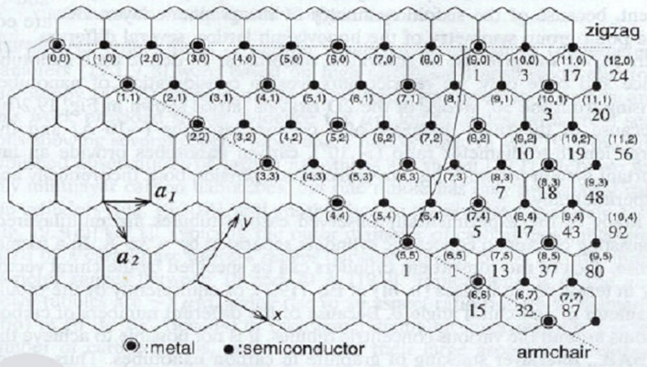
Figure 1 The graphene sheet labeled with the integers (n, m). The diameter, chiralangle, and type can be determined by knowing the integers (n, m).
2.1.1 Armchair; n=m
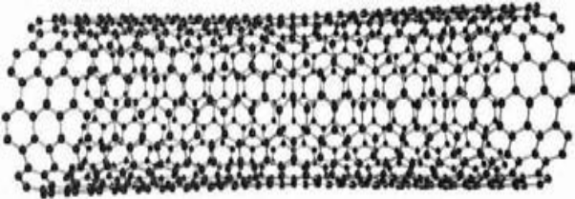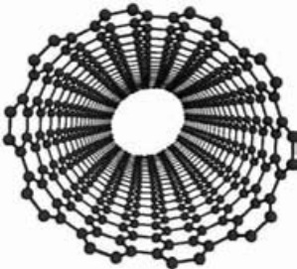
Figure 2 -Armchair SWCNT identified by the integers (n, m).
When graphene sheet is rolled in such a way that its armchair side is open at the side end then its armchair SWCNT.
2.1.2 Zig zag;(n,0)
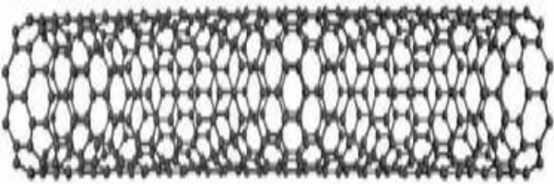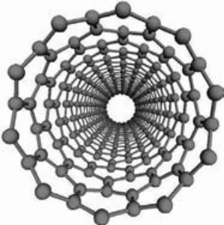
Figure 3 -Zig zag SWCNTs identified by the integers (n, m).
When graphene sheet is rolled in such a way that its zigzag side is open at the side ends then this structure is known as Zig Zag SWCNT.
2.1.3 Chiral;(n,m)
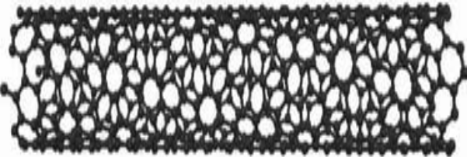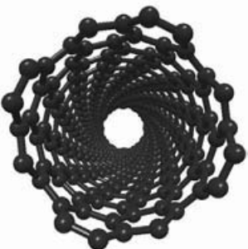
Figure 4 -Chiral SWCNTs identified by the integers (n, m).
When the n,m chosen such as an angle formation takes place then these type of CNTs are known as Chiral SWCNT.
2.2 Multiwall carbon nanotubes:-
Multiwall nanotubes can be categorized in the way of they rolled with the respect of cylindrical axis (Figure 2.5) that can be in two manners known as:.
2.2.1 Russian doll model: When multiple single wall nanotubes with different diameters are concentrically arranged, such structures known as Russian doll model MWCNTs.
2.2.2 Parchment model:In the parchment model a single graphene sheet rolled around its axis.

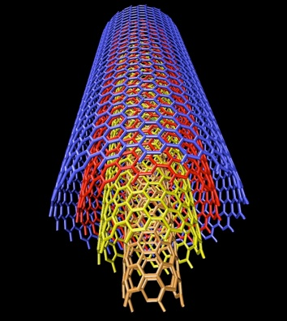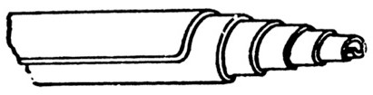
Figure 5 Russian doll model (colored) concentic single wall tubes makes MWCNTs and Parchment model (black & white) a single graphene sheet rolled around its axis.

3. Synthesis of carbon nanotubes
For the synthesis of CNTs there are various methods available. In figure 4.1 these methods are shown by the different circles by using a flow chart. A lot of methods are used for the synthesizing the CNTs for the commercial and research purpose. But mass production of the carbon nanotubes are still a challenge for industrial purpose.
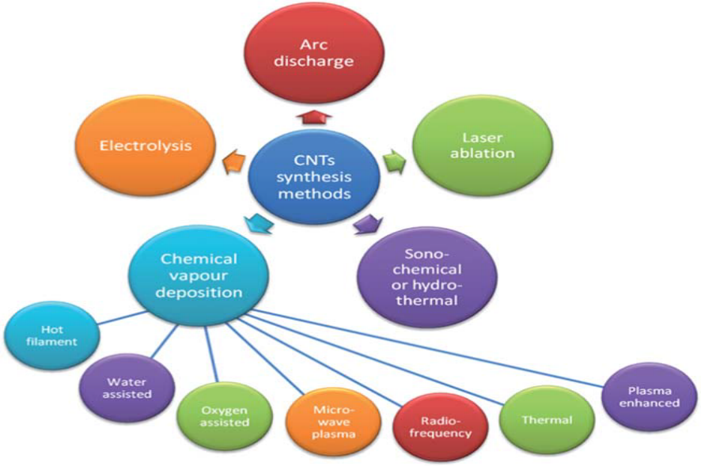
Figure 6- Various synthetic methods of preparation of carbon nanotubes.
On the basis of carbon source. Synthesis methods are divided in two main category, solid carbon source and gaseous carbon source based synthesis techniques.
3.1 Solid carbon source based synthesis
When carbon source is solid material like graphite is used then this type of synthesis process is known as solid base synthesis. Mainly two methods are discussed here for the preparation of SWCNTs and MWCNTs. These techniques are LASER ABLATION and ARC DISCHARGE, and they allow growth of substrate free CNTs.
3.2Gaseous carbon source based synthesis
The catalyst enhanced thermal cracking of gaseous carbon source (hydrocarbons, carbon mono oxide etc.); commonly referred to as catalytic chemical vapor deposition (CCVD) has been known to produce carbon monofilaments for long time [3].
The synthesis of carbon nanotubes (SWCNT or MWCNT) by CCVD methods involves the catalytic decomposition of a carbon containing source on small metallic particle or clusters.
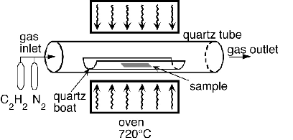
Figure 7 Schematics of a CCVD deposition oven.
Our work is mainly focused on this process because it has some advantages over the other synthesis techniques such as;
- The metals generally used for the reaction are transition metals such as Fe, Cu and Ni. It is rather low temperature process compared to arc discharge and laser ablation methods. Synthesis of CNT takes place between the temperature 600°C to 1000°C because of low temperature selectivity of CNTs with respect to graphite and amorphous carbon is generally better.
- CNTs prepared by CCVD method are generally much longer (few tens to hundred of micrometers and also possible to grow dense array of nanotubes.
- MWCNTs prepared by CCVD have more structural defects that can be removed by the heat treatment.
- CCVD provides large scale production and low cast process and also the diameter is less compared to other techniques.
- For the application development at the industrial scale CCVD is more promising technique with also provide some control over the growth of selective CNT synthesis.
This process can be categorized in two types:
1. Homogeneous CCVD (if everything takes place in gaseous phase only).
2. Heterogeneous CCVD (if a solid substrate has a roll)

4.Growth mechanism of CCVD
Growth mechanisms of carbon nanotubes are still debated. But researchers have been impressively imaginative and have represented a number of hypotheses. Reason behind it is that conditions allowing carbon nano-filaments to grow are very diverse, which means that related growing mechanisms can be many. For given conditions, the truth is even probably a combination or a compromise between some of the proposals. Another reason is that phenomena are quite fast and difficult to observe in situ to give actual growing mechanism. It is generally agreed, however, that growth should occur so that the number of dangling bonds is limited, for energetic reasons. Generally there are two types of mechanism are growth of CNTs.
4.1 Catalyst-Free Growth
Catalyst free growth takes place in solid base synthesis methods like electric arc discharge and laser ablation. As the growth of C-MWNT as a deposit onto the cathode in the electric-arc method is a rare example of catalyst-free carbon nano-filament growth. The driving forces are obviously related to the electric field, i.e. related to charge transfers from an electrode to the other via the particles contained in the plasma. How the MWCNT nucleus forms is not clear, but once it has started, it may include the direct incorporation of C₂ species to the primary graphene structure as it was formerly proposed for fullerenes [4]. This is supported by recent C₂ radical concentration measurements that revealed an increasing concentration of C₂ from the anode being consumed to the growing cathode, indicating, first, that C₂ are secondary species only, and second, that C₂ species could actually participate actively in the growth mechanism of MWCNTs in the arc method.
4.2 Catalytically Activated Growth
Growth mechanisms involving catalysts are more complex, since they are more diverse. Although a more or less extensive contribution of a VLS (Vapor-Liquid-Solid) [5] mechanism is well admitted, because it is quite difficult to find comprehensive explanations able to account for both the various conditions used and the various morphologies observed. Hence it is an attempt to provide overall explanations of most probable phenomena, while remaining consistent with the experimental data. We are also not considering hypotheses for which there are lack of experimental evidence, such as: Moving nano-catalyst mechanism: which proposed that dangling bonds from a growing SWCNT may be temporarily stabilized by a nano-sized catalyst located at the SWCNT tip [6].
Scooter mechanism: which proposed that C dangling bonds are temporarily stabilized by a single catalyst atom, moving all around the SWCNT cross section edge, allowing subsequent C atom addition [7].
The growth mechanism of carbon nanotubes is still not clearly understood although extensive experimental and theoretical studies given ideas to propose some hypothetical mechanism to grow SWCNTs & MWCNTs. More recently, in situ HRTEM [8] have provided numerous hints about the possible mechanisms. But, it is still an art to select the right materials and process parameters to grow the desired CNTs. The most accepted growth model is the vapor–solid–solid (VSS) model which derives from the vapor–liquid–solid (VLS) model originally suggested by Wagner and Ellis [9] for growth of silicon whiskers. Using the VSS model, the excess carbon from the decomposition of the hydrocarbon gases precipitates on the surface of the catalyst, diffuses into the catalyst, and nucleates the nanotube at the edges of the catalyst. For catalysts on a substrate, two main growth models have been reported:
a) Base-growth
In base-groth mechanism the nanotube nucleates and grows above the catalyst, which remains attached to the substrate as in figure 4.4(a). Also some teams claim growth models that combine tip and base growth, usually achieved by the presence of more than one catalyst dot during growth [10].
b) Tip-growth
In this mechanism, the nanotube lifts the catalyst from the substrate during the growth, as the nanotube nucleates and grows below the catalyst as depicted in Figure 4.4(b).
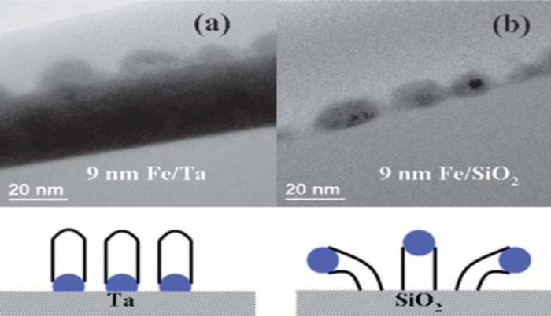
Figure 8 Comparison of CNT growth on Ta (base growth) and on silica (tip growth) using Fe catalyst.[30] Figure is adopted from: Y. Y. Wang, B. Li, P. S. Ho, Z. Yao and L. Shi, Appl. Phys. Lett., 2006, 89, 183113.

Figure 8 depicts possible mechanisms from two groups who have made significant contributions to the understanding of CNT growth: Hofmann et al. [11] who model tip-growth and Puretzky et al. [12] who model base-growth. Although the relative simplicity of the models just described is deceptive as a wide variety of parameters, all inter-related, are critical for the successful synthesis of CNTs, the base-growth and tip-growth mechanisms have been observed using in situ HRTEM techniques.
Which of the two mechanisms is favored during growth depends on the interactions between the catalyst and the substrate materials. Wang and coworkers observed tip-growth using Fe catalyst on SiO₂ and base-growth using Fe on Ta [13]; by measuring the contact angle of the catalyst dots with the substrates, they inferred that base-growth was at play when the surface energy of the Ta substrate was higher than the Fe/Ta interface, while tip-growth was at play when the surface energy of the SiO₂ substrate was lower than the Fe/SiO₂ interface. As it is common to grow CNTs from catalyst and under layer thin films (e-beam evaporated or sputtered onto a substrate), a critical mechanism is the way the catalyst thin film deposited to form the catalyst dots. Controlling the size of the catalyst dots is critical as this will influence the diameter and number of walls of the resulting CNTs.

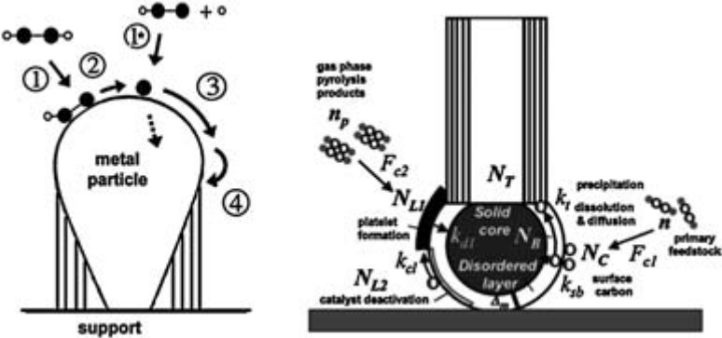
Figure 9 Popular models of carbon nanotube growth mechanism (sources: Hofmann et al. [32] (left) and Puretzky et al.[33] (right)). Figure on the left and right were reprinted from: S. Hofmann, G. Csanyi, A. C. Ferrari, M. C. Payne and J. Robertson, Phys. Rev. Lett., 2005, 95, 3. and A. A. Puretzky, D. B. Geohegan, S. Jesse, I. N. Ivanov and G. Eres, Appl. Phys. A: Mater. Sci. Process., 2005, 81, 223–240 respectively.
However, this task is extremely complex of the interplay between catalyst and underlayer materials, catalyst layer thickness, gas atmosphere and thermal process, which will all influence the rates of dewetting complex because and subsequent coarsening. Extensive studies have been done using the catalyst–under layer system of iron on alumina because it can yield dense carpets of vertically aliened CNTs ( VACNTs) with large tolerance on the process parameters.
c) Kite Mechanism
Another very interesting mechanism is proposed a “kite-mechanism” with the catalyst nanoparticle having a long nanotube tail floating in the gas flow. The kite-mechanism contains several important stages. The most important stage is the initial stage of the growth. In “fast-heating” CVD [14,15] the samples were heated to reaction temperature (900°C for most cases) over a very short period. As the result of fast heating, the solid sample and the surrounding gas were heated at different speeds and had different temperatures during the heating. A convection flow was formed due to such temperature difference. Such a convection flow could lift some of the nanotubes up with the catalysts on their tips. The nanotubes grew up, leaving the surface region where the flow velocity of the feeding gas was slow. Then the horizontal laminar flow of the feeding gas above the substrate surface carried the nanotubes while they were growing and aligned the nanotubes along the direction of gas flow. During growth, the active ends of the nanotubes were always floating while the sections close to the original sites where the catalyst was deposited might form van-der Waals contacts with the substrate. The nanotubes kept growing until they lay down onto the surface or until termination of the carbon source.
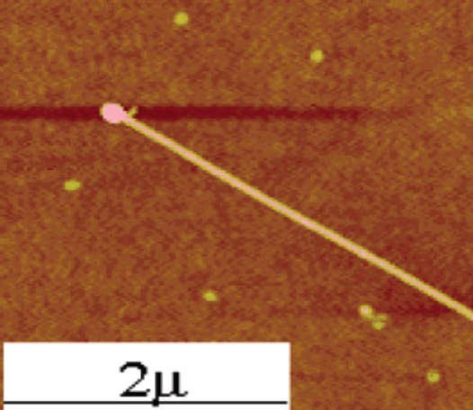

Figure 10 AFM image of the oriented long nanotubes with particle on the tip.

If the proposed mechanism is correct, the key requirement to grow long and aligned SWNTs is to make the nanotubes grow away from the substrate surface at the nucleation stage. Since it was reported previously that electric field can be used to align nanotubes on the surface along the direction of the electric field, we could envision that the application of a vertical electric field would make more nanotubes grow vertically, thus more long and aligned nanotubes can be grown even without the fast-heating step. We did observe the growth of aligned nanotubes along the direction of the gas flow using an applied vertical electric field rather than the fast heating CVD method. Such an observation further proved the validity of the proposed mechanism.
4.3 Nanotube nucleation and growth
At the initial nucleation stage, where the carbon species starts diffuse into the catalyst dots and start CNT growth, is extremely complex as its kinetics is very fast (milliseconds) [16] and difficult to observe. Recently, there have been interesting studies of nucleation using in situ HRTEM [17]. A possible interpretation of the mechanisms is proposed below based on a composite analysis of various studies, before delving into the gases and process parameters.

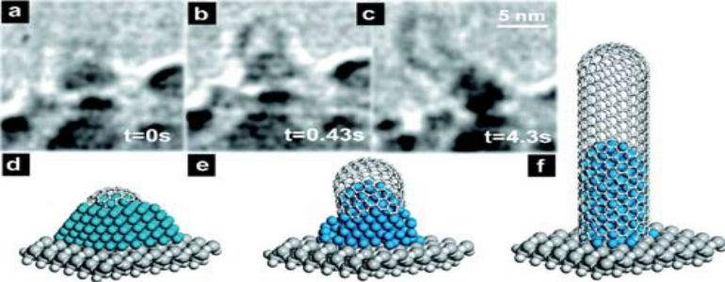
Figure 11 In situ HRTEM images and depictions of initial stages of CNT nucleation.[32] S. Hofmann, et al., Nano Lett., 2007, 7, 602–608.

Smalley and Dai et al. [18] proposed the ‘‘yarmulke’’ model of MWCNT growth where the carbon compounds arriving at the catalyst surface initially assemble into a graphene cap, eliminating energetically expensive dangling bonds, thus reducing the catalyst surface energy. Once the first dome is formed on top of the catalyst dot, additional caps will form underneath in the case of MWCNTs. Finally, the cylindrical part of the CNT will grow. This model has been validated by in situ [19] and isotope labeling [20] experiments as well as by abinitio simulations [21] (Fig. 4.7 and 4.8). The structure of a crystalline cap is similar to the structure of a (half) fullerene.

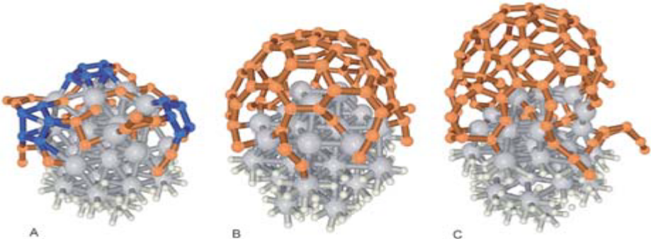
Figure 12 Ab initio simulations of the early stages of SWCNT growth on a 1 nm Fe catalyst. [41] Figure is from J. Y. Raty, F. Gygi and G. Galli, Phys. Rev. Lett., 2005, 95, 9.

Pope et al. [22] described a kinetic mechanism of fullerene formation based on the growth of polycyclic aromatic hydrocarbons (PAHs) and subsequent chemical reactions with hydrocarbons. Using the Pope model, Eres et al. [23] hypothesized the cap formation as starting from PAHs such as fluoranthene, followed by stepwise addition of acetylene. For SWCNTs, once the cap was formed, the CNT wall started to grow thus lifting the cap.

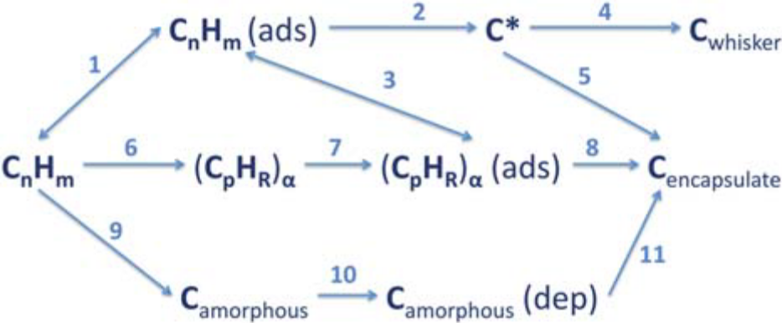
Figure 13 Alternative routes for the formation of carbon on metal catalysts showing the complexity of hydrocarbon decomposition. [24] Examples of possible routes: A (1, 2, and 4): (1) reversible adsorption of hydrocarbon, (2) dehydrogenation reactions on the surface, (4) to form a catalytic fibrous type of carbon (C_{whisker)}; B (6, 7, and 8): (6 and 7) gas phase conversion of the hydrocarbon to form a polynuclear hydrocarbons, irreversibly adsorbed onto metallic sites of the surface, (8) surface rearrangement leading to encapsulating carbon; C (9, 10, and 11): (9 and 10) formation of amorphous carbon in the gas phase, (11) dissolution and precipitation leading to encapsulating carbon. Reproduced from: A. I. La Cava, C. A. Bernardo and D. L. Trimm, Carbon, 1982, 20, 219–223.

4.4 Different catalysts used in CCVD
The initial development of CNT synthesis revolved heavily around the use of 3d valence transition metals (such as Fe, Ni & Co). More recently noble metals (for e.g. Au & poor metals, In, Pb) have been shown to also yield CNT. Various ceramic and semiconductors also used as catalyst particles for formation of CNT & some hybrid metal or metal oxide systems are possible.
We have collected the tabular data regarding the selection of proper catalyst for the synthesis of CNTs by using CCVD method;
 | Catalyst | Weight % | Temp.(°C) | Result | Mean diameter
a. | Ni/Co | [0.5/0.5] | 1200 | SWCNT | 1.2
b. | In/In₂O₃(Ni/Co) | [25/25(0.5/0.5)] | 1200 | SWCNT | 1.6 [1.2, 2.4]
C. | Fe₂O₃(Ni/Co) | [15(0.5/0.5)] | 1200 | SWCNT | [1.2, 2.3]
d. | In/In2O3(Ni/Co) | [5/5(0.5/0.5)] | 600 | SWCNT | 1.8
e. | In(Ni/Co) | [5(0.5/0.5)] | 1200 | MWCNT | N/A
f. | Fe₂O₃ | [5] | 1200 | SWCNT | N/A
g. | In₂O₃ | [5] | 1200 | SWCNT | N/A
h. | Mg0 | [1] | 500-700 | SWCNT,MWCNT | 1.4
i. | PbO₂ | [1] | R.T. | SWCNT,MWCNT | 1.5
j. | In | [5] | R.T. | SWCNT,MWCNT | 1.8
Table 1 different catalyst and their results for CCVD.

In my project proposal the catalyst I am planning to use:
Takaing that catalyst there are various benefits. Such as; FeRu nano particles:- CNTs are potential materials for future nano electronics. Since electronic &optical properties of SWCNTs strongly depends on tube diameter chirality. FeRu catalyst with nano diameter & chirality distribution, due to chemical separation highly single chirality achieved. It iscatalyst high photo luminescence found. Increased inter atomic distance then Fe, Ni, Co. It is possible that the chirality distribution different than other catalyst. FeRu catalyst used then might be unique & responsible for growth result. FeRu nanoparticles are size less than 2nm [25].
5.Application of carbon nanotubes
Carbon nanotubes are becoming very important research material because of their special and unique properties like they can be inert and can have a high aspect ratio, high tensile strength, low mass density, high heat conductivity, large surface area, and versatile electronic behaviour including high electron conductivity. While these are the main characteristics of the properties for individual nanotubes, a large number of them can form secondary structures such as ropes, fibbers, papers, thin films with aligned tubes, etc., with their own specific properties. The combination of these properties makes them ideal candidates for a large number of applications provided their cost is sufficiently low. The cost of CNTs depends strongly on both the quality and the production process. High quality single shell carbon nanotubes can cost 50–100 times more than gold. But synthesis of carbon nanotubes is constantly improving, and sale prices fall by 50% per year. Application of CNTs is therefore a very fast moving area with new potential applications found every year, even several times per year. Making an exhaustive list is again a challenge we will not take. Here we have listed some “current” applications either because already marketed, or because up-scaling synthesis is being processed, or because prototypes are currently developed by profit-based companies. Other applications are said to be “expected”.
5.1 Current Applications:
High mechanical strength of CNTs makes them a near to ideal force sensor in scanning probe microscopy (SPM) with a higher durability and the ability to image surfaces with a high lateral resolution, the latter being a typical limitation of conventional force sensors (ceramic tips).

5.2Nano-Electronics:
Nanotubes can be either metallic (with an electrical conductivity higher than that of copper), or semiconductor. This has inspired the design of several components for nanoelectronics. First, metallic SWCNTs can be used as mere ballistic conductors. Moreover, as early as 1995 realizing a rectifying diode by joining one metallic SWCNT to one semiconductor SWCNT (hetero-junction), field effect transistors (FET) can be built by the attachment of a semiconductor SWCNT across two electrodes (source and drain) deposited on an insulating substrate that serves as a gate electrode. Recently the association of two such SWCNT-based FETs has made a voltage inverter. All the latter developments are fascinating and provide promising perspectives for nanotube-based electronics. But progress is obviously needed before making SWCNT-based integrated circuits on a routine basis.
5.3Supercapacitors:
Supercapacitors include two electrodes immersed in an electrolyte (e.g., 6M KOH), separated by an insulating ion-permeable membrane. Charging the capacitors is achieved by applying a potential between the two electrodes, making the cations and the anions moving toward the electrode oppositely charged. Suitable electrodes should exhibit a high electrical conductivity and a high surface area since the capacitance is proportional to it. Actually, the surface area should originate mainly from the appropriate combination of mesopores (to allow the electrolyte components to circulate well, which are related to the charging speed) and micropores (whose walls are the surface of attraction and fixation sites for the ions). Capacitors including nanotubes already have capacitance as high as 180–200 F/g, i.e. equivalent to that\ obtained with electrodes built from regular carbon materials, with the advantage of faster charging. Current works will certainly lead to further optimization of both the nanotube material architecture and the nanotube-supported conductive polymers, giving reasonable perspectives for the commercial use of nanotubes as components for supercapacitors.
6. Conclusion
As conclusion we can say that carbon nanotechnology is very promising for development of the future technology due to its unique properties. It can bring a revolutionary change in almost every field of science with various application developments. Hence it attracted the intension of researchers but there are still number of things which we have to understand and lots of milestones are waiting to be achieved. In our theoretical studies we can synthesis the CNTs by using two catalysts with CCVD methods. This method is better than other methods so that we can synthesis CNTs using this.
CNTs is very interesting material for various applications such as nanoelectronics and other fields of science.
We plan to measure of the conductance of single CNTs and more work also required for this purpose.
References
- S. Iijima, Helical microtubules of graphitic carbon, Nature 354, 56–58 (1991).
- Iijima, S. and Ichihashi, T., Single-shell carbon nanotubes of 1-nm diameter, Nature 363, 603–615, 1993
- P. Schützenberger, L. Schützenberger: Sur quelques faits relatifs à l’histoire du carbone, C. R. Acad. Sci. Paris 111 (1890) 774–778.
- M. Endo, H. W. Kroto: Formation of carbon nanofibers, J. Phys. Chem. 96 (1992) 6941–6944
- R. S. Wagner: VLS mechanisms of crystal growth. In: Whisker Technology, ed. by P. Levit A. (Wiley, New York 1970) pp. 47–72
- T. Guo, P. Nikolaev, A. Thess, D. T. Colbert, R. E. Smalley: Catalytic growth of single-walled nanotubes by laser vaporisation, Chem. Phys. Lett. 243 (1995) 49–54

- Y. H. Lee, S. G. Kim, D. Tomanek: Catalytic growth of single-wall carbon nanotubes: An ab initio study, Phys. Rev. Lett. 78 (1997) 2393–2396

- N. M. Rodriguez, A. Chambers, R. T. Baker: Catalytic engineering of carbon nanostructures, Langmuir 11 (1995) 3862–3866

- S. Delpeux, K. Szostak, E. Frackowiak and F. Beguin, Chem. Phys. Lett., 2005, 404, 374–378.
- M. H. Kuang, Z. L. Wang, X. D. Bai, J. D. Guo and E. G. Wang, Appl. Phys. Lett., 2000, 76, 1255–1257.

- S. Hofmann, R. Sharma, C. Ducati, G. Du, C. Mattevi, C. Cepek, M. Cantoro, S. Pisana, A. Parvez, F. Cervantes-Sodi, A. C. Ferrari, R. Dunin-Borkowski, S. Lizzit, L. Petaccia, A. Goldoni and J. Robertson, Nano Lett., 2007, 7, 602–608.

- A. A. Puretzky, D. B. Geohegan, S. Jesse, I. N. Ivanov and G. Eres, Appl. Phys. A: Mater. Sci. Process., 2005, 81, 223–240.
- Y. Y. Wang, B. Li, P. S. Ho, Z. Yao and L. Shi, Appl. Phys. Lett., 2006, 89, 183113.
- 34.Huang, S. M.; Cai, X. Y.; Liu, J. J. Am. Chem. Soc. 2003, 125, 5636-5637.

- Huang, S.; Maynor, B.; Cai, X.; Liu, J. Adv. Mater. 2003, 15, 1651-1655.

- O. A. Louchev, T. Laude, Y. Sato and H. Kanda, J. Chem. Phys.,2003, 118, 7622–7634.

- M. Lin, J. P. Y. Tan, C. Boothroyd, K. P. Loh, E. S. Tok andY. L. Foo, Nano Lett., 2006, 6, 449–452.

- H. Dai, A. G. Rinzler, P. Nikolaev, A. Thess, D. T. Colbert and R. E. Smalley, Chem. Phys. Lett., 1996, 260, 471–475.

- J. A. Rodriguez-Manzo, M. Terrones, H. Terrones, H. W. Kroto,L. T. Sun and F. Banhart, Nat. Nanotechnol., 2007, 2, 307–311.

- S. S. Fan, L. Liu and M. Liu, Nanotechnology, 2003, 14, 1118–1123.

- J. Y. Raty, F. Gygi and G. Galli, Phys. Rev. Lett., 2005, 95, 096103.

- C. J. Pope, J. A. Marr and J. B. Howard, J. Phys. Chem., 1993, 97, 11001–11013.

- G. Eres, A. A. Kinkhabwala, H. T. Cui, D. B. Geohegan, A. A. Puretzky and D. H. Lowndes, J. Phys. Chem. B, 109, (2005), 16684–16694.

- A. I. La Cava, C. A. Bernardo and D. L. Trimm, Carbon, 1982, 20,219–223.
- Xiaolin Li, Xiaomin Tu, Sasa Zaric, Kevin Welsher, Won Seok Seo, Wei Zhao, and Hongjie Dai Published on Web 12/05/2007.

