Numerical study of the forced convection heat transfer for cooling by Hybrid Nano-fluids

Houda Baghli^{1, 2}, Mohamed Benyettou², Noureddine Tchouar², Mohammed Djafri³

¹ Faculty of Sciences, University M'hamed Bougara of Boumerdes, 35000 Boumerdes, Algeria.
² Laboratory of Modelization and Optimization of Industrials Systems, University of science and technology Oran, 31000 Oran, Algeria.
³High School of aeronautic techniques, 16000 Algiers, Algeria.

Keywords: Nano-fluids, Forced Convection, heat transfer, cooling, hemi-spherical, Navier-Stokes

- Abstract
At the sunrise of the third millennium, the global challenges of sustainable development put scientists face major technological challenges in order to meet the demands of user sectors of power systems, in terms of energy efficiency, maintenance costs as well as optimizing the cooling of these systems. Indeed, these sectors, such as the cosmetic and pharmaceutical industries, renewable energies or telecommunications, use cooling process and device. Their performances are strongly correlated with heat exchange by convection.
This work concerns the numerical study of forced convection heat transfer for the cooling enhancement of a hemi-spherical geometry. The annular space has been filled with a Hybrid nano-fluid CuO-Al₂O₃-water. The cooled interior sphere has been lead from the temperature of 80°C to 25°C. Several volume fractions of the hybrid nano-fluid, from 0,1% to 0,9% have been tested in order to find the optimal value to reach the objectives of the cooling and reduce the cost of the process. The ADI method was used to solve the equations of flow coupled with heat transfer throughout the physical domain. The Vorticity-Stream function formulation has been used to describe the mathematical model of Navier-Stokes equations. The results obtained show that the CuO-Al₂O₃-water improves the heat transfer and reduce the time of cooling, and that the volume fractions of the hybrid nano-fluid has an influence on the enhancement of the heat transfer trough the sphere wall, and the thermal field. The value of the Temperature field has been used to calculate the Nusselt mean number values for each volume fraction of the nanofluid. In comparison with water cooling and simple nano-fluid cooling, this study show from the Nusselt mean number and cost calculus that the hybrid nano-fluid is more efficient in cooling and can lead to interesting technological innovation in this field.

- The temperature field in axisymmetric assumption of the hemispherical domain:
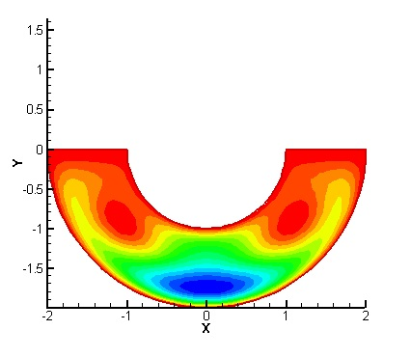
- Reference:
- Abdolreza Moghadassi, Ehsan Ghomi, Fahime Parvizian. A numerical study of water based Al₂O₃ and Al₂O₃–Cu hybrid nanofluid effect on forced convective heat transfer. International Journal of Thermal Sciences Volume 92, June 2015, P. 50-57.
- Minea Alina Adriana. Hybrid nanofluids based on Al₂O₃, TiO₂ and SiO₂: Numerical evaluation of different approaches. International Journal of Heat and Mass Transfer Volume 104, 2017, P. 852–860.
- Ilhem Zeghbid, Rachid Bessaih. Etude numérique de la convection mixte laminaire dans une cavité carrée remplie de nanofluides. Congres de l'association française de thermique, 2014.
- Houda Baghli, Abdelkhalek Cheddadi. Numerical study of the Natural convection between two isothermal concentric spheres. 4th International congress of Thermal Moroccan Association AMT, April 2016.
- Maouassi Ammar. Intensification des échanges de chaleur par l'utilisation des nanofluides. Thèse de Magister, Université de Boumerdes, 2012.

- Biography:
Houda Baghli is an Assistant Professor at the Faculty of Science, University M'hamed Bougara of Boumerdes, she has completed his Polytechnic Engineer degree at the age of 21 years from Polytechnic school of Algiers, Algeria, on Chemical engineering, and a Magister in Chemical Engineering on simulation Industrial Processes at the University of Abdelhamid BenBadis Mostaganem, Algeria. She has founded a mini-company for three years, and then completed a Doctorate of Science in chemical engineering, as charged of research in the laboratory LAMOSI of modeling and simulation in industrial process at the University of Science and Technology Oran, Algeria.
She has over 20 years of experience in multidisciplinary science, Teaching and research. She is passionate to shear her experience in both scientific and coaching fields with young scientist and young entrepreneurs to help them reach their full potential and to be successful.
Certified Trainer in Human Development, Master Coach and International Certificate of NLP Practitioner, from the Association for NLP / USA, she is the Training manager at the Entrepreneurship House at the University of M'hamed Bougara Boumerdes, Algeria. She achieved many workshops and conferences, as a trainer and a speaker in exquisite communication, Brainstorming, creativity attitude, self-confidence, and positive attitude.
Member of the Organizing Committee of several local and international conferences, International reviewer in international journals and conferences, she is a successful author of many international and National publications in Elsevier, AJAS, AIP.

Presenting author details



Full Name: Houda Baghli
Contact number: +213542108591
Twitter account: Baghli Houda
Linked In account: Baghli Houda
Session name: Green nanotechnology
Category: Oral presentation

