Title: TRANSPARENT OXIDE INCORPORATION FOR ANTI-STATIC POLYESTER FABRIC

K.A.A. Ruparathna^{1,2}, W.M. Somasiri² and R.M.G. Rajapakse^{1,2}
¹Department of Chemistry, University of Peradeniya, Peradeniya 20400, Sri Lanka
²Postgraduate Institute of Science, University of Peradeniya, Peradeniya 20400, Sri Lanka

Keywords: Antistatic Textile, Polyester fabric, Fluoride Doped Zinc Oxide, Needle-like nano wires

- Abstract

In textile industry, static electricity generation is witnessed in various high speed processes such as spinning and weaving. Anti–static fabrics are very useful particularly to industrial sector as a means of safety wear (i). Hence, synthesis of anti-static agents assimilated with other properties has become a fascinating area of research. Smart textiles with super-hydrophobicity (ii), anti-microbial activity, anti-pilling activity (iii and anti-static activity can be realized through nano technological approach. Herein, we developed a novel method to synthesize transparent F-doped ZnO (F-ZnO) nanocomposite on textile surfaces in order to introduce anti-static characteristics. In this research, blue color-dyed polyester fabrics were made antistatic by incorporating fluoride-doped zinc oxide needle-like nano-wires in them. First, the Solution-1 was prepared by mixing Zn(CH₃OO)₂ and NH₄F at molar ratio of 5:2 in (100 mL) ethanol medium. A few drops of Triton X-100 were added while stirring. 0.100 mol dm⁻³ NaOH solution was prepared separately as the Solution-2. Then 50.0×50.0 cm fabric was dipped in Solution-1 and after that it was dipped in the solution-2, respectively. Finally, the fabric was heated at 90 ºC for 25 min and dried. The modified fabric was characterized by XRF, SEM, and electrical conductivity determination by the four-probe method. EDEX measurements show the presence of C, N, O, Zn and F indicating that fluoride-doped ZnO nano-needles are present on the surface of the polyester fabric. The fabric surface has an electrical conductivity of 4.63 MΩ cm⁻¹. This is a very easy and straightforward method to attach transparent conducting oxide nano-needles on polyester surfaces and the dipping method can be easily scaled up so that large scale production of antistatic textiles is feasible.

II. Image

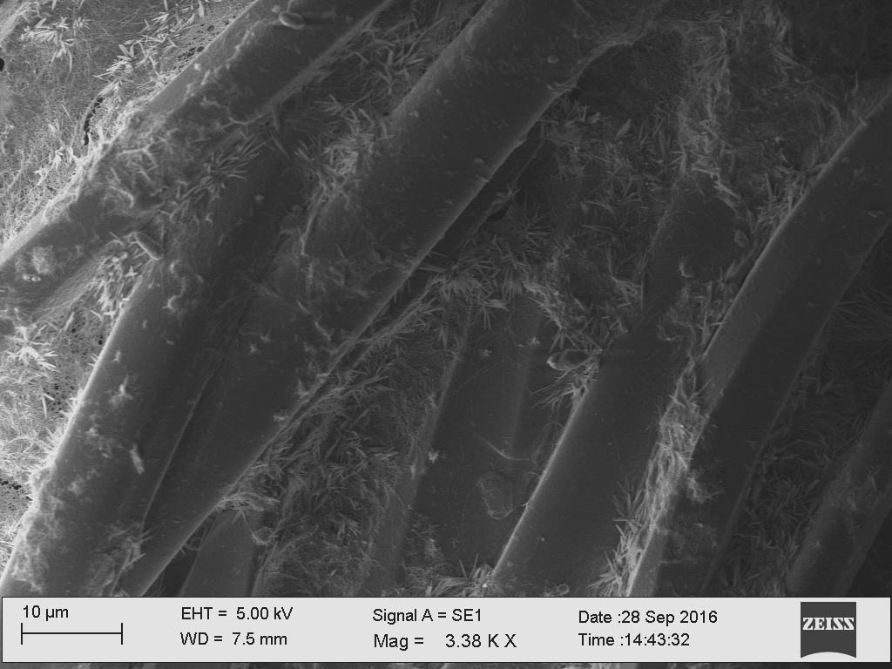

Figure; SEM image of modified polyester fabric

References:
- X. Jing, L. Wang, et al, “Synthesis, Structure, Properties and Applications of Conducting Polyaniline”, Acta Polymerica Sinia . (2005) 655-663.
- J. Drelich, E. Chibowski, D.D. Terpilowski, “Hydrophilic and super hydrophilic surfaces and materials”, Soft Matter 7(2011) 9804-9828.
- K. Thangamani, P. Kumara, “Fabric Structure for Moisture Retention Property and Its Application in Civil Engineering”, World Journal of Engineering and Technology 3

Biography: Amith Ruparathna holds a B. Sc. degree in Chemistry from University of Peradeniya, Sri Lanka and currently he is doing his M. Phil degree studies in the same postgraduate institute. He is developing various methods to prepare different antistatic fabric materials and gloves for industrial purposes using Nanoscience and nanotechnology.

III. Presenting author details



Full Name: Kande Appulage Amith Ruparathna
Contact number: ₊₉₄₇₁₁₂₉₁₁₄₄
Mail address: amithruparathna@gmail.com
Session name/ number:
Category: Oral presentation
Passport Number: N7003972

