Dissolution of nano zinc silicate at ZnO-Si interface by swift heavy ion irradiation
Sanjeev Kumar^{1,*}, Fouran Singh² and A. Kapoor¹

¹Department of Electronic Science, University of Delhi South Campus, New Delhi-110023,India.

²Material Science Group, Inter University Accelerator Centre, New Delhi -110067, India.

Abstract
Nanocrystalline zinc oxide (nc-ZnO) thin films on silicon substrate were deposited by sol-gel processes by spin coating technique. As-deposited films were annealed at 900 ⁰C for improving the crystalline quality of the films. The crystalline quality improves significantly, but there was formation of zinc-silicate phase at the ZnO-Si interface. Therefore, these films were irradiated using the 120 MeV Au ion beam with three different fluences of 5 × 10¹² ions/cm², 1 × 10¹³ ions/cm² and 3 × 10¹³ ions/cm². Grazing incidence X-ray diffraction (GIXRD) data reveal that the relative intensity of the (002) diffraction peak initially increases with the increasing ion fluence. FTIR spectra show a strong absorption band at 410 cm⁻¹ and other mode at around 605 cm⁻¹ corresponds to stretching vibrations of silicon. But the peak of zinc silicate and vibration mode Si-O-Zn having disappears and after the irradiation. Therefore, we can say that XRD and FTIR results show that the thin layer of this unwanted phase can be dissolved by 120 MeV Au ion irradiations. The dissolution mechanisms are understood in framework of bond breaking and diffusion processes.
Keywords: Zinc oxide (nc-ZnO) thin films, Zinc silicate, ZnO-Si interface, Swift heavy ion
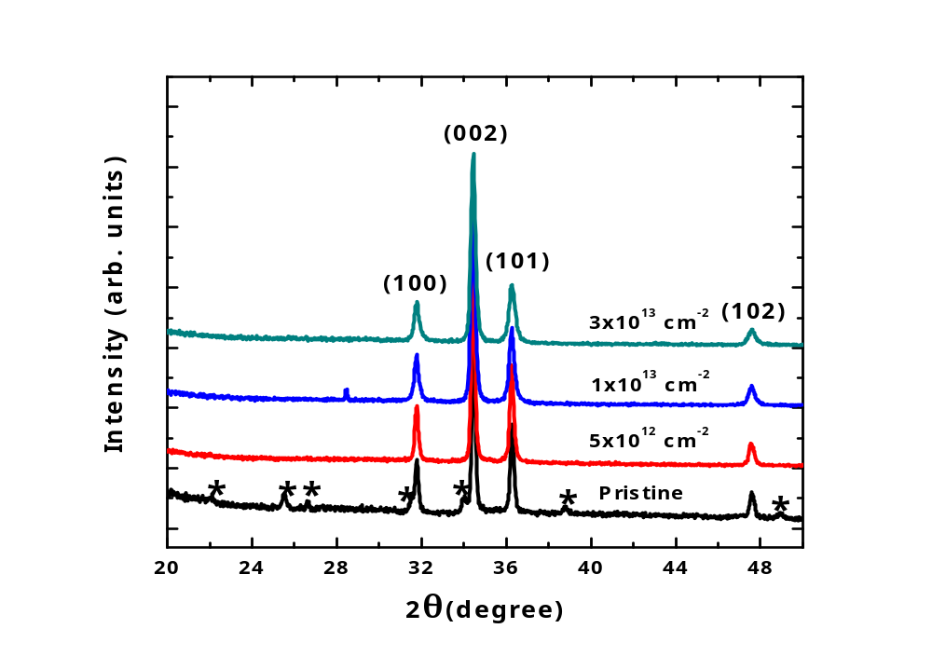
Fig-1 Glancing angle X-ray diffraction of ZnO–Si films at different ion fluence.
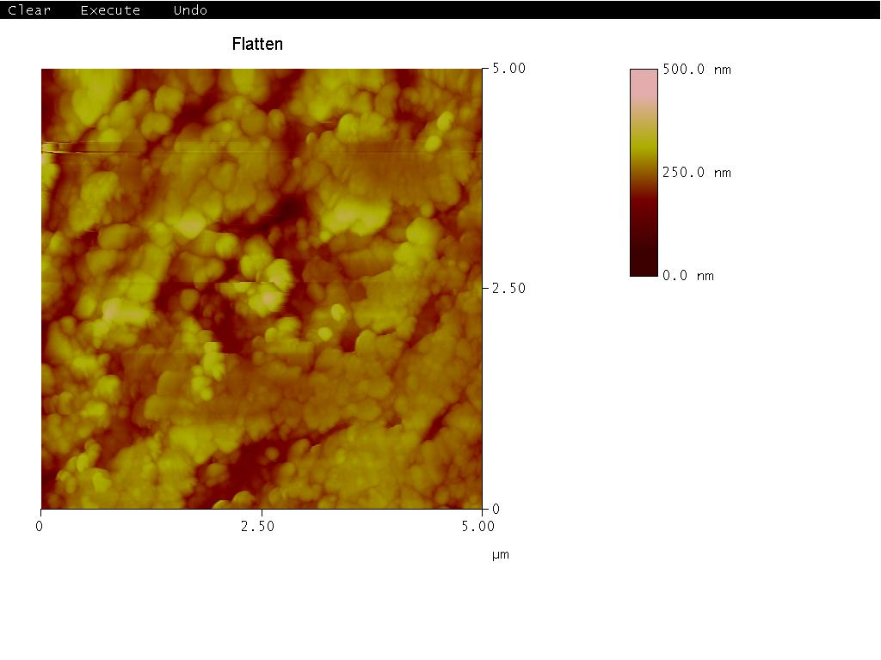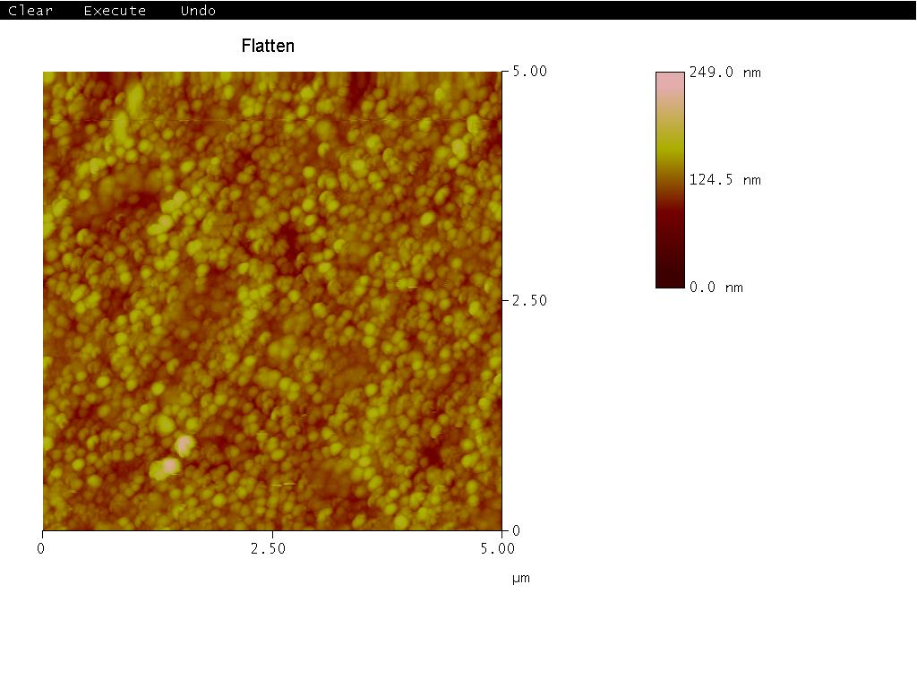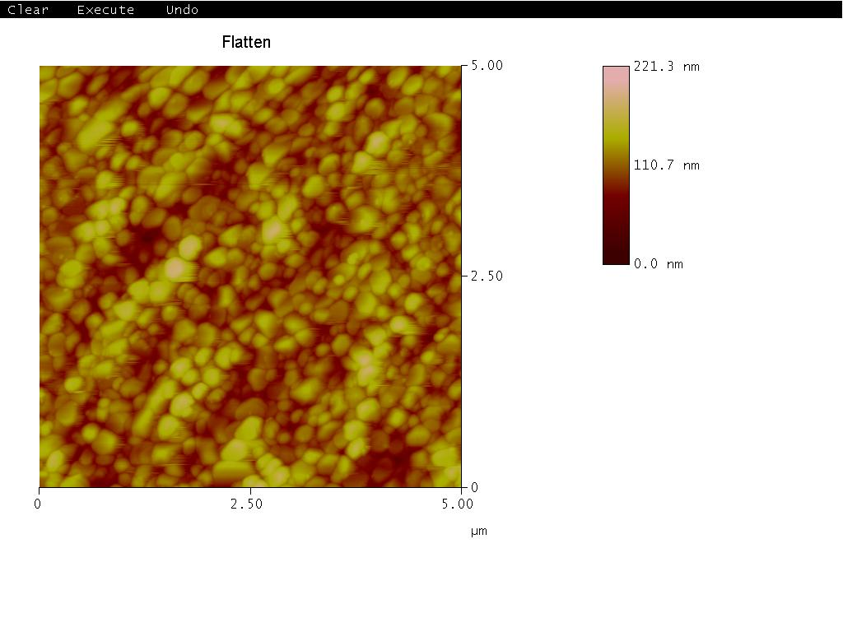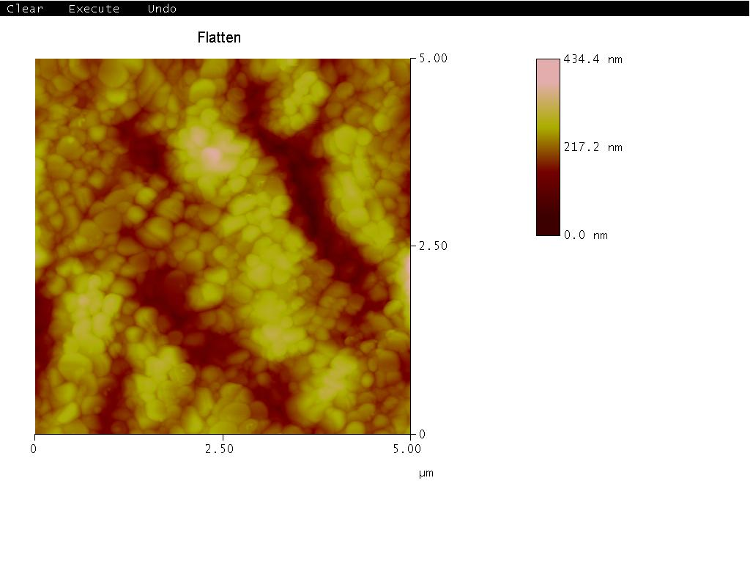
Pristine
1x10¹³ cm⁻²
3x10¹³ cm⁻²
5x10¹² cm⁻²
Fig-2 Atomic Force Microscopy studies of pristine and irradiated by 120 MeV ¹⁰⁷Ag⁹⁺ ions ZnO thin film.

