Breaking the bounds of imaging in micro-endoscopy, label-free nanoscopy and ophthalmology
Zeev Zalevsky, PhD
Faculty of Engineering, Bar Ilan Univ., Ramat-Gan, Israel

Abstract (300 word limit)
Imaging systems as well as human vision system have limited capability for separation of spatial features and this information can also be extracted only from depth limited range. The reasons to the resolution and depth of focus limitations are related to the effect of diffraction i.e. the finite dimensions of the imaging optics as well as the geometry of the sensor.
In this talk I will present novel photonic approaches and means to exceed the above-mentioned resolution and depth of focus limitations and show how those concepts can be adapted to micro endoscopy as well as to microscopy related configurations as well as embedded into ophthalmic device while aiming to correct visual deficiencies.
In the case of micro-endoscopy, I will show how projection of wavelength dependent codes can enhance the resolution of the collected light. This concept of wavelength multiplexing super resolved imaging will also be demonstrated for imaging through biological scattering medium such as biological tissues and liquids as blood [1]. The projected wavelength dependent high-resolution encoding patterns are sent via laser-based illumination fiber while the collected light is collected via ultra-thin multi-core imaging fiber-based endoscope. Another approach to be discussed will include the projection of time dependent high-resolution codes coming from a multi-mode fiber while the result is high resolution imaging in ultra-thin endoscopic multi-core and lens-less imaging fiber.
Then, in the case of microscopy I will present how the resolution limit can go much below sub-wavelength bound towards nanoscopic imaging while using label-free configurations involving time multiplexing (time dependent light collection) based upon label-free non-static metallic nano-particles either moving in uncontrolled Brownian motion [2,3] or being manipulated with light [4].
The last part of the talk will be related to extending the depth of focus of imaging systems in all-optical manner while introducing “interference” effect based extended depth of focal imaging (rather than diffraction and refraction based) [5,6]. The proposed extended depth of focus approaches will be implemented in ophthalmic usage on top of conventional spectacles, contact lenses and intraocular lenses while aiming to simultaneously correct various visual refractive errors, such as myopia, hyperopia, presbyopia, regular/irregular astigmatism, as well as their combinations.

Image
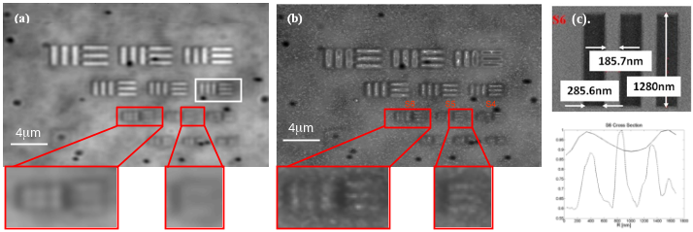
Figure 1: Nanoscopy experimental results. (a). Resolution target reference. (b). Super resolved image with the proposed nanoparticles-based approach. (c). Cross section of the reconstructed S6 group from the imaged resolution target.
Recent Publications (minimum 5)
- A. Shahmoon, S. Aharon, O. Kruchik, M. Hohmann, H. Slovin, A. Douplik and Z. Zalevsky, “In vivo minimally invasive interstitial multi-functional microendoscopy," Sci. Rep. 3: 1805, Nature Publishing Group (2013).
- A. Gur, D. Fixler, V. Micó, J. Garcia and Z. Zalevsky, “Linear optics based nanoscopy,” Opt. Exp. 18, 22222-22231 (2010).
- T. Ilovitsh, Y. Danan, A. Ilovitsh, A. Meiri, R. Meir and Z. Zalevsky, “Superresolved labeling nanoscopy based on temporally flickering nanoparticles and the K-factor image deshadowing,” Biomedical Opt. Exp. 6, 1262-1272 (2015).
- O. Wagner, M. Schultz, Y. Ramon, E. Sloutskin and Z. Zalevsky, “Optical-tweezing-based linear-optics nanoscopy,” Opt. Exp. 24, 8013-8027 (2016).
- A. Zlotnik, S. Ben Yaish, O. Yehezkel, K. Lahav-Yacouel, M. Belkin and Z. Zalevsky, "Extended Depth of Focus Contact Lenses for Presbyopia," Opt. Lett. 34, 2219-2221 (2009).
- Z. Zalevsky, J. Azugi, O. Limon and A. Rudnitsky, “Lens surface roughening for tears invariant contact lens performance,” Opt. Commun. 315, 168-175 (2014).

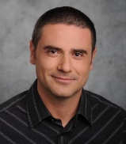 Biography (150 word limit)
Zeev Zalevsky received his B.Sc. and direct Ph.D. degrees in electrical engineering from Tel-Aviv University in 1993 and 1996 respectively. Zeev is currently a full Professor and the Dean of the faculty of engineering in Bar-Ilan University, Israel. His major fields of research are optical super resolution, biomedical optics, nano-photonics and fiber-based processing and sensing architectures. Zeev has published more than 510 peer review papers, 330 proceeding papers, 9 books (6 authored and 3 as an editor), 30 book chapters and about 100 patents. Zeev gave 600 conference presentations with more than 200 invited/keynote or plenary talks. Zeev is a fellow of many large scientific societies such as SPIE, OSA, IEEE, EOS, IOP, IET, IS&T and more. He is also a fellow of the American National Academy of Inventors (NAI). For his work he received many national and international prizes
Email: zeev.zalevsky@biu.ac.il

Notes/Comments:

