Title: Piezoelectric and ferroelectric effects on photonics and electronics in composites and 2D nanomaterials by interface engineering

Jianhua Hao1, 2,
1Department of Applied Physics, The Hong Kong Polytechnic University, Hong Kong, P.R. China
2The Hong Kong Polytechnic University Shenzhen Research Institute, Shenzhen, P.R. China

Keywords: piezoelectric response, ferroelectricity, photonic device, luminescence, electronic sensor

- Abstract Body (up to 250 words)
Piezoelectric materials have shown great potential use for coupling with and control of photonic characteristics of various materials, leading to fertile areas of research in optoelectronic devices, energy devices and sensors. On the other hand, rapid advances in ferroelectric thin-film growth allow for advanced electronics applications of ferroelectrics, including smart sensors, nonvolatile memories, tunnel junctions, field-effect transistors (FET) and tunable microwave devices. Here, I will introduce the tuning strategies of optical process from piezoelectric materials and their heterostructures based on piezoelectric effect. In our works, various composite films and laminates have been prepared, which can sense or harvest broad mechanical energy. Furthermore, the ultimate goal of making atomically thin photonic and optoelectronic devices greatly stimulates the research two-dimensional (2D) materials. It is noticeable that pulsed laser deposition (PLD) previously used for growing oxide thin-films and heterostructures has recently appeared to be applicable for growing 2D layered material based heterostructures. Our works imply that active ion-doped 2D material can play important roles as a platform for fundamental studies and potential applications in nanophotonics and electronics field. Through these works, great potential application can be perceived, which will give rise to unprecedented atomically thin device tecchnologies towards adaptive optoelectronics, active human-machine smart sensors and flexible nanogenerators. The research is supported by the grant Research Grants Council of Hong Kong (GRF No. PolyU 153025/19P) and National Natural Science Foundation of China (NSFC No.51972279).

Image:
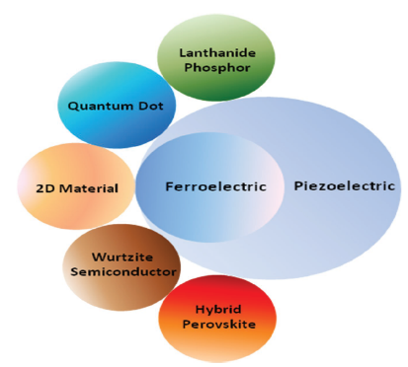
- Reference:

1 Y. Zhang, W. Jie, P. Chen, W. Liu, and J. Hao, Adv. Mater. (Invited Review), 30, 1707007 (2018).

- M.-C. Wong, L. Chen, M.-K. Tsang, Y. Zhang, and J. Hao, Adv. Mater. 27, 4488 (2015).

- G. Bai, S. Yuan, Y. Zhao, Z. Yang, S. Y. Choi, Y. Chai, S. F. Yu, S. P. Lau, and J. Hao, Adv. Mater., 28, 7472 (2016).

- S. Yuan, X. Luo, H. L. Chan, C. Xiao, Y. Dai, M. Xie, and J. Hao, Nat. Commun., 10, 1775 (2019).

Biography:
Jianhua Hao is currently a Full Professor in the Hong Kong Polytechnic University (PolyU). Prof. Hao obtained his B.Sc., M.Sc., and Ph.D. degrees at Huazhong University of Science and Technology (HUST). After working at HUST, Penn State, University of Guelph, and University of Hong Kong, he joined the faculty in PolyU. He has published around 280 international journal papers. He serves as Associate Editor of InfoMat (Wiley) and EBM of Adv. Opt. Mater. (Wiley). He is a Fellow of several international societies (FOSA, FRSC, FInstP). (Hao research group website: http://ap.polyu.edu.hk/apjhhao/).

Presenting author details
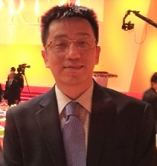
Full Name:Jianhua Hao
Category: Plenary Speaker

