Title: Study of properly activated neutral plasma by a method predicted in BSM-SG unified theory and its association to the natural lightning phenomena

Stoyan Sarg Sargoytchev
York University, Toronto, Canada (retired)

Keywords: BSM-SG atomic models, physical vacuum, plasma research, lightning

- Abstract
A method called the Heterodyne Resonance Mechanism (HRM) predicted in BSM-SG unified theory [1] is studied in neutral plasma. It permits a deeper understanding of the Rydberg state of the atoms, regarded as ion-electron pairs and the Rydberg matter as clusters of such pairs. They exhibit specific oscillations that have a detectable magnetic field and a measurable spectral signature in the MHz frequency range. A properly activated neutral plasma generates a well-defined spectral signature of the HRM effect with identified spectral bands and high signal to noise ratio. The HRM spectra are completely different from the atomic, molecular, and ionic spectra [2]. The analysis based on the BSM-SG models leads to the conclusion that the electrons in the clusters of ion-electron pairs interact with the physical vacuum via the anomalous magnetic moment and spin the flipping of the electron. This takes place in a short transient process. Investigating the observations from natural lightning phenomena it is found that a similar process takes place in them and especially in the thunderstorms between clouds and ground. The conclusion is that the enormous energy released in the thunderstorm is from a similar transient process but in a large volume. [3,4]. Based on this conclusion a laboratory experiment was built permitting simulating a mini-lightning with a possibility for estimating the input and output energy. A study of the effect with noble gases in closed volume leads to the conclusion for existence of a process of plasma expansion that is not explainable by classical thermodynamics.

HRM effect in a neutral plasma

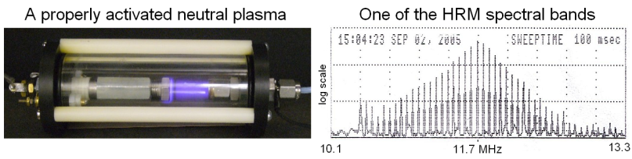
- Reference:

- Stoyan Sarg, Basic Structures of Matter –Supergravitation Unified Theory, 2006, ISBN 1412083877 (books review in "Physics in Canada,", 62, No. 4, July/Aug, 2006).
- Stoyan Sarg, Analysis of the HRM Spectra in Plasma Glow Discharge, viXra:1903.0523 2019-03-28.

- Stoyan Sarg, Analysis of Natural Lightning Phenomena and Method for Laboratory Study viXra:1911.0207 2019-11-17.

- Stoyan Sarg, Hidden Space Energy. The Heterodyne resonance Mechanism: Theory and experiments (2020)
ISBN 9798604920800

Biography:
Stoyan Sargoytchev completed his Ph.D. in Physics at Bulgarian Academy of Sciences in 1984 and Postdoctoral Study as an invited scientist in a Lidar project at the Arecibo Observatory, PR. He was involved in space research programs, by the former Soviet Union, European Space Agency and Canadian Space Agency. From 1991 he worked as a scientist in Canadian government institutions and universities. He retires from York University in 2012 and currently is a distinguished scientific advisor at the World Institute for Scientific Exploration. He has over 90 publications in three languages and four books related to his treatise BSM-SG.

Presenting author details
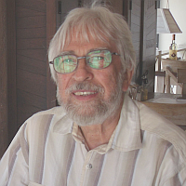

Stoyan Sarg Sargoytchev

Twitter: SARG_BSM
LinkedIn: sto.sarg@gmail.com
Session name/ number:
Category: (Webinar presentation)

