Abstract Template

Title: The Femtoscope shows us that cancer and coronavirus are diseases correlated with the atomic nucleus

Edward H. Jimenez Calderon1, Esteban Jimenez Chacon2,
1Chemical Engineering Faculty, Central University. Gatto Sobral S/N y Bolivia Quito-Ecuador. ehjimenez@uce.edu.ec
2DQPRM (Paris-Saclay), France. Jimenezchacon.edwardesteban@iuct-oncopole.fr.

Keywords: Femtoscope, X-ray low energy, Navier Stokes equations, Coronavirus, Cancer.

- Abstract Body (up to 250 words)
The Femtoscope is a reality and it allows us to measure quantum elements with dimensions of 10-15 m, it seems to be something unimportant but it has enabled us to understand that cancer and coronavirus are diseases that involve the atomic nucleus and have resonance on the nuclear surface, when they are irradiated with low energy x-rays. Breast and prostate cancer are cured early with 99% efficiency, because they are treated with low energy, therefore it can be concluded that: KeV X-rays Cure Cancer While MeV X-rays Only Burn the Cells. DNA and RNA are strategically made up of phosphorous atoms that have X-ray resonance of [2152, 742-0,319, 2152,742 + 0.319] eV. Coronaviruses that are fragments of RNA, being also structured by phosphorous, resonate with the photons of these energies; causing the disintegration of coronaviruses and curing pneumonia. That is, there is a correlation of DNA with the atomic nucleus through the resonance of phosphorus.
On the other hand, the Femtoscope was calibrated with the generalized Rydberg constant (1.0973731568539) 10⁷, allowing us to measure the dimensions of the nucleons, the structure of the nuclear surface and fundamentally verify that the atomic nucleus is an incompressible fluid that complies with the equations from Navier Stokes 3D. Finally, we measured the radii of protons, neutrons, and electrons with accuracies comparable to those of elite research centers. In the case of the proton, we obtained 0.8391 fm, while the Max Plank Institute has recorded 0.8335 fm.

Image:

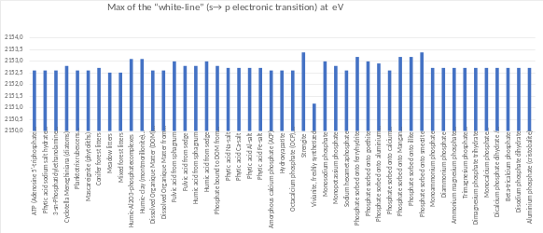

- Reference:

- Edward J. Calabrese, PhD*, and Gaurav Dhawan, MPH. How radiotherapy Was Historically used to treat Pneumonia: could it Be useful today?. YALE JOURNAL OF BIOLOGY AND MEDICINE 86 (2013), pp.555-570.
- Jiménez, E.; Recalde, N.; Chacón, E.J. Extraction of the Proton and Electron Radii from Characteristic Atomic Lines and Entropy Principles. Entropy 2017, 19: 293.60
- Jimenez, E.J. Algorithms of the Femtoscope: KeV X-Rays Cure Cancer While MeV X-Rays Only Burn the Cells. American Journal of Computational Mathematics, 2018, 8, 1-17.

Biography:
Edward Jimenez Calderon, studied Physics and Artificial Intelligence at the National Polytechnic School of Ecuador, his Master's and PhD in Applied Mathematics, He did in Lyon, France. He has worked for more than 20 years in low energy x-ray applications in catalysis and in cancer radiotherapy. He has more than 15 scientific articles with referees, five regional impact books and is a co-participant in scientific patents. He is founder and president of the Bioil Tech Company. Cia. Ltda.

Presenting author details

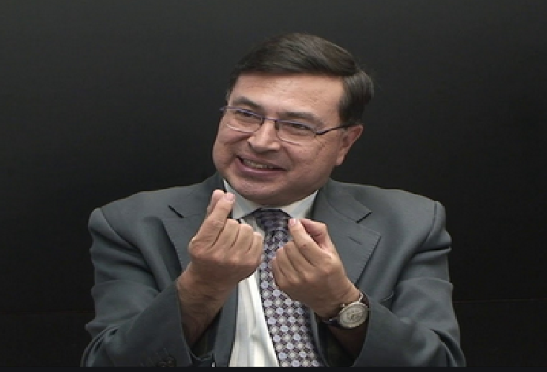

Full Name: Edward Henry Jimenez Calderon
Contact number: +1 593 994643752
Session name/ number:
Category: ( Poster presentation)
Passport Number: 1708042732

