Abstract Template

Title: Nanoparticles and wastewater treatment

NARESH K SHARMA1
1Department of Biotechnology, Kalasalingam Academy of Research and Education, Tamil nadu 626126, India

Keywords: Nanoparticles, Photocatalysis, Wastewater treatment, Bioremediation, Combined treatment

- Abstract Body
Engineered nanoparticles (ENPs) have been intensively studied within the past decade for use in environmental purifications, effluent treatment, energy storage/ conversion, antimicrobial coating agents and so on. Photocatalysis and anti-bacterial effects were tested with doped metallic nanoparticles such as TiO₂, ZnO, Ag TiO₂, Ag ZnO among many others. Phenolic and poly aromatic hydrocarbons commonly present in several industrial effluents were also tested for degradation using TiO₂ nanoparticles. It was found that silver nanoparticles had profound effect on both gram positive and gram negative bacteria due to the generation of highly reactive oxygen species which causes irreversible damage to the cell walls of microbes. From the photocatalysis experiments, TiO₂ nanoparticles could effectively oxidize several aromatic hydrocarbons in span of 250 minutes when the pollutants where present in mixed conditions each with 25 mg/L of initial concentration. Experiments were also conducted with real coke oven wastewater to check the treatment efficiency using nanoparticles. Coke oven wastewater is one of the toxic wastewater containing several hazardous pollutants including cyanide and xylenol. Preliminary studies show that nanoparticles were effective in degrading these toxic pollutants only after biological treatment. Direct exposure of nanoparticles to pollutants blocks several active sites thus suppressing the generation of reactive oxygen species. These studies indicate the potential of utilizing nanoparticles for wastewater treatment in combination with micro-organisms.

Image:

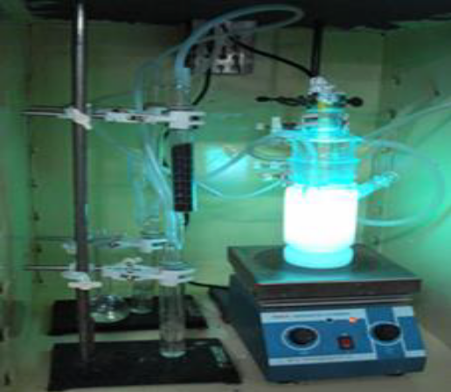

- Reference:

1 Naresh K Sharma and Ligy P, 2016. Combined biological and photocatalytic treatment of real coke oven wastewater. Chem. Engg. J., 295; 20-28

- M Swaminathan, NK Sharma, 2019. Antimicrobial activity of the engineered nanoparticles used as coating agents. Handbook of Ecomaterials, Springer: 549-563

- Karthika A, Swaminathan M and Naresh K Sharma 2020. Photocatalysis for waste wáter treatment with special emphasis on plastic degradation. Handbook of Nanomaterials and Nanocomposites for Energy and Environmental Applications, Springer: (Accepted for publication)

Biography:
Naresh Kumar Sharma has completed his PhD at the age of 29 years from Indian Institute of Technology, Madras, India. He is the Deputy Director of Centre for Water Technology at Kalasalingam Academy of Research and Education, India, a premier higher education and research institution. He has published more than 10 papers in reputed journals and received projects worth 35,000 USD from Department of Science and Technology, India and non-government agencies for wastewater treatment.

Presenting author details

- 
Full Name: Naresh Kumar Sharma
Contact number: +91-9943932035
Linked In account: www.linkedin.com/in/naresh-sharma-333498140
Session name/ number: -
Category: (Oral presentation)
Passport Number:J8524426

