Abstract Template

Title: Nanotechnology innovations for diagnostics

Kimberly Hamad-Schifferli1
1Department of Engineering, School for the Environment, University of Massachusetts Boston, Boston MA USA

Keywords: nanoparticles, paper-based immunoassays, rapid diagnostics

- Abstract Body (up to 250 words)
Diagnostics are important for a broad range of fields including infectious disease, health, food safety, and many other applications. These can provide a yes/no answer on the food we are about to eat is contaminated, or whether we are infected with a virus vs. a bacteria. Paper tests in the same format as pregnancy test possess many ideal characteristics, in that they are low cost, can be mass produced, and operated point of care by non-experts.¹ We discuss how different diagnostics work and their respective advantages and disadvantages. In particular, nanotechnology has enabled many innovations in point of care tests. The unique size and material dependent properties of nanoparticles can enhance sensitivity, enable multiplexing, and impart new capabilities to diagnostics. We will discuss some of these innovations that we have been developing in the lab for infectious disease and also the relevance of diagnostics for the ongoing COVID-19 outbreak.^{2,3}

Image:
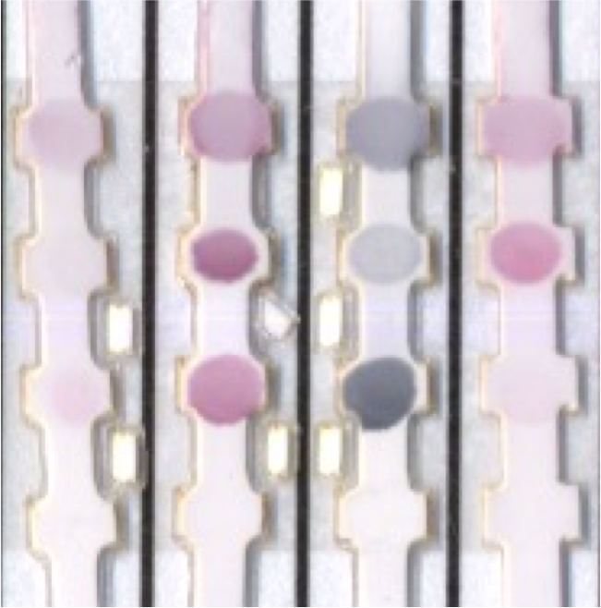
- Reference:

1. D. R. Hristov, C. Rodriguez-Quijada, J. Gomez-Marquez, K. Hamad-Schifferli, 2019. Designing Paper-Based Immunoassays for Biomedical Applications, Sensors, 19: 554.

- C. Yen, H. de Puig, J. O. Tam, J. Gómez-Márquez, I. Bosch, K. Hamad-Schifferli, L. Gehrke, 2015. Multicolored Silver Nanoparticles for Multiplexed Disease Diagnostics: Distinguishing Dengue, Yellow Fever, and Ebola Viruses. Lab on A Chip, 15: 1638-1641.

- C. Rodriguez-Quijada, J. Gomez-Marquez, K. Hamad-Schifferli, 2020. Repurposing old antibodies for new diseases by exploiting cross reactivity and multicolored nanoparticles. bioRXiv, .03.17.995738.

Biography:
Kimberly Hamad-Schifferli is an Associate Professor in the Department of Engineering and the School for the Environment at University of Massachusetts Boston. She obtained her S.B. in Chemistry from MIT in 1994 and Ph.D. in Chemistry from the University of California at Berkeley in 2000. She was a faculty member at MIT in the Department of Mechanical Engineering and the Department of Biological Engineering as a faculty member from 2002-2012. From 2012-2015 she was at MIT Lincoln Laboratory in the Bioengineering Systems and Technologies Group. She has received an ONR Young Investigator Award, was a Foresight Institute Fellow in 2017.

Presenting author details

Full Name: Kimberly Hamad-Schifferli
Twitter account: @KHamadLab Linked In account:
Session name/ number:
Category: Oral presentation
Passport Number:

