Сarboxymethylcellulose film-implant contained silver nanoparticles for the treatment of burns

Kh.E. Yunusov¹, A.A. Sarymsakov¹, A.J. Fayazov², J.Z. Jalilov¹, F.M. Turakulov¹, U.R. Kamilov²,
S.Sh. Rashidova¹

¹Institute of Polymer Chemistry and Physics, Academy of Sciences of the Republic of Uzbekistan, 100128, Tashkent, St. Abdulla Kadyri 7 ^{“b”}. E-mail: polymer@academy.uz; haydar-yunusov@rambler.ru

²Republican Research Center of Emergency Care The Ministry of Health of the Republic of Uzbekistan (RRCEC), Tashkent, st. Farhad, 2.

³Institute of Polymer Chemistry and Physics, Academy of Sciences of the Republic of Uzbekistan, 100128, Tashkent, St. Abdulla Kadyri 7 ^{“b”}.

Keywords: Rice lines, Salt stress, Microsatellite (SSR) marker, Protein analysis, Gene expression

- Abstract Body
Silver nanoparticles inhibit the activity of the enzyme providing oxygen exchange in protozoa, such as pathogenic bacteria, viruses, and fungi (about 700 species of pathogenic flora and fauna) [1]. The transition from the ionic Ag⁺ form to metallic nanoclusters makes it possible to reduce silver’s toxicity to cells of higher organisms without suppression of the antimicrobial activity against pathogenic microflora. Silver nanoparticles, especially stabilized ones, have greater stability and prolonged action [2]. Sodium-carboxymethylcellulose (Na-CMC) - a water - soluble film forming biodegradable polymer widely used in the production of oral pharmaceuticals and drugs for external use primarily to increase the viscosities of ointments, in the production of pastes as hydrogel bases, and in the production of drugs for parenteral use - is of high interest as a stabilizer of silver nanoparticles. In addition, Na-CMC is utilized as a binding and disintegrating agent in the production of tablets. Na-CMC is one of the key components of adhesive absorbing systems employed to treat problematic wounds, to remove extravasates, sweat, and the contents of wounds, and to regulate the kinetics of release of active substances of systems contacting mucous membranes.
The aim of this study is to prepare stabilized silver nanoparticles in polymer films based on Na-CMC and to investigate their structures, physical and chemical properties, and microbicidal activities. Industrial samples of Na-CMC with degrees of substitution of 0.65-0.85 and degrees of polymerization of 200-600 obtained from cotton cellulose were used as polymer matrices after their purification from inorganic and organic admixtures. To prepare silver nanoparticles in the films based on CMC, AgNO₃ aqueous solutions of various concentrations were utilized. The bacterium Staphylococcus epidermidis and the yeast fungus Candida albicans - pathogens of humans and animals-were used as test cultures.
To form the films, 2-4% aqueous solutions of purified Na-CMC samples with various degrees of substitution and polymerization were employed after the removal of the gel fraction via centrifugation with a laboratory centrifuge at 2500 rpm for 20 min. Then, calculated amounts of 0.1-0.001 M aqueous solutions of AgNO₃ and 0.1-0.5% glycerol, which played the role of a plasticizer, were added under stirring to the gel free Na-CMC solutions, and the stirring was continued until homogeneous Ag⁺CMC– hydrogels formed.
The photochemical reduction of silver ions in the Ag⁺CMC– structure to nanoparticles was performed at 25°С through their irradiation with a DB-250 high pressure mercury lamp. The dispersions of silver nanoparticles were prepared via ultrasonic dispersion of the hydrogels with the use of UZDN-1 and U-4.2 ultrasonic dispersers.
With increasing DS, quota of soluble Na-CMC fraction in water was increased, and content of insoluble gel fraction decreased. With increasing DS, quota of gel fraction of Na-CMC, in water decreases. This can be explained by the fact that by increasing the DS, of Na-CMC, intensity of hydrogen bonds between the macromolecules Na-CMC decreases. Moreover, the compounds and properties of the gel fraction Na-CMC, depend on the type of cellulose row material and methods obtaining of Na-CMC.
It was found that the Na-CMC samples of cotton pulp, in all intervals DP and DS, the content of gel fraction is more than of the sample Na-CMC obtained from wood cellulose. This is explained by the different morphological structures of cotton and wood cellulose, and lower reactivity of cotton cellulose, subjected to carboxymethylation reaction. The above-described investigation provided as polymeric base for the obtaining hydrogel Na-CMC containing ions and silver nanoparticles. Further studies were investigations on the formation and stabilization of silver ions and nanoparticles in Na-CMC polymer base and studied their properties.
At the first step of the study, the films were prepared from aqueous solutions of a-CMC with various degrees of substitution and polymerization and their physical and mechanical parameters were examined. The films were applied onto glass plates from a 2% aqueous solution of Na-CMC. The Na-CMC film formed during water removal.
In the next step of the study, Na-CMC films stabilized with silver nanoparticles were formed and then photoirradiated. Photoreduction of silver cations at concentrations of 0.025-2.50 wt % was performed in a 2% solution of Na-CMC with a degree of substitution of 0.85 (pH 8.5) and a degree of polymerization of 600.
After an increase in the initial concentration of AgNO₃ from 0.025 to 2.5 wt %, the UV - induced color of the Na-CMC solution was found to change from pale yellow to brown. Such a change is likely due to the increase in the amount of formed silver nanoparticles of different sizes. Meanwhile, a pure Na-CMC solution did not change color and remained clear after UV-irradiation.
To confirm the formation of silver nanoparticles, electron microscopic investigations of CMC films were performed. Figure 1 shows the electron micrographs of Na-CMC films formed under UV - irradiation that contain 0.025-2.5 wt % silver nitrate.
For the purpose of determination of the forms and sizes of silver nanoparticles in structure Na-CMC were investigate of obtained samples by atomic fors microscope tipe АFМ - 5500 (Austria).
From Fig. 1a, it may be concluded that, during photoirradiation at a AgNO₃ concentration of 0.025 wt % AgNO₃, clusters and nanoparticles of silver with sizes 2-30 nm are formed in the structures of the films of Na-CMC. After the addition of 0.25 wt. % AgNO₃, 5 to 35 nm spherical silver nanoparticles are formed in the structures of the Na-CMC films (Fig. 1b).
An increase in the silver nitrate concentration in the Na-CMC structure up to 2.5 wt % induces an increase in the number of 5 to 35 nm silver nanoparticles, and rod shaped silver nanoparticles 50-140 nm [3] in length and 15-45 nm in width are formed simultaneously (Fig. 1c). Thus, an increase in the silver ion content in the Na-CMC films leads to a relatively narrow size distribution of the spherical and rod shaped silver nanoparticles formed during photoirradiation.

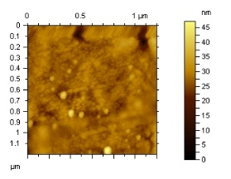 | 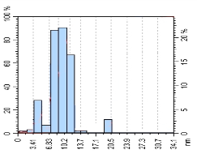
а
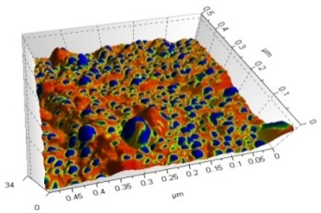 | 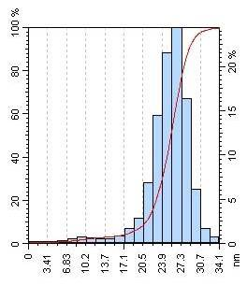
b
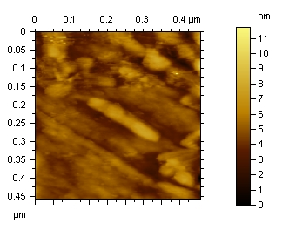 | 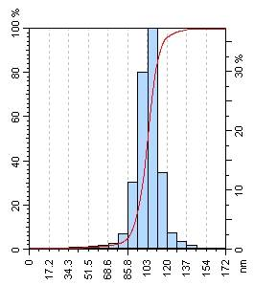
c
Fig. 1. AFM microphotograph of gel Na-CMC contained SNP (a), (b), (c) and their histograms
Concentration of [Na-CMC] = 8 ∙ 10⁻³ mol; Time of UV - irradiations 30 min. Na-CMC films containing (a) 0.025, (b) 0.25, and (c) 2.5 wt % AgNO₃

The microbicidal activities of the samples of Na-CMC films containing silver cations and nanoparticles were examined with the use of the opportunistic test cultures Staphylococcus epidermidis and Candida albicans. To identify an antimicrobial effect, the samples of the composites were placed into test tubes containing a thioglycolic medium in the case of Staphylococcus epidermidis or Saburo in the case of Candida albicans.
Microbiological examinations showed that all the samples manifested antimicrobial activities of varying degrees against opportunistic pathogens of humans.
Experiments results has shown that the Na-CMC film containing 5-35 nm silver nanoparticles completely inhibits the growth of Staphylococcus epidermidis and Candida albicans and, thus, is the most active film. The samples of Na-CMC films containing relatively large (50-140 nm long and 15-45 nm wide) rod shaped nanoparticles are less active than the 5 to 35 nm spherical nanoparticles. This circumstance may be explained by their small surface areas [4].
In addition, Na-CMC films containing Ag clusters proved to be less active then those containing 5-35 nm silver nanoparticles. This result may be explained by the fact that the total content of silver nanoparticles in such Na-CMC films turned out to be almost an order of magnitude less than that in the samples of films containing 5-35 nm silver nanoparticles. Because the concentration of silver ions in the Na-CMC hydrogels utilized for the film formation was low (0.023%), they almost completely associated with carboxylate anions of Na-CMC. It is this limited mobility of ions that is responsible for the lower rate of silver nanoparticle formation that seems to occur only in a “nanoreactor” structure [5].
Determined, optimal conditions of formation of silver nanoparticles with different shapes and sizes in structure CMC film with different DS and DP.
It is established that to restoration, first of all, are subject replaced cations silver in macromolecules Na-CMC which carry out a role «nanoreactors» where the negative ion carboxylic groups under the theory of Mott-Gurney is «trap» for positively charged ions of silver and process photostimulated formations silver nanoparticles. It is developed the UV- spectroscopic method control of the form and sizes silver nanoparticles at process their restoration.
It is established that depending on concentration of polymeric substrate, ions of silver and conditions UV - irradiations in structure Na-CMC are formed with the various sizes stabilised of silver nanoparticle spherical and rod - like forms. Formation conditions of the various form and sizes of silver nanoparticles depending on parametres of reaction of interaction of components and photochemical restoration are revealed.
Correlation dependence between the size and form silver nanoparticles in structure Na-CMC and their biological activity is established. It is shown that at decreasing in the sizes the silver nanoparticles promotes increase of their bactericidal activity at their identical concentration in polymeric matrix that speaks difference of values of the area of surface nanoparticles the various form and sizes.
The prepared biodegradable Na-CMC films containing silver nanoparticles are of interest as bactericidal and bacteriostatic coatings for the treatment of burns and trophic ulcers.

Acknowledgment. This work was supported by applied project of А-FА-2019-34 “Development of a new generation of nanopolymers for the treatment of various types of burns” for 2019-2021 years Ministry of Innovative Development of the Republic of Uzbekistan.

- Reference:

- Morones J.R., Elechiguerra J.L., Camacho A., Holt K. Kouri J.B., Ramirez J.T., Yacaman M.J. // The bactericidal effect of silver nanoparticles. Nanotechnology. 2005. V. 16. P. 2346-2353.
- A.B. Shcherbakov and other. Preparations of silver yesterday, today, tomorrow// Farmaseutica journal, 2006, No. 5, pp. 45-57.
- U. Kreibig and M. Vollmer, Optical Properties of Metal Clusters (Springer, Berlin, 1995).
- Kh. E. Yunusov, A. A. Atakhanov, A. A. Sarymsakov, S. Sh. Rashidova, K. V. Lobanova, and Zh. Zh. Tashpulatov // Silver nanoparticles, formed on polymeric matrixes and their bactericidal properties. Pharmaceutical journal. Uzbekistan, 2010, No. 1, pp. 55-59.
- M. V. Kiryukhin, B. M. Sergeev, A. N. Prusov, and V. G. Sergeyev. Photochemical restoration cations of silver in polielectiritic matrix Polym. Sci., 2000. Ser. B, №6(42), pp. 1069-1073.

Biography:
Khaydar Yunusov has completed his Doctoral degree at the age of 25 years from Institute of Polymer Chemistry and Physics Uzbekistan Academy of Science, He is expert on the field of polymer chemistry, cellulose chemistry and technology, nanochemistry and nanotechnology. He is the Manager of scientific projects at the Institute of Polymer Chemistry and Physics Uzbekistan Academy of Science. He has published more than 95 papers in reputed journals.

Presenting author details


Full NName: Khaydar Yunusov
Contact number: +998903568820
e-mail: silver4727@yahoo.com
Linked In account:
Session name/ number:
Category: (Oral presentation/ Poster presentation) Passport Number:AA3300470

