Abstract

Title: Identification of universal constant for estimating TIME
By: Sahriar Ahamed,
Individual Researcher,
44, Gollamari North Bank(GNB) Kahal Road, Khulna -9100, Bangladesh.

Keywords: Time, Space, Relativity, Albert Einstein, Stephen Hawkins, Black Time Dilation, Black Hole

Abstract

Variables to determine the unitary calculation of rotational speed of the earth as TIME, is completely misleading for primary level of physical research which we know as years, months, days, hours, minutes or second. Ever since the knowledge is flourishing in this earth people used to need estimating the total span of period is passed by us. Thus they noted the measurement of the Erath rotation on its own axis and around the sun and made the rotational speed segmented in a very scientific manner. Those segments were given name such as seconds, hours, days, and month or as the year. In fact rotational speed can’t be the unit of measuring time. Neither it was in the ancient time nor even now and never will be in the future. Time has a particular truth. The fact becomes reality in 0 hour. Without giving any count, the fact become past and within no count the future begins to happen. This fact is true everywhere in this universe. Thus, Time has a universal constant. The present occurs in 0 hour.
Or the Present = 0 or
Pr=0 (Pr= Present). There is a relation between past present and future too. If we put the time diagram on a graph paper we may see that the past side always remains in the negative side and future remains in the positive side. So, we may say that the past= - (negative) and future = (+) thus if we add past and future we will get 0 or the present. So, we may say Past+future= Present.
So, its time to resolve the ancient countdown process of TIME. TIME has no measurement unit. It can’t be measured. If we don’t stop counting time, many scientist will make mistake same as Albert Einstein did in Time Dilation, or Stephen Hawkins did in his Black Hole Theory.
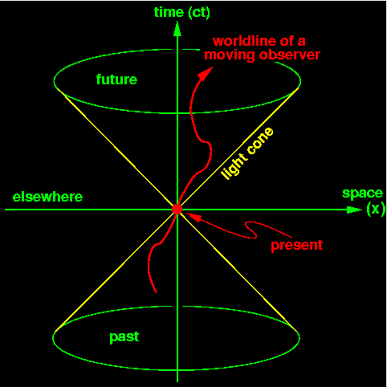

Reference:

- https://www.arcjournals.org/international-journal-of-advanced-research-in-physical-science/volume-6-issue-6/3
- https://www.arcjournals.org/international-journal-of-advanced-research-in-physical-science/volume-5-issue-6/5
- https://www.sryahwapublications.com/open-access-journal-of-physics/volume-2-issue-4/5.php
- https://www.arcjournals.org/international-journal-of-advanced-research-in-physical-science/volume-7-issue-2/

Sahriar Ahamed, is an individual researcher. And doing research by personal fund without affiliation to any institute for more than 8 years. Currently living in Khulna , Bangladesh with family and related with social service, research and education

Presenting author details

Full Name: Sahriar Ahamed
Contact number: 08801971063223 Twitter account: https://twitter.com/sahriarahamed Linked In account:
https://www.linkedin.com/in/sahriar-ahamed-b3a6234/
Session name/ number:
Category: ( Poster presentation)
Passport Number:
EE 0818912

