

Abstract

Title: Near infrared tunable hybrid metasurface based on graphene and localized surface plasmons

Edgar O. Owiti ¹ * Calvine F. Ominde² and Xiudong Sun³
¹ Machakos University, School of Pure and Applied Sciences, Department of Physical Sciences, Kenya
Email address: edgar.owiti@mksu.ac.ke
² Jomo Kenyatta University of Agriculture and Technology, College of Pure and Applied Sciences, Kenya
³ Harbin Institute of Technology, Institute of Modern Optics and Nano photonics, China

Keywords: tunable birefringence, graphene plasmons, localized surface plasmons, hybrid metasurface, quarter wave-plate

- Abstract Body (up to 250 words)
Weak graphene plasmon is a major challenge for graphene based metasurfaces in the visible and near-infrared regions. This challenge emanates due to weak coupling between the graphene plasmons and the shorter wavelengths. This work shows numerical and theoretical designs of a hybrid metasurface that can enhance coupling between incident near-infrared light, and induce birefringence in the structure. Additionally, tunable birefringence performance, exhibiting wave-plate function are demonstrated. The metasurface comprises of graphene, silver metal, and a glass substrate. The metal rods are integrated to act as resonant dipole antennas that convert the incident light into localized surface plasmons (LSP). Launching of propagating surface plasmon over the graphene surface is initiated by the LSP. Birefringence tuning is obtained through variation of the number of layers of graphene, the Fermi energy of graphene and the physical dimensions of the metasurface. The design achieves a very high polarization conversion ratio (0.95) transforming the state of incident light from a linear state to a circular state, with a near unity value of ellipticity at a wavelength of 1500 nm. The thickness of the structure is about 0.5 λ which is ultrathin and suitable for integration into photonic sensing devices.

Image:

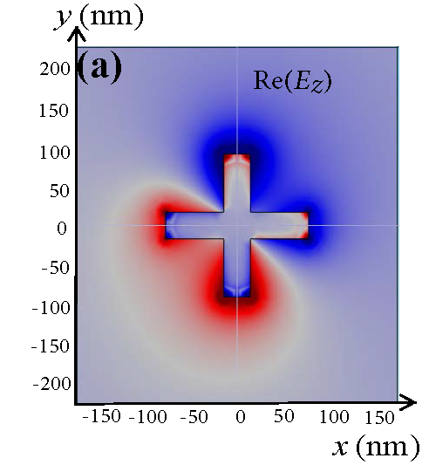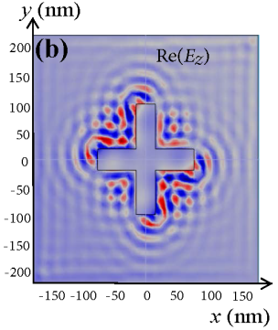

- Reference:

- Chen, M., Sun, W., Cai, J., Chang, L. and Xiao, X., 2017. Frequency-tunable mid-infrared cross polarization converters based on graphene metasurface. Plasmonics, 12(3), pp.699-705.

- Ding, F., Wang, Z., He, S., Shalaev, V.M. and Kildishev, A.V., 2015. Broadband high-efficiency half-wave plate: a supercell-based plasmonic metasurface approach. ACS nano, 9(4), pp.4111-4119.

Owiti, E., Yang, H., Ominde, C. and Sun, X., 2017. Dual-band graphene-induced plasmonic quarter-wave plate metasurface in the near infrared. Applied Physics A, 123(8), p.556.

Biography:
Edgar Owiti completed his PhD at the age of 35 years from the Harbin Institute of Technology, Harbin, China. He is currently a lecturer at the Machakos University (MksU), Kenya, and the acting Director for center for renewable energy at MksU. He has published more than 10 papers in reputed journals and has been continuing with his research in Nano-photonics since completion of his PhD.

Presenting author details



Edgar O. Owiti +254 742024 221: Twitter account: @EdgarDewitts
Session name/ number:
Category: (Oral presentation) Passport Number:A2231880


