Namrata Anand, Postdoc fellow (Panjab University),Chandigarh, India.
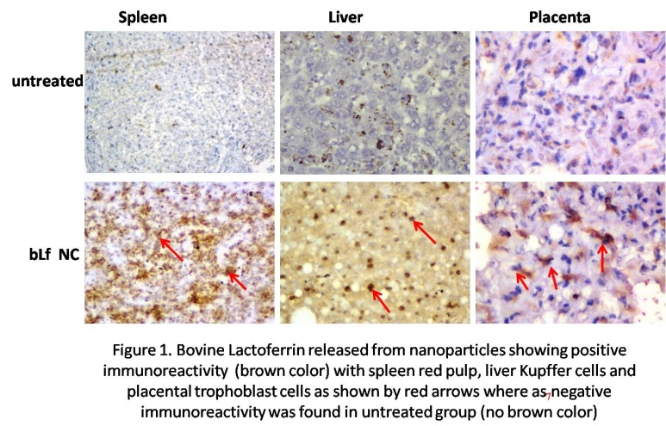
Background: Toxoplasmosis in pregnancy is a great health issue as the disease is fatal to mother as well to developing fetus. There are many drugs available for the treatment of congenital toxoplasmosis but all of them have side effects of toxicity and unable to transmit placenta. Bovine lactoferrin (bLf), a milk protein has shown antitoxoplasmal activity and studies have described its effects in maintaining iron metabolism in pregnant women. With this background, we have tried to look for its effect in pregnancy model of toxoplasmosis. Methodology and Results: For targeted delivery of bLf, we have used alginate enclosed chitosan bLf nanoparticles (bLf NC) for treatment. Pregnant Balb/c female mice were infected with T. gondii tachyzoites at gestation period of 10 (G10). After 24 hours, bLf NC (1.2%) and sulphadiazine (20mg/kg/ per day) were given through oral route and untreated mice were kept as negative control. Parasite count through histopathology, quantitative PCR, radical oxygen species (ROS) were found to be high in untreated group compared with treatment groups. Cytokine response and immunohistochemistry were performed to access the Th1 response and localization of bLf respectively. High Th1 cytokine levels were found in treated groups as compared to Th2 cytokine levels. Immunohistochemistry of bLf in placenta, liver and spleen described the immunoreactivity with trophozoite, Kupffer and red pulp respectively. Conclusion: Vertical transmission of bLf has shown its application in pregnancy model which can be used to treat placental infection, improving immunity of mother as well as developing fetus and it can be used as a drug against placenta infections.
Image:

Recent Publications:
- Anand N (2016). Antiparasitic and immunomodulatory potential of oral nanocapsules encapsulated lactoferrin protein against Plasmodium berghei. Nanomedicine (Lond.) (2016) 11(1), 47–62.
- Anand N (2015). Oral administration of encapsulated bovine lactoferrin protein nanocapsules against intracellular parasite Toxoplasma gondii. International Journal of Nanomedicine 2015:10 6355–6369.
- Anand N (2015). Effect of lactoferrin protein on red blood cells and macrophages: mechanism of parasite–host interaction.
- Anand N (2010). Standardization of Plaque Assay of Japanese Encephalitis Virus (Nakayama NIH Strain) on BHK-21 (Cl-13) Cell Line. American J of Bio Sci. 2010, 2(1), 43-50


Photo

Biography: Namrata Anand has her expertise in parasitic infections especially in animal models. She has been working on intracellular parasites; Leishmania, Plasmodium and Toxoplasma since seven years. Her main focus is to discover the importance of bovine Lactoferrin (milk protein) nanoformulation against intracellular parasitic diseases as well as against their pregnancy models. She has successfully described the role of bovine lactoferrin nanoparticles as a potential drug against parasitic infections.

Email: a.namrata356@gmail.com

